Bailey Head celebrates reaching final four

02/12/2024 by Timothy Hampson

Campaign

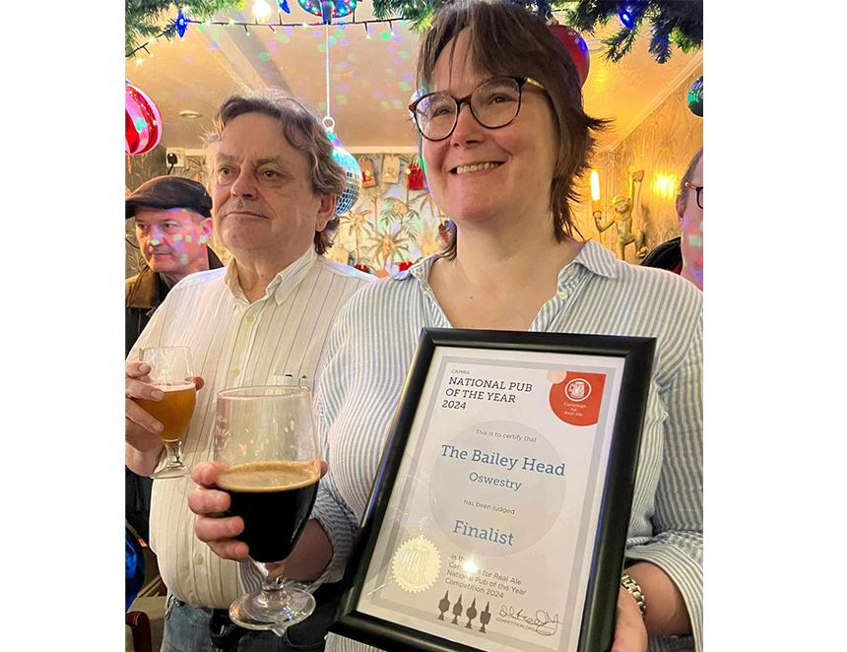

Regulars and visitors from far and wide came together to celebrate the Bailey Head in Oswestry receiving its certificate for reaching the final of CAMRA’s National Pub of the Year award. Presenting the award CAMRA West Midlands regional director Shelly Bentley said: “To come in the top four in the whole of the UK out of 40,000 pubs is a massive achievement.  “The Bailey Head has won through several rounds: Shrewsbury & West Shropshire, Shropshire, the West Midlands Region and then the Super Regional round to reach the final four. “From the first time I visited to judge it in the West Midlands round I knew it was special, not just for the beer quality, but the atmosphere, the knowledge of the staff and the cleanliness.” The certificate was received by landlord and landlady Duncan Borrowman and Grace Goodlad.  Grace (pictured) said: “I would like to thank our great staff and the regulars who come in and make the pub what it is all year round.” The bar included three special beers brewed by Grace and Duncan with Stonehouse brewery in Oswestry, Castle Rock in Nottingham and Riverhead in Yorkshire. The overall winner will be announced in January.