Fab four fight for CAMRA’s club crown

01/12/2024 by WB Reporter

Campaign

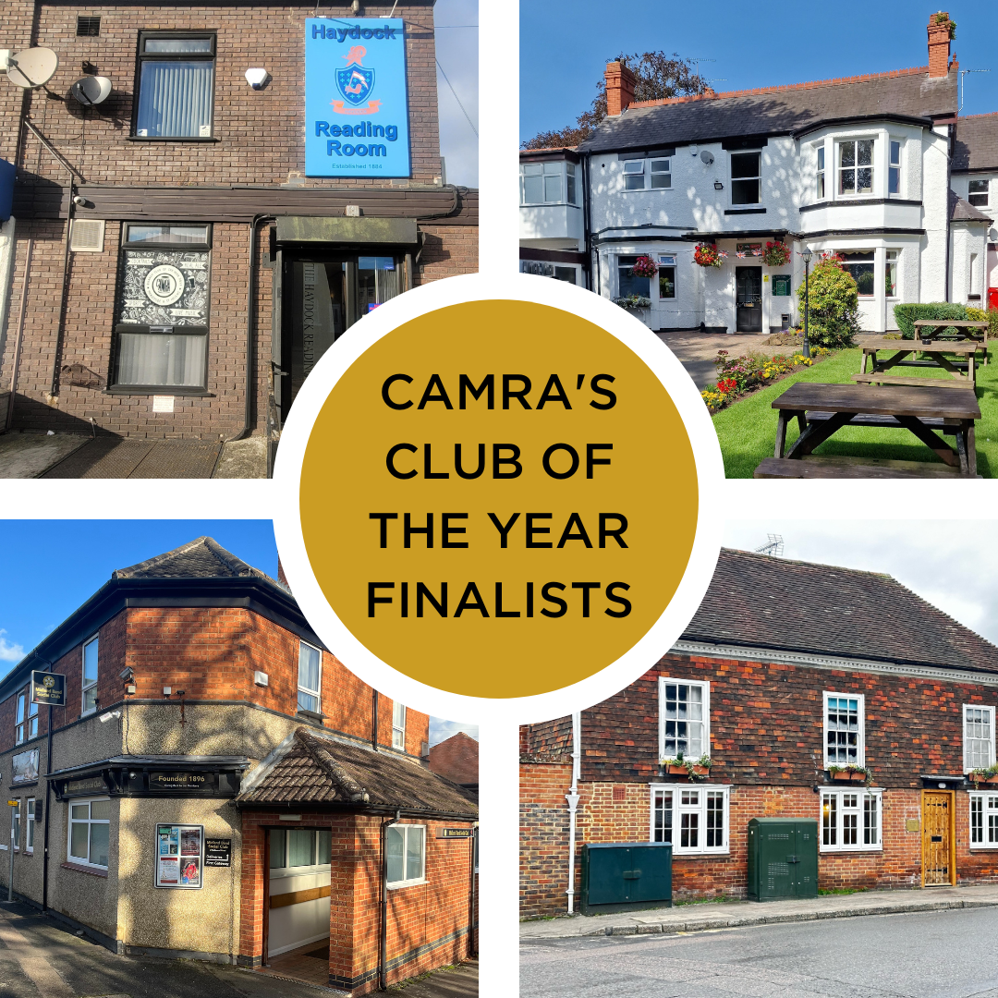

CAMRA has revealed the final four in its search for its 2024 Club of the Year.   The top four are:  Haydock Reading Room St Helens   The Haydock Reading Room has provided a warm and welcoming place for all who like a well-maintained pint with good company since 1884. Three cask beers are available with at least one from a local brewery. The club hosts live music and other events for the community over weekends.  Club steward Nigel Arnold said: “It has been an incredible achievement from everybody involved at the Haydock Reading Room. We set out each year to get nominated for Club of the Year and everything beyond that is a bonus to us and the job we do here. I have a great team of staff that are all fully trained on looking after and serving real ales. As well as that, we have a great committee supporting the work we do.   “In the last three years since I took over, we have gone from strength to strength, progressing in this competition and it’s just wonderful to get the recognition from CAMRA that we have. The St Helens branch has been great in supporting us and advising when they can. It’s just an incredible achievement for all of us involved at the Reading Room.”  Merseyside and Cheshire regional director Ian Garner said: “This award for the Haydock Reading Room is absolutely deserved. Their reputation for good quality, local beers and a welcoming atmosphere, as well as providing live music and community events, has landed them with the claim of being one of the top four clubs in the whole of the UK.   “This accomplishment, along with the inclusion of the Turks Head pub in St Helens as one of the top 17 in CAMRA’s Pub of the Year competition this year, is a great source of pride for all those in Merseyside. Congratulations to steward Nigel Arnold and his team, whose commitment to cask beer was commended by the local branch two years ago, and to all the staff at the club!” Kettering Midland Band Social Club Kettering  A popular club tucked away close to Rockingham Road Pleasure Park. The Midland Band club has plenty of space to accommodate guests, with a long public bar, sunken lounge area, a separate games space and a large concert room for events. Five guest beers from independent breweries are on the bar including one dark option, with bar manager David Bellamy having previously been Club Mirror’s Bar Manager of the Year. The club strives to entertain its community with a busy social diary and regular organised trips.   David said: “To say I am overwhelmed is an understatement. It makes six and a half years of hard work all worthwhile in taking the club from strength to strength and promoting good real ale with the management committee's full support.”  Acting East Central regional director Hubert Gieschen said: “The Kettering Midland Band Social Club should be immensely proud of this achievement, to be included in the final four of the Club of the Year competition is no mean feat. Their commitment to giving their members a choice of top-quality beers has meant they’ve been awarded Northamptonshire’s Club of the Year for the last three years, and now it’s only right that they have secured a place in the final four in the UK.” Marden Village Club Marden   This Grade II-listed community hub won the Club of the Year title in both 2022 and 2023. The Marden Village Club boasts six cask beers, usually from local microbreweries and with one dark brew always available. Snooker and darts teams are very popular, along with regular bingo nights.   Club chair Les James said: “We are very proud and honoured to be named by CAMRA as one of the top four clubs in the UK. This is testament to the tremendous efforts and accomplishments of Simon, the club’s manager, his amazing bar team and the dedicated cleaners. They are all ably assisted by the committee in ensuring the club has a warm and welcoming atmosphere for members to socialise and drink. None of this would have been possible without the continued support of the members.”  South East regional director Paul Sanders said: “The Marden Village Club will soon be running out of space to display its ever-growing haul of awards! Their consecutive successes are not only consistent, but a real testament to the hard work that the team has poured into the social club to make it the beating heart of its community. There is a real chance the fabulous Marden Village Club could win a stunning threepeat of the celebrated title and it would be richly deserved.”  Firs Club Codsall   A comfortably furnished private club with its own onsite microbrewery, the Firs Club’s highlight of the year is its November beer festival, which is a great showcase for its own brews. At the bar there are five, locally sourced, changing cask beers, usually including one mild. Guests can enjoy a pint in the bar area, relax in the quiet lounge, play pool and darts in the separate sports lounge or snooker upstairs.   Club manager Anna Reynolds said: “Here at The Firs in Codsall we are extremely honoured to hear we have achieved a place in the top four clubs in the country. This would not have been possible without the support of CAMRA members who have voted for us year after year, our committee, staff, members and customers.  “We strive to provide a welcoming atmosphere with a good selection of ales, including ales from our onsite microbrewery. We consider the club as a central part of the community of Codsall and surrounding areas.”  West Midlands regional director Shelly Bentley said: “The Firs has been the CAMRA West Midlands Region Club of the Year since 2022, so I could not be happier to announce that it has gone one stage further this time round, with a well-earned place in the final four. The onsite brewery certainly sets this social club apart from many others. I would recommend everyone to visit the Firs, settle into the comfortable seating, and enjoy any of the five high-quality cask beers at the bar with a home-made scotch egg. Soak in the warm, welcoming atmosphere that exemplifies this impressive club.” The winner will be announced in early 2025.   National Club of the Year co-ordinator Phil Gregg said: “We have a very exciting competition this year, with a fantastic final line-up. These four clubs exemplify what people come to expect from an excellent social club – important community spaces that promote the social wellbeing of their area with a commitment to top-quality cask beer. I urge everyone to seek out the top four clubs in the UK, and to visit social clubs in your area.”