Campaign writers scoop top awards

29/11/2024 by WB Reporter

Campaign

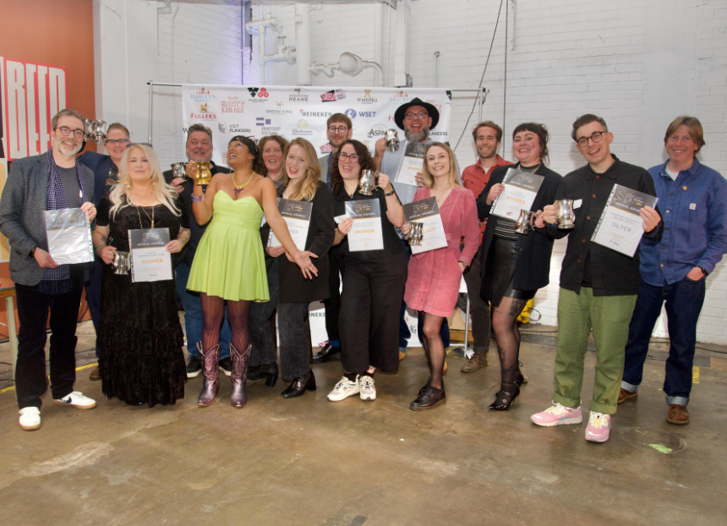

Work commissioned by CAMRA took home top prizes at the prestigious British Guild of Beer Writers Awards.  The CAMRA-published Devils In The Draught Lines by historian Dr Christina Wade won the Gold award in the Best Book about Beer or Pubs category.   The groundbreaking publication charts the rise and fall – and rise again – of women in Britain’s brewing trade over the past 1,000 years. The book features interviews with some of the most influential women working in the contemporary beer industry, from award-winning writers and educators to brewers and pub owners. The book offers insights into the beer world and its history, exploring the reasons why female brewers became marginalised while also debunking some old myths along the way.  Christina said: “I am absolutely blown away and delighted, I am so honoured to have won best beer book, it was a love letter to the beer industry and to women of beer everywhere.”  The Silver in the category was also won by a CAMRA publication – Manchester’s Best Beer Pubs and Bars by Matthew Curtis. From traditional pubs serving top-quality cask beer, to contemporary bottle shops and taprooms, Manchester is bursting with great beer. With detailed reviews of nearly 200 must-visit venues, this book will direct you to the very best places to drink and explore the North-West beer scene. The book also claimed Silver in the Best Communication about Beer and Travel category.  Adam Wells took home Gold in The Susanna Forbes Award for Best Communication about Cider category for his CAMRA-published book, Perry: A Drinker’s Guide. The first dedicated and comprehensive guide to this traditional beverage, the title takes readers on a journey through the magical world of perry.  Adam said: “I’m absolutely honoured to have won the Susanna Forbes Award. The impact on the quality of and interest in cider and perry writing that the guild’s addition of an award for cider has made has been enormous, and the strength of the shortlist of communicators is remarkable year on year. It’s an incredible privilege to have been chosen, and I can’t wait to read, watch and listen to the cider and perry communications that are produced in 2025. I also hope the guild makes its decision to name the award in Susanna’s honour a permanent fixture.”  For a third time in four years, CAMRA’s educational Learn & Discover platform won Gold in the Best Corporate Beer Communication category for the article Mexican Lager: A History of Colonialism, Adaption, Appropriation and Ascendence by Ruvani de Silva. Ruvani went on to win the coveted Michael Jackson Award for Beer Writer of the Year crown.  Many other Learn & Discover collaborators also won awards. Charlotte Cook claimed Gold in the Best Technical Communication about Beer category. Her Learn & Discover articles, Adjuncts Vs Additives and Understanding Hop Compounds are some of the most detailed the platform has released. Rachel Hendry won Silver in the Best Communication about Pubs category. Her article A history of beer dispense is a fascinating look into how beer gets from the barrel to your pint.  CAMRA’s popular Pubs. Pints. People. podcast was also nominated for the Best Audio or Video Beer Communication award. CAMRA national chairman Ash Corbett-Collins said: “It was a pleasure to celebrate the best of British beer, cider and pub writing last night in such esteemed company. We are delighted that three CAMRA works, and the Learn & Discover platform, took home top prizes in their categories, against stiff competition, and we’re looking forward to another year working with a stellar line-up of authors and content creators to bring quality information and educational information to beer and cider consumers.   “On behalf of CAMRA, I want to congratulate all the winners and shortlisted nominees – they really do represent the best of what we do.”  A full list of winners can be found here: https://www.beerguild.co.uk/awards-2024/ CAMRA’s award-winning publications can be found on our online bookstore: https://shop1.camra.org.uk/  Photo by Cath Harries and The British Guild of Beer Writers