Still time to nominate top pub designs
28/11/2024 by Matthew Rogers
Campaign

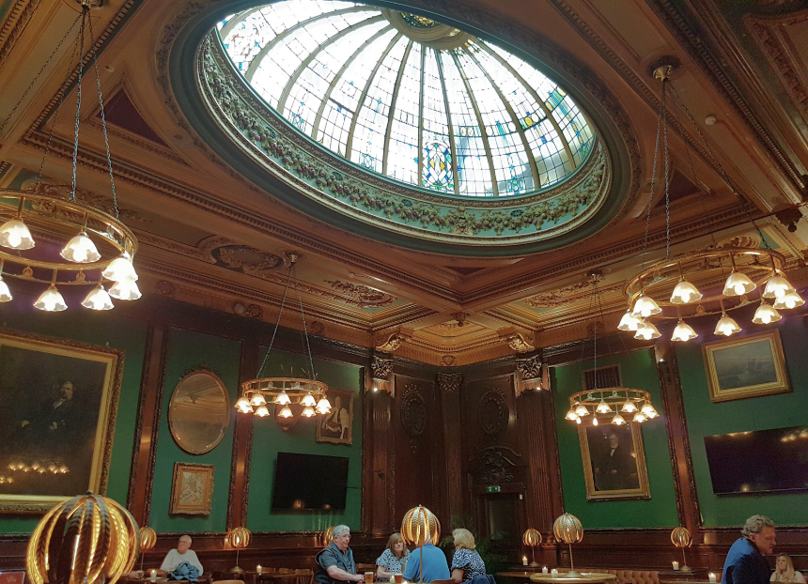

CAMRA has reopened nominations for the Pub Design Awards. Lovers of pub architecture, history and design now have until 3 December to nominate a pub that deserves recognition for its recent conservation or refurbishment project. There are five categories and pubs can be entered in more than one: New Build, Community Local, Historic England Conservation, Conversion to Pub Use and Refurbishment. The awards attract a wide range of nominees, from small village locals whose community have rallied together to renovate it, to once dilapidated Edwardian venues being resurrected to their stunning former grandeur. The annual competition also celebrates the construction of new pubs across the UK, rewarding those who have gone above and beyond to build new venues from the ground up or convert a space not initially designed for hospitality into an innovative place to enjoy cask beer and real cider. Held in conjunction with Historic England, the Pub Design Awards are judged by a panel of experts in design and conservation. The Pub Design Awards are open to all pubs that have completed work between 1 July 2023 and 30 June 2024. To enter and see examples of previous winners, visit: camra.org.uk/awards/pub-design?selected_year=2024 Pictured: Historic England Conservation category winner 2024, the Vines in Liverpool

