Airbnb backs pubs with £10,000 spare room makeovers

27/11/2024 by WB Reporter

Pub

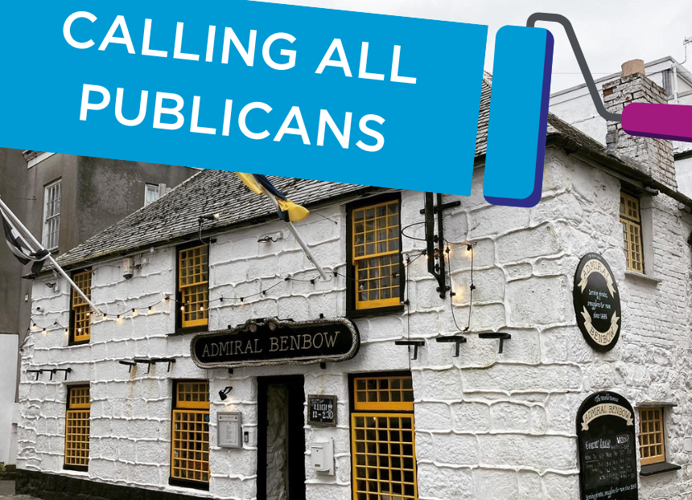

Airbnb has partnered with CAMRA to offer three pubs a £10,000 makeover of a spare room in a bid to boost the pub’s revenue and help the local economy.  The makeover, paired with hosting support from the Airbnb Community Team, rolls out at a time when almost 200 UK pubs have been demolished or converted for a different use in the past 12 months due to increasing financial pressures. Airbnb has seen firsthand how hosting has helped pub owners to diversify their income and support rebuilding their finances post-pandemic. Building on this existing support, Airbnb has partnered with CAMRA to open applications for three pubs to win a makeover of a spare room and hosting support from a member of the Airbnb Community Team.  Pubs in England and Wales are invited to apply via a form on the Airbnb website which is open from 27 November 2024. The three finalists will be selected by a panel of judges from the hospitality industry including Culture & Tourism Select Committee chair Dame Caroline Dinenage, Culture & Tourism All Party Parliamentary Group chair Chris Webb, London Standard restaurant critic David Ellis and CAMRA’s pub and club campaigns director Gary Timmins. Together, they will consider the unique stories behind the pub and its owners and their impact on the community, among other factors.  Airbnb will work with the three winning pubs on the makeovers to create a cosy stay in keeping with each pub’s style and character. The pubs will also have the support of a hosting advisor from Airbnb’s Community Team and online resources on best practice to boost bookings and help make their hosting business a success.   Airbnb UK & Northern Europe general manager Amanda Cupples said: “Britain’s pubs and traditional room-and-board inns are an integral part of our identity when it comes to hospitality and festivity. With research showing that they are facing financial challenges, we want to breathe life into these beacons of the community by refurbishing spare rooms and helping them to diversify or boost their income from tourism. Together with CAMRA, we look forward to spotlighting some of Britain’s most loved pubs and encouraging visitors to discover some incredible new stays this winter.”  CAMRA campaigns and communications director Nick Boley said: “I am delighted CAMRA is offering support on this unique initiative. Pubs are an essential part of communities and heritage across the UK, and we are committed to campaigning for pubs, pints and people. Nothing quite beats the warm atmosphere, friendly welcome and top-quality cask beer, real cider and perry they offer.   “We hope this will be a project that will help preserve our pubs and also help to protect and build communities, while playing an integral part in people’s social lives and wellbeing. I am very much looking forward to working with Airbnb and look forward to seeing the results, while encouraging more people to visit and stay in our beloved pubs.”  The judging panel will select the winning pubs after considering:   – the contribution of the pub and/or its owners to the local community – whether the pub will be a great host on Airbnb – its independence, sustainability, choice (including provision of cask beer). Applications close at 11.59pm GMT 31 December 2024 and winners will be announced in early 2025. Full T&Cs including eligibility criteria can be found here.