Kelp! not just any beer

25/11/2024 by Timothy Hampson

Industry

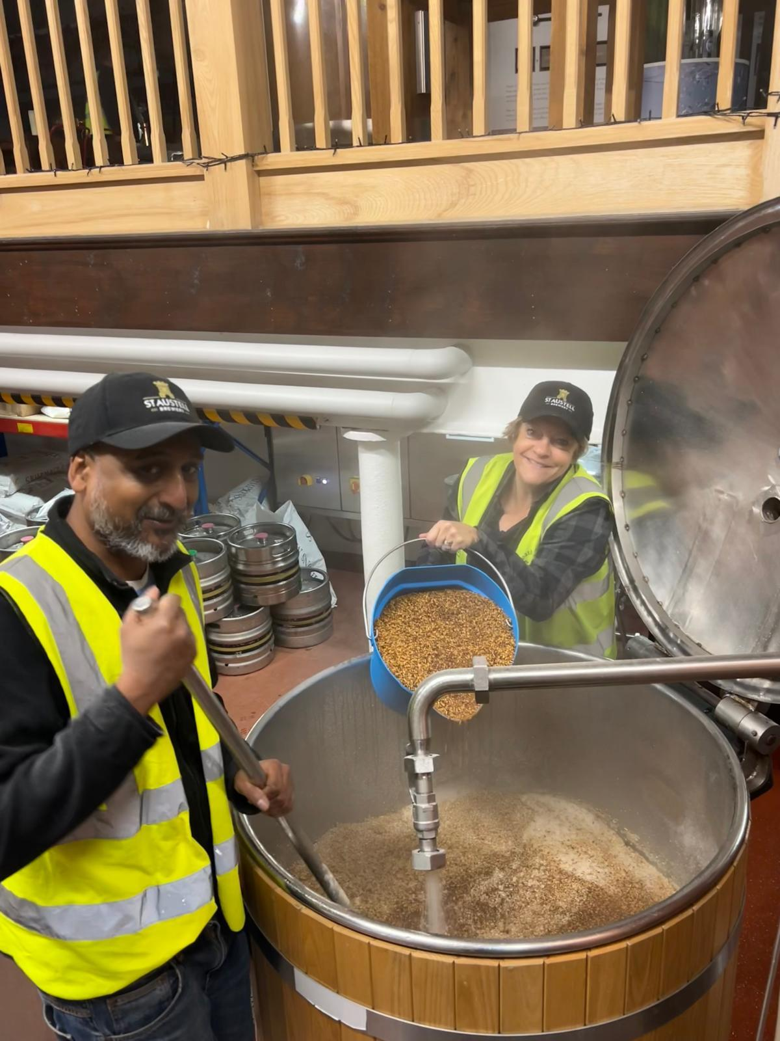

Two British Guild of Beer Writers award winners have come together to brew a special bitter which will be served at this year’s prizegiving. BEER contributor David Jesudason (above left), who scooped five awards for his writing at the 2023 event and St Austell’s head brewer Georgina Young (right), who took the Brewer of the Year title, came up with the idea to mark their wins with a unique brew. Together they brewed Kelp! – a 4.5 per cent seaweed-salted best bitter for the Celtic Beer Festival at St Austell brewery on 30 November. A cask is also being made available at Jesudason’s local, the Shirkers Rest in New Cross, London, where he will be on hand to pull a pint or two on 6 December. David said: “It was my first time brewing a cask beer and it was a real honour to brew on the same kit as the first Tribute, which started its life as Daylight Robbery.” Taking inspiration from the Beatles’ album Help!, Kelp! is a rich mahogany beer, brewed with crystal malts giving it rich raisin and toffee notes, as well as dark fruits from Bramling Cross and Target hops. A kilo of flaked Cornish seaweed was added into the four-barrel kit along with the county’s sea salt to give it a rounded, saline finish. Georgina said: “The brew day was great fun and a brilliant way to celebrate our wins and also St Austell brewery’s Cornish roots by using natural ingredients sourced in the county. The beer is reminiscent of rock pooling, the kelp adding a salty tang, which will complement the menu on the night at the guild awards. We can’t wait for everyone to try it.”