Energy-saving cash in the Attic

24/11/2024 by Timothy Hampson

Industry

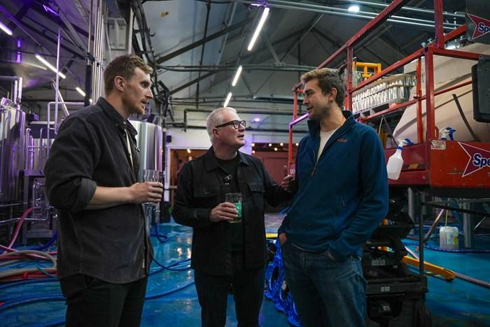

Birmingham brewer Attic Brew Co is one of more than 2,000 businesses being backed by a multi-million-pound scheme helping firms cut their energy bills. Run by friends Sam Back and Oli Hurlow, Attic Brew Co has been given a net zero grant to help buy energy-efficient beer-making equipment and boiler, double glazing and lighting for its Stirchley brewery. The new equipment will cut the brewery’s carbon emissions by 65 tonnes a year – the same amount produced by three family cars over their entire life on the road and slash fuel bills by £30,000 a year at current prices. The energy efficiency scheme is run by the West Midlands Combined Authority (WMCA), through Business Growth West Midlands, and funded by the Department for Energy Security & Net Zero (DESNZ). Attic has an annual turnover of £2.2m and employs 40 people at its multi-award-winning brewery and taproom in Stirchley and at its Barrel Store in Birmingham city centre. The company also supplies Waitrose and CrossCountry trains as well as pubs and other retailers. But like many businesses, high energy costs have been threatening to slow down its ambitious plans to continue growing and be more sustainable. West Midlands mayor Richard Parker visited the brewery to toast the success of the business and hear how it will be boosted by becoming more energy efficient. Back said: “Our bills had gone up by 50 per cent which is a massive amount for us, and it was set to start eroding our margins. We’re a very energy intensive business and currently spend around 10 per cent of our production costs on fuel. “The support we’ve had means we’ve been able to reduce equipment running costs, the level of heating we need and the CO2 we produce. It has also unlocked additional support to help find future avenues for improvement. “Without this help it’s likely we’d have had to scale down our plans to maintain the growth we’ve seen since we began brewing commercially in 2018.” Parker said: “Stirchley has changed so much over the years, and Attic brewery is a great example of that. It’s amazing to see how this brewery has grown into such a hub for the community. And it’s businesses like this one that I am delighted to be supporting with grants that will help them grow. “During my visit, Sam and Oli showed me how this investment in energy-saving technology will help them cut costs, reduce carbon emissions, and continue their ambitions for sustainable growth. “Local breweries like Attic Brew Co are an important part of our communities, creating jobs and offering spaces where people can come together. I’m backing our breweries and would encourage residents to do the same.” CAMRA has called for more support to help pubs and breweries deal with high energy bills. National chairman Ash Corbett-Collins said: “Breweries, along with the pubs that they serve, are battling to stay afloat against a horrendous tide of financial challenges, including spiralling cost of goods and high energy bills, and a restricted access to market. “With many independent breweries not being able to see a light at the end of the tunnel, WMCA’s funding comes at an ideal time for a brewery like Attic. “They are integral parts of local economies and provide greater choice to consumers in a space dominated by giant international breweries who often have a stranglehold over draught beer served in pubs and bars.” Pictured from left: Sam Back, Richard Parker and Oli Hurlow