Kismet Hardy

23/11/2024 by Roger Protz

Opinion

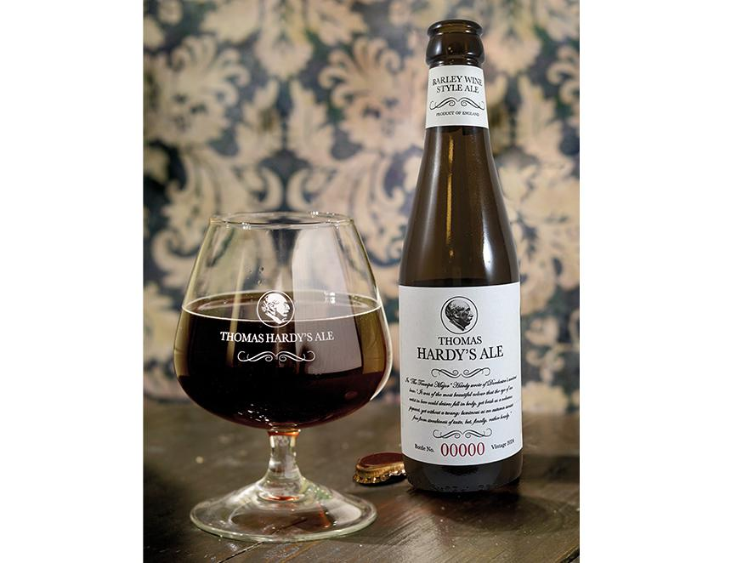

It’s the Return of the Native – the launch of a new edition of Thomas Hardy’s Ale, the celebrated English barley wine that beer lovers feared might disappear as a result of brewery closures. The beer commemorates the life of the great novelist who lived and worked in Dorchester and had a great love of the local beer. The ale named in his honour has a turbulent history that could have stepped from the pages of one of his Wessex novels. The original brewery, Eldridge Pope, closed in 2003. The brand was bought by George Saxon, an American beer importer, who had it brewed by O’Hanlon’s brewery near Exeter. It stopped making the ale in 2008 as it took up so much time and space that it interfered with the production of its regular beers. In 2013 George Saxon sold the rights to Thomas Hardy’s Ale to Sandro and Michele Vecchiato who own Brew Invest, Italian drinks importers and exporters. They spent three years researching the history and brewing methods of the beer and in 2015 launched an edition brewed by Meantime brewery in Greenwich, London. Meantime was bought by the Asahi brewing group that also owns Fuller’s in Chiswick. When Asahi closed Meantime, the Vecchiato brothers looked for a new home for the beer, which they felt strongly had to be in England to be true to its roots. The new edition has been brewed at the Hepworth brewery in West Sussex, with master brewer Derek Prentice in charge. A classic English ale has been saved and restored. Eldridge Pope, which opened in 1837, brewed the beer as a one-off in 1968 for a literary festival that marked the 40th anniversary of Hardy’s death. The beer was based on a 19th-century recipe and was aged in wine casks. It created so much interest that it became an annual vintage. Eldridge Pope was founded in 1837 by Sarah and Charles Eldridge. When Charles died, Sarah continued to run the brewery – it was most unusual for a woman to have such a role in the 19th century. The Popes arrived in the 1870s and built a much bigger plant close to the new railway line that runs through the town to Weymouth on the coast. It became a large and impressive site but as a result of some disastrous business decisions it closed in 2003, leaving a legacy of an acclaimed beer said to have been the strongest in Britain at the time. Thomas Hardy would no doubt have approved of the beer. In his novel The Trumpet Major he described the beer of Casterbridge – his name for Dorchester in his novels – as “the most beautiful colour the eye of an artist in beer could desire, full in body, yet brisk as a volcano, piquant, yet without a twang; luminous as an autumn sunset; free from streakiness of taste, but, finally, rather heady”. At 11.3 per cent ABV the beer is certainly heady. As it’s bottled conditioned with yeast, it will not only age and mature beautifully but will also gain a little more in strength. Derek Prentice earned his brewing spurs with Young’s and Fuller’s in London. The version of Thomas Hardy’s Ale he has brewed is made with Maris Otter pale malt, a small amount of crystal malt and cane syrup – he says the syrup is needed to create the finished strength. The hops are Fuggles and Goldings, which would have been available in Hardy’s time. The beer is matured for three months, and yeast is pitched several times to ensure a continued strong fermentation. The finished beer has a flaming red-bronze colour with a massive hit of caramel and sultana fruit on the nose, with hints of butterscotch and sweet grain. Luscious vinous fruit dominates the palate with notes of caramel and spice. The finish is smooth and mellow with sweet grain, sultana fruit, butterscotch and a gentle hint of spicy hops. It’s Cognac with hops. Not content with this edition of the beer, the Vecchiato brothers asked Derek to produce a “historical” version. It’s the same beer and strength but, in the manner of the first beer brewed by Eldridge Pope, it has been aged in French wine casks for three months. It’s a little darker and has an oak aroma with vinous fruit. The palate is sweet and vinous with a continuing oak note and gentle spicy hops. The finish is long with Cognac notes, sweet grain and a hint of hops. It’s a memorable beer and one to lay down and treasure. The beers are available from the British distributor James Clay: www.jamesclay.co.uk