Duck’s open all hours

22/11/2024 by Timothy Hampson

Industry

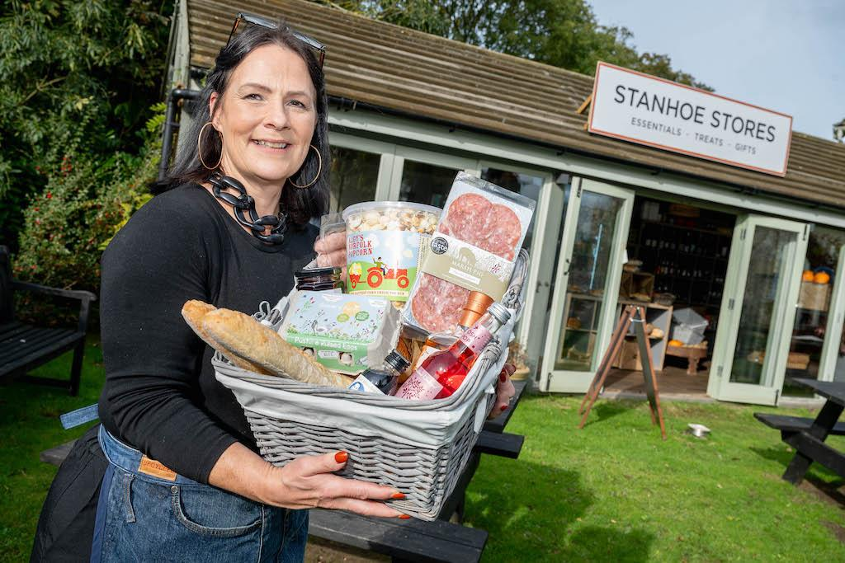

Licensees Rachael and Jeremy Parke have opened a new village store at the Duck in Stanhoe, Norfolk, with help from Pub is The Hub and a Community Services Fund grant.  The publicans have established a thriving trade at the Duck which serves as not only a local pub but a destination food venue.  Stanhoe is a small village with just under 200 residents and limited facilities apart from the pub and village hall.  The Parkes realised there was a need for a store to support both locals and visitors, as it is four miles to the nearest shop, and there is limited public transport.   Rachael said: “We have had so much support from residents for the village store. The log-burner seating area is proving to be very popular with people popping in for a chat, a coffee and to read the paper in a relaxed environment. “The store is an essential service that is helping villagers get their provisions without having to travel many miles to the nearest shops. We are dedicated to supporting other local suppliers which will help boost the local economy.”  Pictured: Rachael Parke