Post-Budget blues for independent pubs

21/11/2024 by Timothy Hampson

Industry

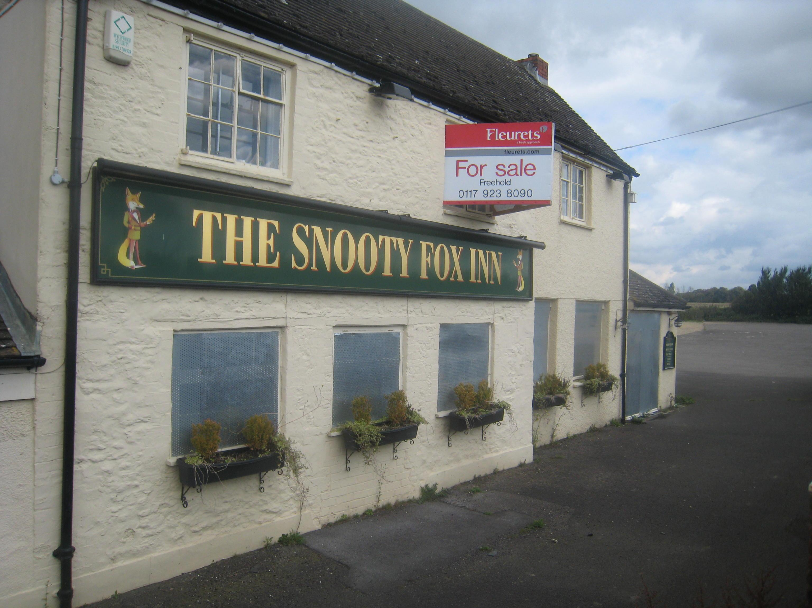

One in four independent pubs are set to fail as they face a wall of taxes from the chancellor’s Budget. A new survey from the British Institute of Innkeeping (BII) shows the impact of the additional costs on small pub businesses from the Autumn Budget. It adds the new costs of employment and increases in business rates will render 80 per cent unprofitable. According to the survey 75 per cent will cut staff hours, 40 per cent will reduce opening hours and one of three will make staff redundant. BII CEO Steve Alton said: “The Budget is devastating for our members, their teams, their pubs and their communities. Words from the government recognising the vital role of pubs in every community and the unique social value they bring are simply hollow. Ahead of the budget it was clear that many pubs were unprofitable through exceptional costs of doing business, with ongoing high energy costs, embedded high inflation in food and drink costs as well as spiralling employment costs alongside repaying covid-debts.   “The government’s response has been to ask these small, fragile pub businesses to pay additional taxes, for many 10 per cent of their current turnover in new costs. The personal distress this has caused to long-standing publicans is palpable through the surge in calls to our professional helplines. “The government’s actions will reduce employment, investment and cause unnecessary business failure. Those that are able to carry on, will have to raise prices in an attempt to offset these additional costs, 84 per cent will increase prices with 80 per cent raising them by at least 10 per cent, driving further inflation in the economy.  “Our members are extremely concerned on how sustainable further price increases are for consumers and how this will drive down visits and vital spend.”