Strong trading for pubco

20/11/2024 by Timothy Hampson

Industry

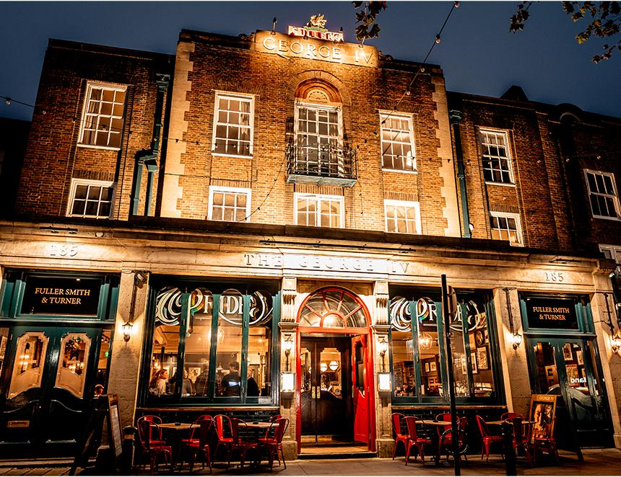

Pub company Fuller’s has reported strong current trading with like-for-like sales rising 5.4 per cent this year and Christmas bookings up 15 per cent. The pubco also said it is “positive and optimistic” about the future despite the “challenges” posed by the Budget.  It comes as the business reported revenue of £194.1m for the 26 weeks to 28 September 2024, up from £188.8m in the 26 weeks to 30 September 2023. The company is now largely “back to where we expected to be if Covid hadn’t happened”, although this has taken three years of hard work, investment and a return to more normal working patterns, said chief executive Simon Emeny. Last year, the company invested more than £10m refurbishing its pubs. The latest to reopen is the George IV in Chiswick (pictured), following a refurbishment of the bar, dining area and its purpose-built function space, the Boston Room. General manager Ben Bullman said: “The place looks amazing, with new furniture, colour scheme and décor while keeping the charm that our customers love. “Over the years, we’ve worked hard to create an exciting calendar of events – cementing our position at the heart of the High Road. The calendar continues to grow, and we have events on every week – either in the bar or our event space, the Boston Room. “We’ve partnered with local organisations, such as the West London Queer Project and the Chiswick Calendar, to ensure we have something for everyone.”