Rocking Rudolph returns

19/11/2024 by Timothy Hampson

Industry

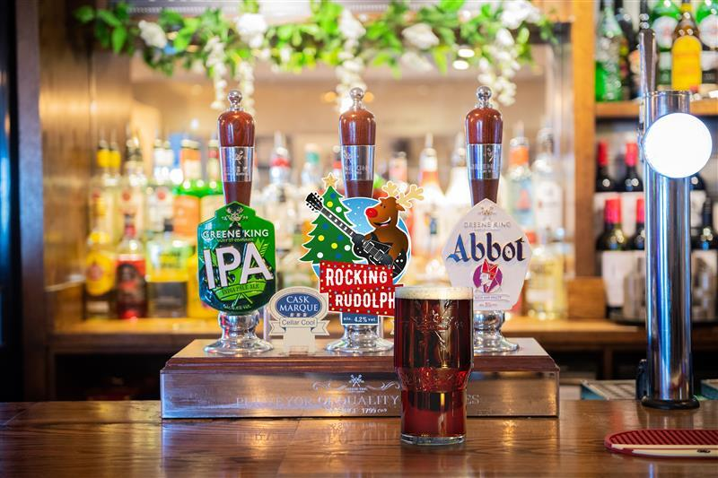

Greene King is hoping to spread more cheer this Christmas as it launches its seasonal cask beers for November and December, including the return of the popular Rocking Rudolph. The seasonal 4.2 per cent cask ale has been the UK’s number one Christmas beer in the on-trade for the last decade and is filled with fruity esters and a malted toffee taste, as well as a crisp finish, providing the flavours of Christmas all in a pint. For each pint sold, Greene King will give 5p (plus VAT) to Macmillan Cancer Support with the money raised going towards helping the charity to continue to provide vital care and support for people living with cancer. Since partnering in 2012, Greene King has raised more than £20m for Macmillan. The other returning ale is Fireside, a 4.5 per cent ruby winter ale with a mellow fruity finish and grapefruit and lemon citrus characters. For December and into the New Year, Abbot Reserve will be available. The 6.5 per cent ale is bursting with fruit cake and toffee flavours. Greene King head brewer Jack Palmer said: “You can’t find a more festive beer than Rocking Rudolph and it’s always the brightest and boldest beer on the bar at Christmas.  “We are proud to continue our fundraising for Macmillan Cancer Support through the sales of Rocking Rudolph and to also raise awareness for such an important cause at this time of the year. Last year we gave over £36,000 to the charity from Rocking Rudolph and this year we hope to raise even more. “Winter is also the perfect time to introduce those deeper and bolder cask beer styles and Fireside and Abbot Reserve are the perfect beers to offer during those chillier months. If you are looking for the ideal ale selection as we head into winter, then our seasonal ales have got you covered.”