Brewer’s Westminster showcase

18/11/2024 by Timothy Hampson

Industry

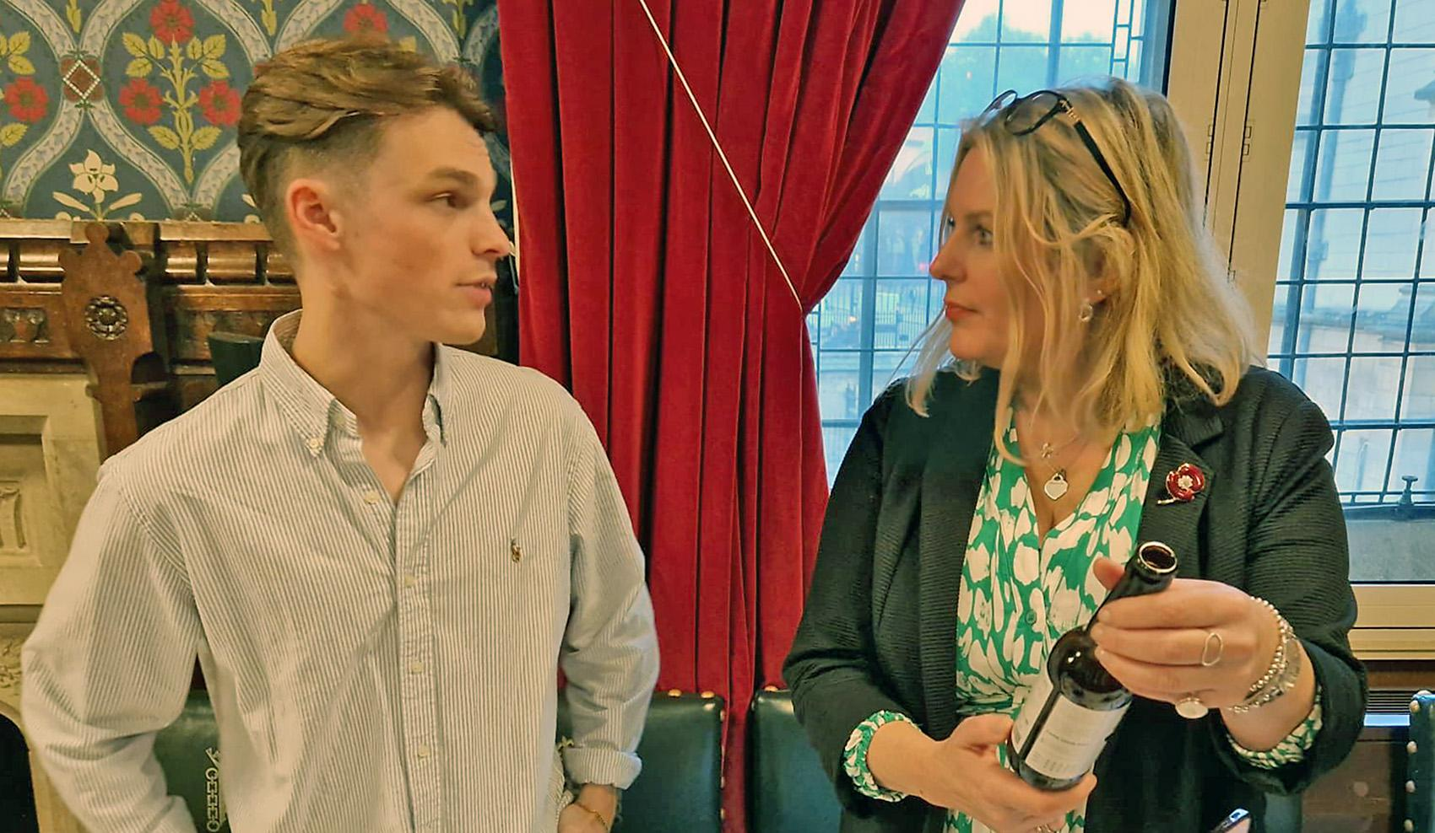

An East Sussex brewery took its beers to parliament as part of an event showcasing the best food and drink produced in the area. East Grinstead and Uckfield MP Mims Davies extended the invitation to Three Acre brewery for the event, which was visited by many MPs, peers, parliamentary staff, the mayors of Uckfield and East Grinstead, councillors and guests. Everyone had the chance to sample the produce. Three Acre brewery director Chester Broad said: “Our beers were received very well and went down a treat as an accompaniment to the award-winning cheeses, other savouries and cakes on show.” Davies said: “The reception provided our extremely hard-working local businesses the chance to showcase their fabulous products; as well as the chance for my colleagues, their staff and visitors the fantastic opportunity to sample our businesses’ award-winning produce.” Pictured: Chester Broad with Mims Davies