Spicy beer pickle

17/11/2024 by Christian Gott

Uncategorised

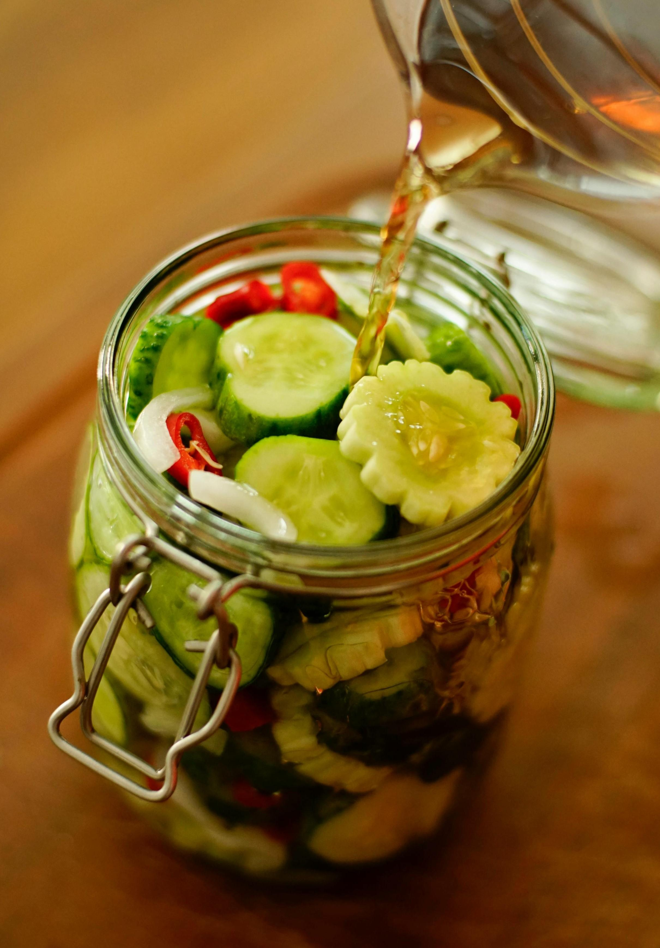

It has just been half-term in our household and following tradition we made our Christmas cakes - yes, we have several, having first soaked the fruit in strong ale overnight. My children then feed the cakes every week with vintage port before decorating. We also started to make supplies for the festive period, which also make excellent gifts, jars of home-made mincemeat, packs of twice-baked biscotti biscuits, and my spicy beer pickles, a wonderful accompaniment to Boxing Day cold meats. A sour beer, vinegar, chilli, and spices give the pickles the perfect balance of tart, sweet, and heat. Pickles have a 4,000-year history and some of the first documented examples are cucumbers. Cleopatra believed pickles in her diet contributed to her health and beauty, and Ceasar fed them to his troops believing it made them stronger. By the end of the 1600s, immigrant Dutch farmers grew cucumbers in what is now modern-day Brooklyn to pickle in barrels. The technique of storing pickles in glass jars was an innovation that won its inventor the equivalent of a £250,000 prize from Napolean to help preserve food for his troops. Traditional pickles rely partly on flavour from natural fermentation, my version relies on a sour beer and is a much quicker process that you store in the fridge.  Sour beer has an intentional flavour created by a similar fermentation process to naturally preserved pickles from the Lactobacillus bacteria. Another technique is to add fruit with a high acid content to give the necessary tartness. From its origins underneath an arch at Manchester’s Piccadilly Station, Track Brewing has gone on to create a huge range of beers from hazy hop-forward pale ales to imperial stouts. Its Lipari Lemon Sour has a bunch of tart lemon flavours balanced with lactose sweetness, perfect for my pickles. I use a firm cucumber that is thickly sliced but you can use wedges or even small whole cucumbers which will take a little longer to pickle. Spicy Beer Pickles When you are pickling and preserving it is really important to make sure that the glass jars you intend to use are scrupulously clean and sterilised. You can do this by carefully washing the jars first, rinsing and then placing in a pan of boiling water and leaving the jars immersed in the boiling water for 10 minutes. 2 large cucumbers, washed440ml Lipari Lemon Sour150ml cider vinegar50g golden caster sugar1tbs sea salt2 medium red chillies, sliced4 cloves of garlic, peeled and sliced1tsp black peppercorns1tsp coriander seedsSmall handful of fresh dill Heat the beer, vinegar, sugar, salt, garlic, peppercorns and coriander seeds in a pan, stirring until the sugar and salt dissolve. Remove from the heat and let it cool to room temperature. Wash the cucumbers, dry them, and cut them into chunky slices. Pack in a sealable glass container with the sliced red chilli and the dill. Pour the cooled pickling solution over the cucumbers, making sure that everything is covered. Cover and refrigerate for at least a day, preferably two before serving. Store in the refrigerator for up to a week.