Independence versus authenticity

16/11/2024 by Matthew Curtis

Industry

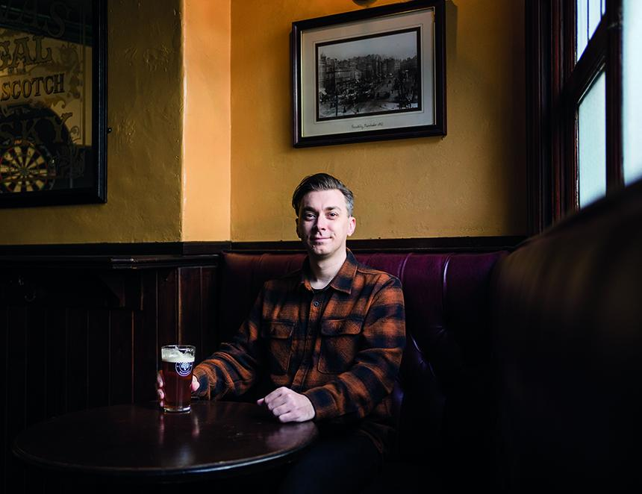

Who makes your beer, and does that matter to you? That’s the question SIBA (Society of Independent Brewers and Associates) is asking with its latest initiative. Called Indie Beer, its intent is to help consumers easily identify if the beer they’re drinking is produced and sold by an independent brewery, or by one of the handful of multinationals that dominates the British beer market. Drinkers can easily look this up via a specially designed website and participating venues also have access to various point of sale materials if they want to help their customers easily identify genuinely independent beer.  “The campaign really seems to have resonated with people,” SIBA head of comms and marketing Neil Walker told me. “We've seen around 40,000 searches on the brewery checker from more than 16,000 active users in the first week or so, from a complete standing start.” For a long time, the majority of beer made and sold within the UK has been made by a handful of big producers. Back in the 1970s the market was dominated by a group affectionately referred to as the Big Six. Consisting of Allied Breweries (Tetley, Ansells and Ind Coope), Bass Charrington, Courage, Scottish & Newcastle, Whitbread and Watney Mann, in 1976 they were accountable for 83 per cent of the beer consumed in Britain. Much of their dominance was down to the steady acquisition of several smaller brands, each of them merging to form a lumbering beast that meant – unless you knew where to look – consumer choice was highly limited. By the late 1980s calls from the industry about the lack of competition in the market were heard by the then Conservative government, which in 1989 introduced legislation called the Beer Orders designed to break up what was agreed to be a monopoly. It meant that no brewery was allowed to own more than 2,000 pubs, and tenants were allowed to buy in guest beer other than that from their premises’ owner.  The orders were effective in that they saw these brewing giants sell thousands of pubs. Whitbread, for example, had sold 2,500 by the end of 1992, as it pivoted into new ventures such as the Premier Inn hotel chain and Costa Coffee, the latter which it sold to Coca-Cola in 2019 for $4.9bn.  None of the historic Big Six exist today as brewing concerns, with their demise giving rise to the modern pubcos that dominate a huge proportion of todays on-trade. The Beer Orders were eventually repealed in 2003 citing that “no one company… holds a dominant position in the total market for beer”. However, 21 years on I consider that the UK beer market once again finds itself in a similar position as it did in the 1970s – with one significant difference: with the exception of Diageo, none of the breweries that now dominate the market now originated in Great Britain. According to data published in October 2023, AB InBev, Heineken, Molson Coors, Carlsberg, Asahi, Mahou San Miguel and Diageo account for 81.6 per cent of beer sold in the UK. By the time you’ve filtered out smaller non-independent brands such as Greene King, around 13 per cent of the UK beer market remains for British-owned independent breweries to operate in. That’s not a lot of wiggle room. On paper this looks and feels a lot like I imagine the dominance of the Big Six did in the 1970s. However, there’s a significant difference between then and now. By the end of the 1970s there were reportedly 145 breweries operating in the UK. In 2024 that number is now 1,700. This means, in real terms, 99.6 per cent of the UK’s breweries are competing against one another for that 13 per cent market share, which is one way of understanding why SIBA has launched Indie Beer.  “The issue for small breweries isn’t lack of demand, it’s restricted access to market and consumers who believe they are buying independent when they’re not,” Neil said. But does identifying whether a beer is independently produced or not actually matter to drinkers? Surely the majority of drinkers know, and don’t particularly care that their Carling or Stella or Budweiser is mass-produced. There’s a reason why these brands are so popular, after all. The issue is that these multinationals aren’t content with the fact they already own the most popular beer brands in the country, but that they seek further growth. This means eating into the market share occupied by the UK’s small, independent breweries. To achieve this, they’ve employed various strategies, such as creating pseudo brands steeped in manufactured authenticity. Madri, from Molson Coors, which plays on the current surge in popularity for Spanish lager, is a great example of this. Although in terms of its Spanishness its authenticity ends in Tadcaster, where it’s brewed.  Another strategy is straight out of the original Big Six playbook, which has seen multiple small independents hoovered up and turned against their former peers. AB InBev has Camden Town, Carlsberg has Marston's and all of its subsidiaries, Asahi has Fuller’s, Dark Star and Meantime, and Heineken – arguably the most successful at subverting the notion of independence via shrewd acquisition – has Beavertown and Brixton brewery.  It acquired the latter in 2021 after buying an initial stake in 2017. Thanks to Heineken also owning 2,400 pubs via its Star Pubs and Bars subsidiary, it means it has a modern offering prepped and ready for this channel without the need to invest in developing a new brand from scratch. The question remains if customers care about who owns the beer they’re drinking, as independent or not, authenticity comes in many shapes and sizes.  “At Brixton we have always been transparent about who owns us, where our beers are brewed, and the values that guide us,” Jez Galaun, who co-founded Brixton brewery in 2013, told me. “While we are no longer an independent brewery, we are still founder-led and remain deeply rooted in our local community.” At Hop Burns and Black, an off-licence based in Peckham, South London, owners Glenn Williams and Jen Ferguson have been championing independent beer exclusively for a decade. When Camden Town sold to AB InBev in 2015 Williams told me it forced them to “codify our approach”. It meant that when subsequent stocked brands ceased to become independent, they delisted them, which happened with Brixton in 2017 and Beavertown in 2018.  “The reason we got into craft beer in the first place was that it brought interest and excitement back to beer,” she says. “We didn't start a shop in order to sell Stella Artois.” The independent sector of the beer industry needs to be taken seriously. This isn’t a handful of disgruntled brewers we’re talking about, but thousands of small British businesses, many of whom also employ several staff. Each brewery has an immense amount to worry about, from rising costs to an increasingly lop-sided beer market, the routes to which are seemingly becoming narrower every day – much of which is due to intensifying competition from the industry’s largest operators.   On the positive side, independence is one thing these smaller brands have on their side that the multinationals don’t, so it’s certainly an angle worth exploiting. Despite admitting it's a step in the right direction, however, Williams worries that SIBA's new Indie Beer initiative might be too little, too late for the independent beer market.  “The time to do this was when [it] first started, not six years down the track when brands like Beavertown and Brixton have such a foothold and are firmly entrenched with drinkers,” Williams says. “It feels like trying to put the genie back in the bottle.”