PUBlic Affairs round up – November

15/11/2024 by Tori Wood

Campaign

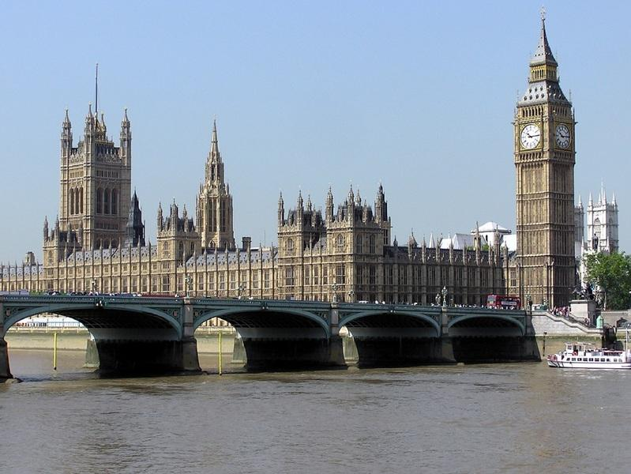

The regular PUBlic Affairs update series returns to What’s Brewing covering CAMRA’s Campaigns and Communications Team’s campaigning efforts across Westminster and devolved parliaments.  The announcement of a new government on 4 July kept the team and campaigners busy, particularly around the new chancellor’s Budget on 30 October.  The team prepped and campaigned ahead of the Budget, which included an e-lobby campaign that resulted in almost 5,000 emails being sent to MPs.   You can read a special Budget edition of this series covering our targeted campaigning, including the outcome for beer, cider, brewers and the hospitality industry, here.   WESTMINSTER  New government & MPs The announcement of the Labour government introduced new ministers and parliamentary private secretaries.  CAMRA sent introductory letters to these officials, including an invitation to discuss the future of beer and pubs at a pub of their choosing, in a bid to ensure pubs, pints and people are at the heart of the new Labour government’s priorities.  We communicated with new MPs through the party conference season and ahead of the Budget to inform them what pubs and the sector need to thrive in every community. Westminster Hall debates Ahead of the Budget, two House of Commons debates took place in Westminster Hall. We supplied briefings to MPs on our key asks to ensure the hospitality sector’s main financial issues were heard.  On 16 October the regeneration of towns and city centres debate took place, followed by the support for pubs and the hospitality sector debate on 22 October.   For both events we thanked MPs who convened the debates and those who raised supportive points in line with our campaigning asks, via our social media.  Community right to buy (England only) Members of the team will be meeting with civil servants in the Ministry of Housing, Communities and Local Government on 5 November at the Antwerp Arms to discuss working with government to develop new Right-to-Buy policies to make community ownership more accessible and help more groups across the UK save their pub.  Handpump hijack In April, we sent a complaint regarding Carlsberg Marston’s Brewing Company’s (CMBC) Fresh Ale concept to West Northamptonshire Trading Standards.   CMBC has a Primary Authority agreement with West Northamptonshire Council. This means that West Northampton Trading Standards give advice on all CMBC sales practices, so its decision could make a huge difference to how Fresh Ale is marketed.   Receipt of this complaint has been confirmed, however, we are waiting for a formal decision to be made before we begin further campaigning on Fresh Ale.  Deposit Return Scheme As part of the Extended Producer Responsibility scheme the government has announced a tax on beer and cider bottles.  The Campaigns and Communications Team attended the Department for Environment, Food and Rural Affair’s Drinks Industry Forum meeting to discuss issues relating to the recent added tax, where concerns about the cumulative impact of regulation was raised from the industry.   An administrator will soon be appointed for the Deposit Return Scheme which will come into action from October 2027, who will also take the reins for Scotland, Wales and England and Northern Ireland schemes.    SCOTLAND  Cross-Party Group on Beer and Pubs (secretariat service provided in part by CAMRA) The Cross-Party Group’s report on the cultural, social and economic value of pubs in Scotland was launched in Scottish Parliament on 25 September 2024.  It recommended Scottish pubs pay a fairer business rates system, moved towards a better access to market for independent breweries, as well as pausing the new regulation on the beer and pubs sector in Scotland.  CAMRA members from the Edinburgh & South East Scotland branch attended the launch to discuss the report, and our campaigning issues, with MSPs, with several keen to submit parliamentary questions relating to our key campaigns.  Craig Hoy MSP, Cross-Party Group convenor, is applying for a parliamentary debate to cover the report and the recommendations entailed.   You can read the Cross-Party Group’s report here.  Scottish Pubs Code CAMRA has been invited to take part in a six-weekly stakeholder round table series with the Scottish Pubs Code adjudicator on the implementation of the new rules which is due in Spring 2025.  CAMRA’s campaigns and communications manager Paul Edgeworth attended the first round table. Further meetings will prioritise individual aspects of the code, which we will attend.  A consultation will be held by the Scottish Pubs Code adjudicator to discuss the principles used to investigate potential breaches of the rules.   You can read the consultation report here.   The Scottish government also held a phase three consultation on the following aspects of the Scottish Pubs Code: the market rent only process, use of flow monitors on guest beer lines, and the information provided to potential tenants prior to the decision to take on a lease or not.  Our response on 4 November 2024.  Planning To tackle the loophole on pub demolitions in Scotland, we are asking MSPs to submit written parliamentary questions to prevent further pubs being lost to this lack of protection.  WALES  Cross-Party Group on Beer and Pubs (secretariat provided in part by CAMRA) Joel James MS has recently been elected as the new hair of the Cross-Party Group (CPG) and is looking to produce more briefings for MSs and participate in debates in the Senedd.  CAMRA has been reappointed part of the secretariat of the CPG in the Senedd, along with SIBA and the Westminster All-Party Parliamentary Beer Group. The CPG is eager to work on planning issues, community ownership, business rates and the Deposit Return Scheme which will include glass in Wales.   NORTHER IRELAND Licensing review The University of Stirling carried out an independent review of the licensing system, which is due to be handed to the executive soon. Ministers will publish a response and recommendations in the new year.   CAMRA and SIBA have produced a joint briefing on the matter and has been sent to all MLAs.  The Belfast Beer Festival hosted a round table specifically for local producers and MLAs, campaigning resources were available at the festival, as well as opportunities for festivalgoers to lobby on the licensing system and any other beer and pub related issues in Northern Ireland. Read more about the campaign here.    Shepherd Neame commitment to cask Following reports by the Telegraph that Sheperd Neame was planning to move away from cask, we issued a strong condemnation and were pleased when the brewer’s commitment to cask was swiftly reaffirmed.   If you have any questions about our campaigns, or are keen to find out how you can become more involved, email campaigns@camra.org.uk