Record-breaking Steel City fest

12/11/2024 by Dave Pickersgill

Campaign

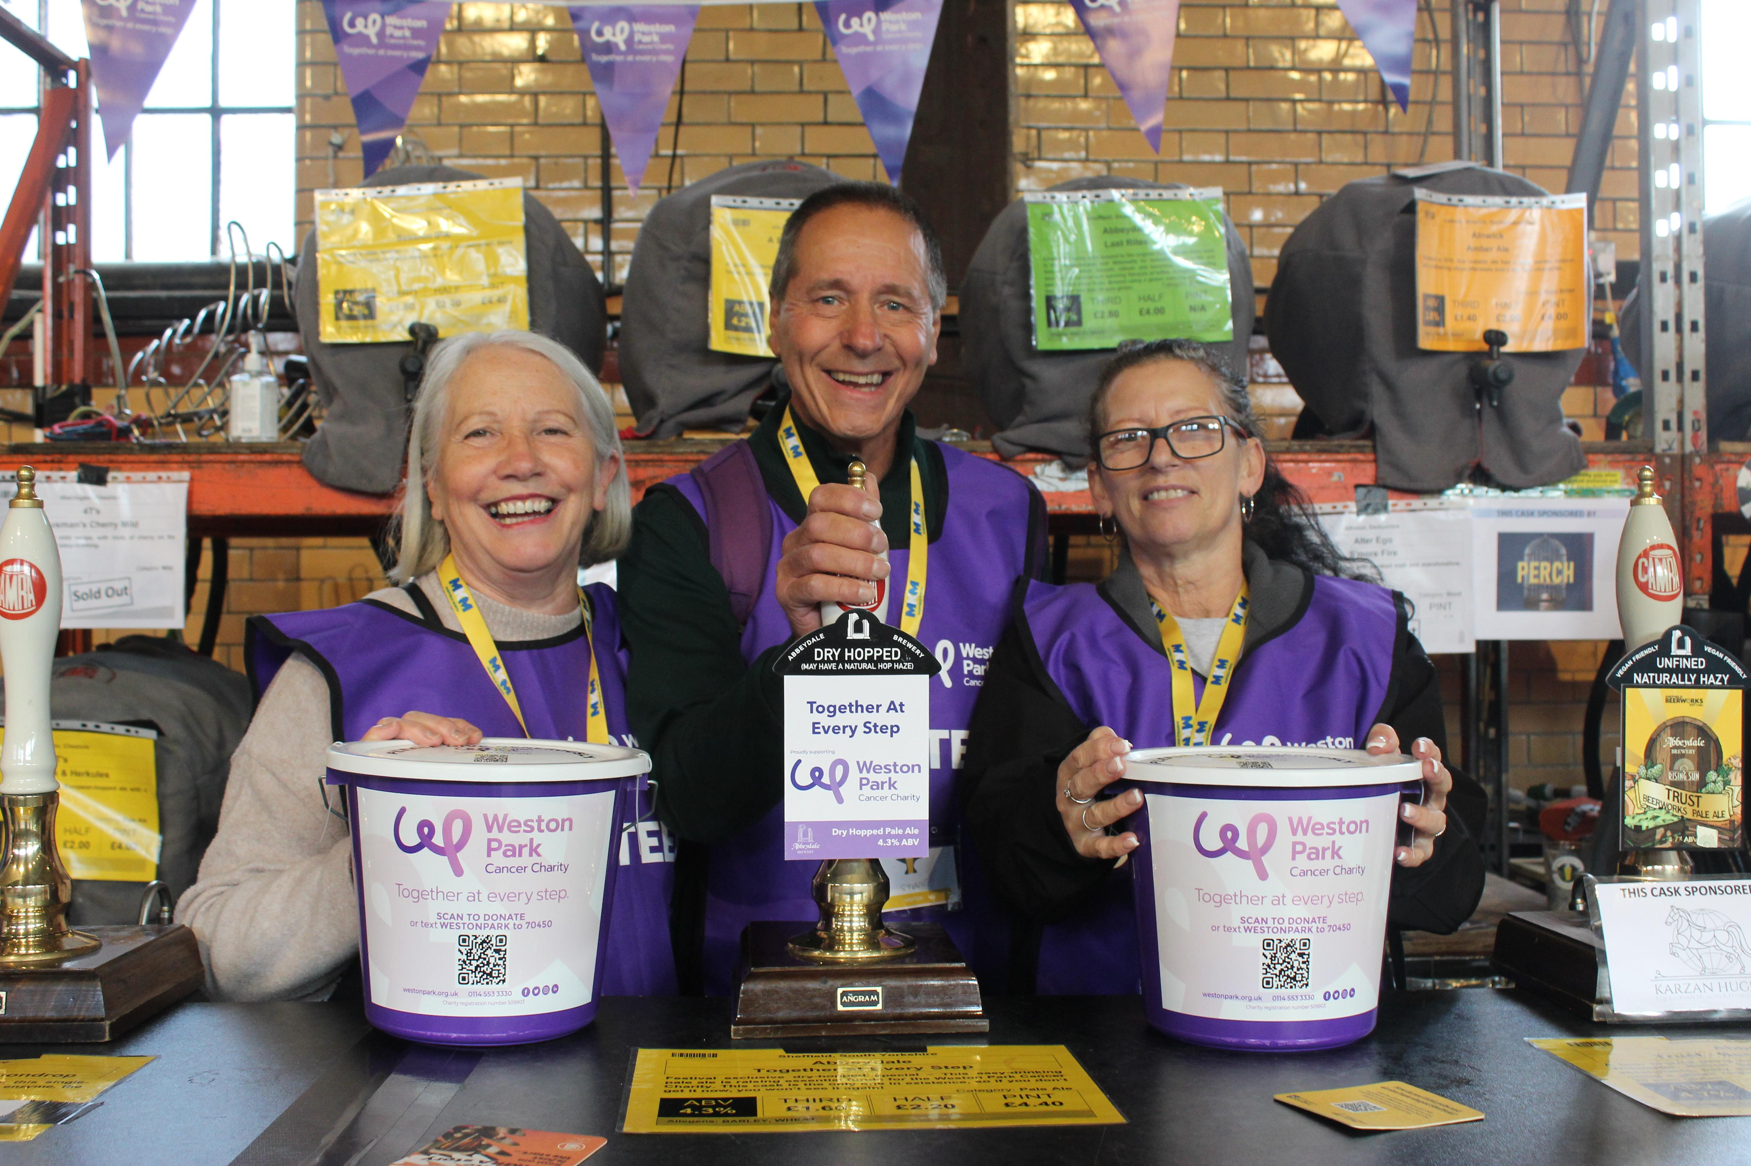

The Sheffield Beer Festival (SCBF48) raised a whopping £2,700 for Weston Park Cancer Charity (WPCC) – a remarkable donation rate of £1.20 a minute. This magnificent sum includes loose change, unused beer tokens, eBay sales of three sets of SCBF48 festival beer mats, proceeds from the charity beer (Abbeydale brewery’s Together at Every Step, a 4.3 per cent ABV dry-hopped pale ale). Festival organiser Paul Crofts said: “It’s a fantastic sum to raise for such a good charity. It was far more than we predicted and shows how much local people appreciate the work of Weston Park.” WPCC fundraising manager Sam Heritage said: “We are very grateful for your generous support and for making our team of volunteers and staff, plus Brontë feel so welcome. I've had amazing feedback on just how brilliant it has all been. It really will make such a difference.” The festival was opened by BBC Gladiators 2024 runner-up, South Yorkshire firefighter and WPCC supporter Brontë Jones.  Sheffield’s Weston Park Hospital is the main cancer treatment centre for South Yorkshire and large parts of Derbyshire and Nottinghamshire. Pictured: WPCC volunteers at the festival. Photo: Dave Pickersgill