Three Acres grows brewing team

11/11/2024 by Timothy Hampson

Industry

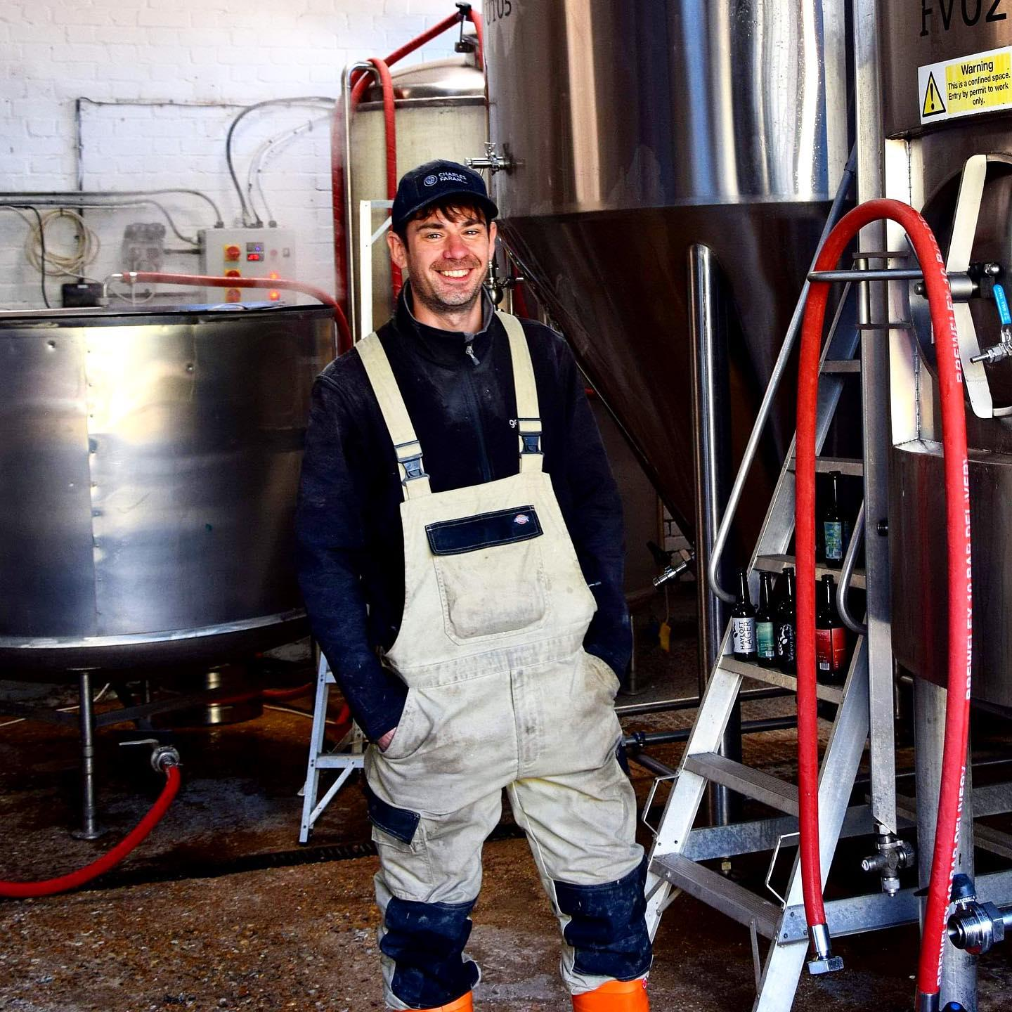

A Sussex brewery is taking on new staff in an effort to keep up with rising demand for its ales. Ed Stubbs (pictured) has joined Three Acre brewery, near Heathfield, as assistant brewer and the team is also looking to increase its sales force. The new recruit grew up in Sussex and worked in the county’s vineyards before taking a sideways step into brewing. Gaining experience at East London Brewing, Mondo and Beavertown, he’s delighted his journey has led him home to Sussex.  “I am so excited to be starting my next chapter, crafting my skills as a brewer and teaming up with the guys at Three Acre. They are creating some of the finest and most exciting beers the market has to offer today”, said Stubbs. Head brewer Jamie Newton said: “Ed brings a lot of experience, new ideas and is full of energy and enthusiasm which is the perfect combination as we work flat-out to meet ever-increasing demand for our beers.”