Keep your eyes on the Prize

10/11/2024 by Roger Protz

Industry

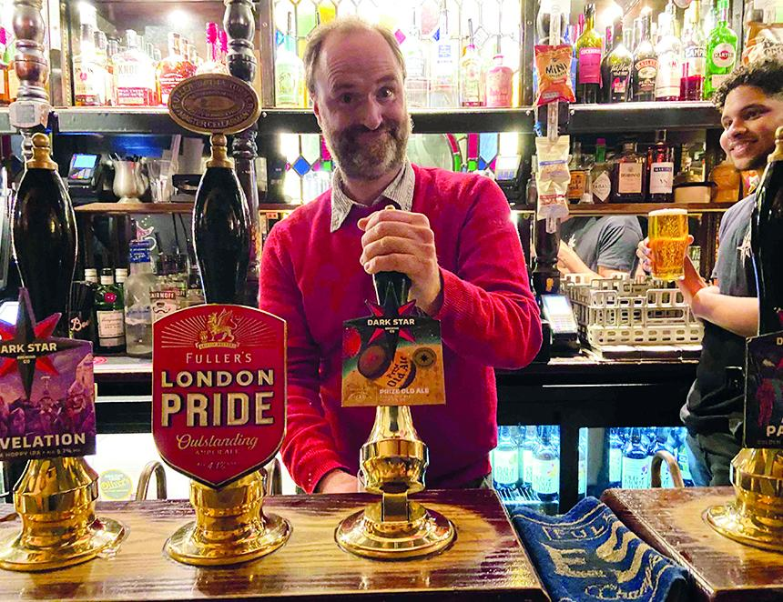

The launch of a new edition of Dark Star’s Prize Old Ale (9 per cent) cements a potent link with a family of English beers known as stock ales that date back to the 17th century.  They have much in common with the oud bruin (old brown) and sour red beers of Flanders and the spontaneous fermentation lambic brews from the Senne Valley region of Belgium.  But stock ales should be judged in their own right as a distinctive English style. The name is thought to have derived from the fact that the beers were aged or stocked for long periods, unlike running beers that were consumed soon after production ended.  Prize Old Ale is not dissimilar to Greene King’s Strong Suffolk Ale that’s a blend of two beers, one aged for a year or more in oak tuns and blended with a fresh young beer. Stock ales are also similar to the Spanish wine industry’s solera system for making sherry, where one aged batch is topped up with fresh wine once a year. In the case of Prize Old Ale, it is a blend of a fresh beer that is just two months old with one that has been aged for several years. The aged beer was stored in oak vessels and has been attacked by Brettanomyces, Lactobacillus and other wild yeasts and bacteria trapped in the wood. POA, as it’s known for short, was first brewed in 1923 by a brewer called William Mears at Gale’s brewery in Horndean, Hampshire. It was made with pale and black malts with torrefied wheat, and it was boiled for two hours with Fuggles and Goldings hops. The long boil caramelised some of the malt sugar and created a dark amber beer. It was fermented in vessels made from New Zealand wood and was matured for between six months and a year. The vessels were home to colonies of yeast and bacteria that ate the remaining malt sugars. In 2005 Fuller’s in Chiswick, West London, bought Gale’s and closed the brewery a year later. Fuller’s head brewer John Keeling had a final 80-barrel batch of POA brewed at Horndean and he added a new batch at Chiswick. He then blended 20 barrels of fresh beer with 20 barrels of aged beer. John said the sales team at Fuller’s “hated POA and didn’t want to promote it”. He hid 42 barrels of the beer in the Chiswick tank room and made only two batches of the beer before he retired. Five years later, Henry Kirk (pictured) a brewer at Fuller’s, discovered the beer in its tank. “I thought it smelt liked Rodenbach Grand Cru,” he said. That is brewed at the Rodenbach brewery in Roeselare, Belgium, where the beer is aged in giant oak vats and blended with a fresh brew in a ratio of two thirds old to one new. There’s an interesting historic twist here, as in the 1870s, a member of the Rodenbach family, Eugene, toured a number of British breweries to learn how stock ales and porter were brewed and then returned to Roeselare to develop his own aged and blended “sour red” beers. Henry campaigned to have POA launched again. Then, in 2019, Asahi bought Fuller’s and Henry was transferred to the Dark Star brewery in Sussex. He brewed a new batch of POA, but the launch was delayed by Covid until 2022. It was brewed with 73 per cent Maris Otter pale malt, 17 per cent invert sugar, 8 per cent torrefied wheat and 2 per cent black malt. The hops were once again Fuggles and Goldings. The batch of 3,600 bottles sold out within 48 hours. It was the fastest-selling beer ever brewed at Dark Star. This remarkable success was marred six weeks later when Asahi announced it was closing Dark Star. The new edition of the beer has been produced at the Chiswick brewery by Sven Hartmann and Luke McCullock. The fresh beer was fermented with Gale’s yeast and the recipe is once again Maris Otter pale malt, invert sugar, torrefied wheat and black malt with Fuggles and Goldings hops.  The beer pours a deep chestnut brown, and it has an oaky and lactic aroma with pronounced notes of butterscotch and burnt fruit. The palate is fruity – raisins and sultanas – balanced by dark grain and gentle hop bitterness with continuing oak and lactic notes. The finish is bittersweet with tart fruit, roasted malt, butterscotch and spicy hops. The beer is available in 500ml bottles from www.darkstarbrewing.co.uk. The draught version is on sale in these pubs:Admiralty Tavern, Trafalgar Square, LondonStar, Belgravia, LondonRed Lion, BarnesDuke of Wellington, Shoreham-on-Sea, Sussex: the pub is run by Rob Jones, the founder of Dark StarVictoria, PaddingtonGeorge IV, ChiswickOld Custom House, PortsmouthOld Joint Stock, BirminghamOld Mitre, Hatton Garden, London.