Hidden gems and destination pubs

09/11/2024 by Laura Hadland

Opinion

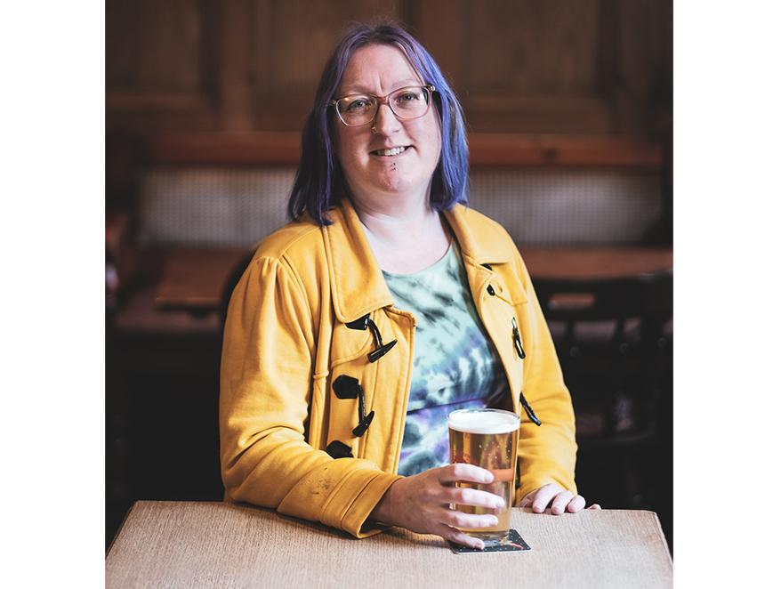

I think we’re all old enough and wise enough to see that the government’s promised penny off a pint in the latest Budget is quite the insult to our intelligence. Publicans will be hit hard by the chancellor’s decision to increase employer’s NI contributions and the National Minimum Wage, for example. That’s not to mention all the other ongoing costs of doing business that continue to put pressure on our treasured public houses. The cost of a pint is only going to rise further. It’s got me thinking about the value of pubs once more. Why do I care so much about them? Why should anyone care? Last month I had one of those most joyous experiences – discovering a fantastic pub for the first time. I was in Hampshire, and an industry friend reached out to see if I would like to visit his local. I’d never heard of it before. It was the Flower Pots Inn in Cheriton.  The sizeable pub occupies a beautiful, early 19th-century brick farmhouse. A barn has been converted into rooms for B&B and further renovations during lockdown have created event spaces and multiple cosy areas for customers to dwell. There is a brewery on site too in the converted stables. Founded in 2006 it is Hampshire’s oldest independent brewery. It is truly a rural idyll. There is a huge beer garden with beautifully maintained borders and the whole site is flanked by mature trees. Inside the pub, an open fire crackled amiably in the grate. The Flower Pots brewery beers are all served on gravity, the seven black-jacketed casks smartly lined up on a robust wooden stillage, with copper bowls hanging over the taps as drip trays. As I treasured my first sips of the 4.4 per cent ABV Heritage Hop, a wonderful green hop beer made with fresh Goldings from Kent, one of the locals crossed over to say hello. A mischievous older gentleman with a twinkle in his eye, he’d seen me taking a little tour and taking some pictures and he had a few choice words for me. “I hear you’re a journalist,” he said with a wry smile. “Don’t be telling everyone about this place. We want to keep it for ourselves.” I can well believe it. I’d caught a glimpse of the chalkboard from the pub’s recent beer festival in the barn and it had at least 50 brews on there. A veritable who’s who of the best in British brewing; Roosters, Anspach & Hobday, Bat Country and Utopian, they certainly know how to treat their punters well in Cheriton. Experiencing that wonderful establishment for the first time brought me joy, and no small measure of jealousy crept in too because I have no idea when I shall ever pass that way again. But I love knowing it’s there doing good things, quietly providing a heart (and fantastic beer) to its local community and holidaymakers fortunate enough to happen upon it. A couple of weeks later, I was reminded that good people are doing great things in fabulous pubs all around the country – sometimes conveniently closer to home. The Unicorn Inn in Little Dawley, Telford, might be mistaken at first glance to be a sleepy estate pub. In fact, it had fulfilled that function quite adequately for several decades. In August 2023, Gina and Denzil Martin took over the reins and in a short space of time they have transformed it. Regular events, a wonderful selection of food and a lot of hard work renovating the space have made it a welcoming, uplifting place to spend time. But it is the beer selection that makes it truly special. It has become, for those in the know, a destination pub. In October, they relaunched the bar. Quite literally, the bar counter. It had been completely transformed with new lines added – there are now five cask lines and 10 for keg and cider. The cellar has had a refit too, to accommodate the additional beers. It looks awesome. They offer a great range of beers from Shropshire, but also some of the best and most hyped breweries from elsewhere in these isles. I had a delicious plum porter from Holy Goat, followed up by a pint of the mighty Enville’s Gothic Stout. It’s the sort of selection that you wouldn’t be out of place in the most praised districts of Manchester or Sheffield. Remarkably, Molson Coors has footed the bill for the bar and cellar work. The pub is a freehouse and yes, now there is Carling and keg Doom Bar on the bar. But I find it incredible – inspirational even – the way the Unicorn Inn has played its hand, balancing the tied lines against its vibrant, exciting selection from independent brewers. I don’t know exactly how Gina and Denzil have done it, but I hope it’s a route more pubs are able to follow. After all, it doesn’t seem like we should hold our breath for any material government support to be forthcoming. Perhaps we should be turning our attention to where we know the money lies. The macros. It’s in their interests to support a thriving pub sector after all. Maybe now is the time for more negotiation. A little give and take could help to create more robust businesses that serve beers we can all get behind. We may like our guest ales, but dyed-in-the-wool Carling quaffers are pub-goers too.