Collab beers to star at Pub of the Year presentation

08/11/2024 by Timothy Hampson

Campaign

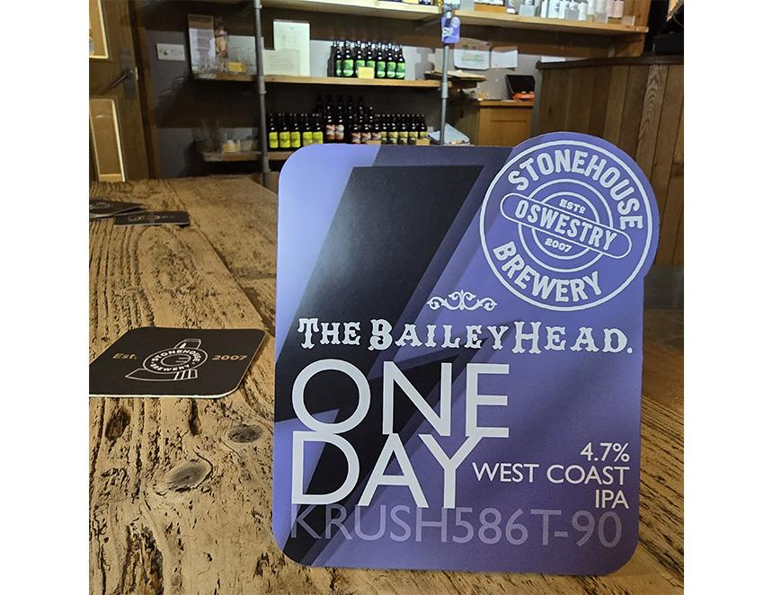

The Bailey Head pub in Oswestry, one of the four finalists in CAMRA’s National Pub of the Year competition, has brewed three collaboration beers with different brewers that will go on the bar at its certificate presentation on 23 November. The latest of the three, One Day, is a 4.7 per cent ABV west coast IPA brewed with local Oswestry brewery, Stonehouse (pictured) where the bar team took part in the brew day. The past two weeks has seen landlord and landlady Duncan Borrowman and Grace Goodlad travel to Riverhead (Ossett) brewery in Yorkshire to brew Wild Flower, a 4.2 per cent hazy pale and Castle Rock in Nottingham to produce Super Creeps, a 4.5 per cent sister beer to Scary Monsters. Scary Monsters was brewed with Castle Rock two years ago, when the pub was the first collaboration brewer on the brewery’s Pilot Project. Grace said: “We have been brewing many more collaboration beers and this will make it eight in the past 12 months. It helps to keep us in touch with brewers we work with, and every brew day teaches us something new, which adds to our understanding of the beer we are selling. I am really looking forward to everyone trying the three beers from 23 November.” Duncan added: “I want to thank everyone at the breweries involved in these brew days – the brewers who did the recipe development and brewed with us on the brew days, the back room staff who made them happen and the designers who worked on the naming and badges.”