New research aims to protect British hop farming

06/11/2024 by Timothy Hampson

Industry

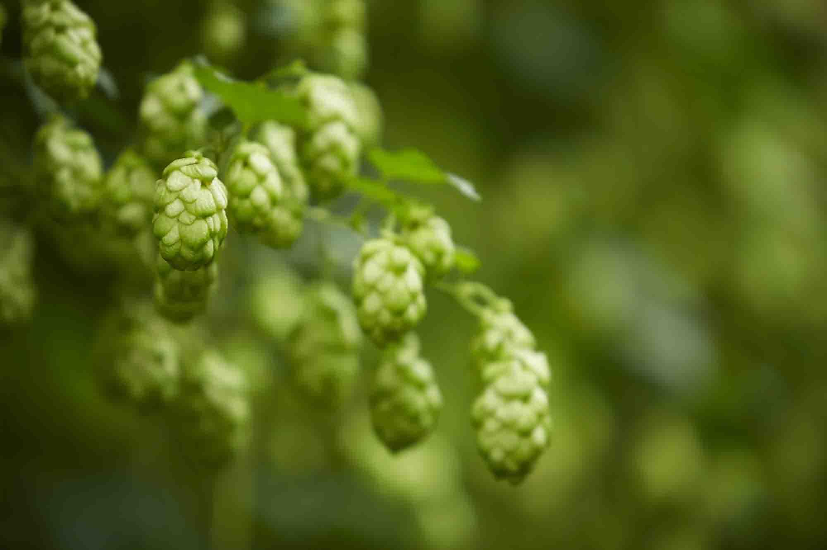

Asahi UK and the Worshipful Company of Brewers have teamed up with the Royal Agricultural University (RAU) and the University of Warwick to fund two PhD research projects looking at how to develop sustainable approaches to British hop production in a bid to stop the further demise of the UK’s hop growing industry. Despite the significance of hop farming to British heritage, climate change and the prevalence of disease has meant that production in the UK has declined substantially since its heyday in the 1800s when it is believed there were almost 3,000 growers working more than 77,000 acres in the UK. There are now just 45 growers and only 2,000 acres of hops in the UK. The total acreage dedicated to growing hops used in our traditional British beers has halved in the last decade. Dean of Land and Property Management at the RAU Professor Duncan Westbury, who will be supervising the work, said: “Going forward, we need to support British hop growers, and this includes developing approaches that make production more environmentally and economically sustainable. “As well as the problems caused by a changing climate, growing hops in the UK is now also more difficult due to the increasing incidence of fungal pathogens in the soil, particularly a disease called verticillium wilt which can significantly reduce yields. “Hop growers currently do what they can to prevent disease, and this includes the use of chemicals and regular cultivation of the alleyways between the hop bines. However, these practices not only significantly impact biodiversity and soil health, they are also carbon intensive meaning that, while they may support the short-term production of hops, they contribute to the long-term problem.” The two PhDs, for which the RAU is now inviting applications, will look to develop sustainable approaches to enhance UK hop production by increasing resilience to disease through the implementation of wildflower alleyways and the use of biochar - a carbon-rich, charcoal-like material. Asahi sustainability manager Sam Goodenough said: “With climate change comes high temperatures and also more rainfall, increasing the chances of droughts and flooding which can lead to a decrease in crop yields.  “Hops are also particularly vulnerable to pests and disease and the strain these changes in weather put on the crop further lowers their resilience and increases their risk to disease. “However, our research also found that the content of alpha acid, which is vital for delivering the flavour to beer, is likely to fall by up to 30 per cent by 2050 under the current climate projections of hotter weather and more frequent droughts.  “We believe cross sector collaboration is key to identifying the solutions needed to safeguard the long-term future of hops and hop farming.”