New release for Old Ale

05/11/2024 by Timothy Hampson

Industry

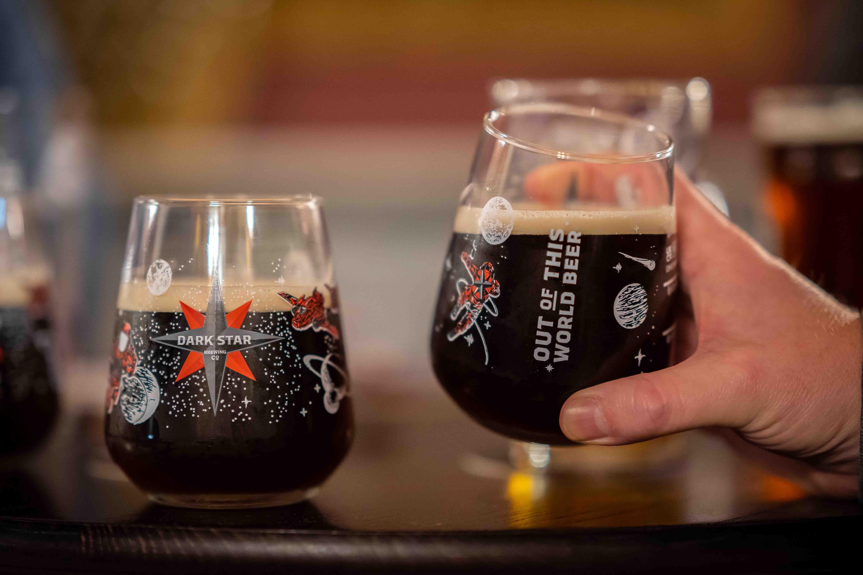

Asahi-owned Dark Star Brewing has announced the return of Prize Old Ale – a rare gem and one of the last remaining examples of its style.  The strong, dark ale (9 per cent ABV) is a remarkable survivor of a brewing tradition that dates back several hundred years when brewers learned how to create beers that could mature over extended periods. Its depth of flavour and rich complexity have made it a coveted drink among beer connoisseurs. First brewed in 1923 at Gales brewery in Horndean, Hampshire, this release will be available in both nine-gallon firkins for pubs and 500ml bottles for retail via the Dark Star web shop.  The latest brew features Maris Otter malt, Fuggles and Golding hops with the Gale’s yeast that makes this beer a stand-out addition to any winter table. The launch of Prize Old Ale will be marked by a series of special events at selected pubs across the UK. The beer is already in pubs with bottles available online through Dark Star’s web shop starting the week commencing 18 November.