Sound support for community hub

04/11/2024 by Timothy Hampson

Pub

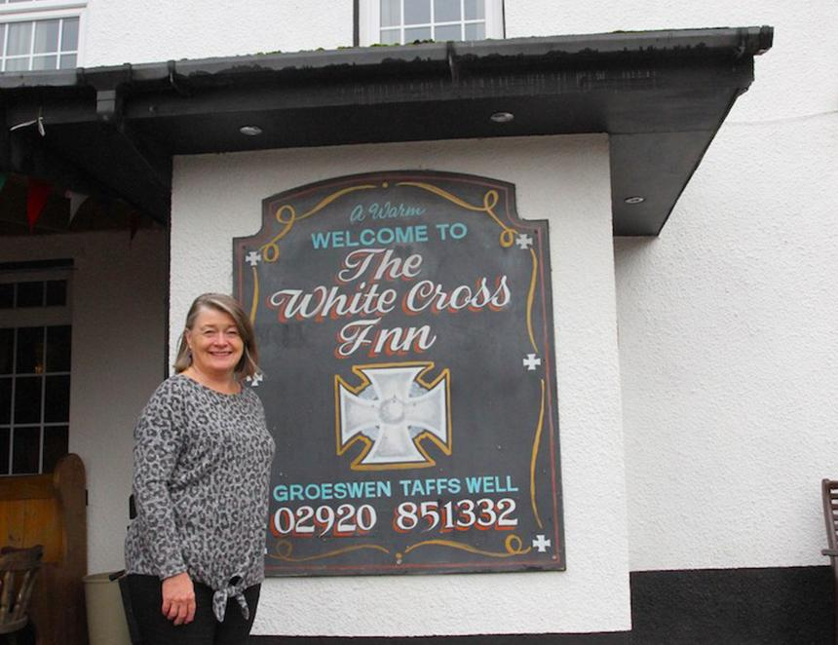

The White Cross Inn in Grosewen, near Caerphilly, which supports its community by running a variety of events to tackle social isolation, has been given a boost by Pub is The Hub. Licensee Mair Arthur (pictured), who has run the freehold pub, which dates back to 1750, since 2011, has worked hard to make it the beating heart of the local community.  Expert help and a Community Services Fund grant from Pub is The Hub has seen a new PA and music system bought to support the pub’s busy calendar of events. The pub plans to use the new system to support existing events and also host new ones such as open mic nights for young musicians and groups, such as for local farmers, for talks and meetings. Mair said: “This pub is a place for people to meet and form friendships. It is a very special place. This new PA and music system will enable us to run more events supporting the community and raising more money for charity. “It is so important people can come here to have that conversation and social interaction that is so important for tackling feelings of loneliness.” Pub is The Hub regional advisor Roger Belle added: “Mair and the services and activities that the White Cross provides have always had a real social impact on people in the local area and the new PA system helps to continue this and has already been put to good use. “These events and charity fundraising really show this pub is at the hub of its local community. The warm welcome at the pub along with these events is crucial in helping to overcome social isolation especially in such a rural area.” The pub featured in the latest series of Doctor Who, and hosts a variety of events including quiz nights, charity fundraisers, ale festivals and music nights. The White Cross Inn is also the meeting place for many groups that encourage people to socialise including Knit and Natter, the Beerbellies Club and the Wacky Wanderers walking group as well as sports teams including darts and cricket.