Rewarding passionate design

02/11/2024 by Matthew Rogers

Campaign

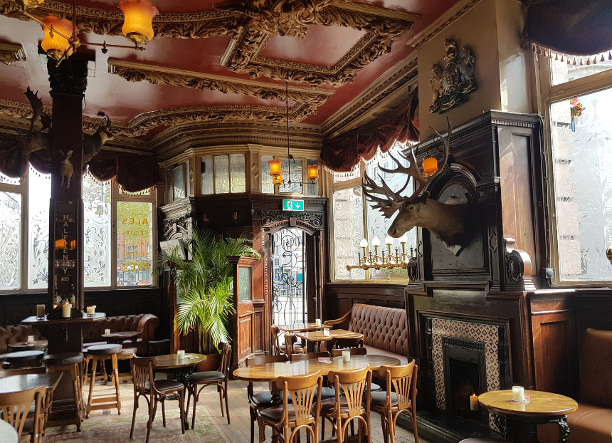

Since the publication of this article, the deadline for the Pub Design Awards has been moved to 3 December. The UK is full of beautiful pubs, from grand Victorian gin palaces with ornate stained-glass windows and endearing village locals with a story to tell, to contemporary new visions with innovative use of repurposed materials. CAMRA’s Pub Design Awards seeks to celebrate those who have preserved, repaired or created visually stunning venues.  Over the past 40 years, the Pub Design Awards have honoured a diverse range of pubs. Held in conjunction with Historic England and judged by a panel of experts in design and conservation, the awards shine a light on the highest standards of architectural design in the refurbishment and conservation of existing locals, as well as in the construction of new venues plus the conversion of buildings to pub use.  With less than three weeks left to nominate pubs for the award, What’s Brewing interviewed Pub Design Awards chair Andrew Davison about the importance of these awards, and the significance of protecting, celebrating and reinvigorating pubs.  Andrew said: “I have long held a professional and personal passion for architecture and design, strongly believing that the hard work undertaken to preserve public houses is not only significant to the UK’s heritage, safeguarding pubs for future generations, but also provides a greater choice for consumers.  “I am keen to see as many pubs as possible enter this year’s competition. Gorgeous pub design and vital conservation work deserves to be celebrated, and those who have worked so hard to achieve the incredible results should rightfully be lauded for their efforts.   “The possibilities really are endless with the Pub Design Awards, which is what makes this particular CAMRA competition so exciting to be involved in. Whether it be a passionate community banding together to fix up their much-loved local, or a dilapidated historic establishment being brought back to its former glory, this is a great opportunity for pub owners and managers to showcase flair, originality and quality of design.  “It is not just the refurbishment of existing pubs that is fascinating, but the imaginative ways which new public houses are being designed is always a real showstopper. It is always thrilling to witness innovative, modern design in a newly built, contemporary pub, or see the quirky ways which buildings have been converted to become a striking new pub. The only limit is one’s imagination! You can really see the outstanding achievements pub owners and architects have realised with their inspired vision and determination.  “By putting forward pubs which have undergone visually astounding transformations, we can help encourage more people to visit them, inspiring others across the UK to think about what could be achieved.”  There are five categories and pubs can be entered in one or more:   New Build: for newly built pubs, whether reflecting traditional design or completely modern.

Conversion to Pub Use: outstanding conversions of buildings which were built for other purposes.

Refurbishment: for flair, quality and originality in pub renovation.

Historic England Conservation: this award is given for work which conserves a pub’s architectural features, enhances the viability of a historic building, while restoring and updating the original facilities to give it a viable future.

Community Local: reserved for outstanding refurbishments of street-corner locals.  The Pub Design Awards are open to all pubs that have completed work between 1 July 2023 and 30 June 2024.  The competition is free to enter and closes on 17 November. Once submissions have closed, judges will visit and assess the nominated pubs throughout the year, with judging set to be completed by mid-April 2025. An awards ceremony at one of the winning pubs will be aimed to be staged in June 2025.  To enter and see examples of previous winners, visit: camra.org.uk/awards/pub-design?selected_year=2024  Pictured: Vines, Liverpool, Historic England Conservation category winner 2024, photo by Matthew Rogers