PUBlic Affairs Round Up – Budget Special

01/11/2024 by Tori Wood

Campaign

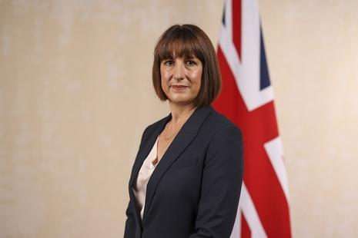

Chancellor Rachel Reeves (pictured) has delivered her first Budget – an event highly anticipated by many publicans, brewers and consumers.  It was also a key event for CAMRA’s Campaigns & Communications team. Here we round up what they got up to ahead of the Budget, how they reacted on the day and how they will continue to campaign for a fairer deal for beer, cider, pubs and breweries.   What did CAMRA ask from the chancellor?  Ahead of the Budget, CAMRA had two main asks with a call for a cut in tax on beer and cider sold on draught being one. CAMRA won a new system for taxing draught products a few years ago, and we wanted to see a 20 per cent difference between tax on pints in pubs compared to supermarket alcohol, to use the new system to reach its full potential.  Their second main ask was for reform of the unfair Business Rates system in England due to the current levels damaging pub businesses and leading to far too many licensees struggling to stay profitable. Additionally, CAMRA asked for an extension of the 75 per cent discounted rates help for hospitality businesses until this new, fairer system is in place.  While draught duty and Business Rates were at the top of its priorities, CAMRA also called for a review of the definition of cider for tax purposes including a minimum juice content of 50 per cent, a VAT cut for hospitality businesses, and the removal of the red tape in the duty system that is preventing pubs from making takeaway sales.   To deliver CAMRA’s fundamental asks to the hundreds of new MPs who won their seats at the last election, the team set up a simple online tool which let anyone ask their MP to convince the chancellor to put beer and pubs at the heart of her priorities.   Almost 4,000 emails were sent, with 95 per cent of MPs receiving at least one email. This resulted in the chancellor and the Treasury receiving emails from MPs asking them to support beer and pubs in the Budget.  CAMRA chief executive Tom Stainer and the Campaigns & Communications team joined forces with the Society of Independent Brewers and Associates (SIBA) to host an MP drop-in event at parliament, which saw 70 attending  – the Campaign’s biggest yet.  After all CAMRA’s campaigning efforts how did the chancellor prioritise pubs, pints and people?  She announced duty charged on draught beer and cider served in pubs, social clubs and taprooms will be reduced by 1.7 per cent. CAMRA welcomed the commitment to introduce a lower rate for hospitality Business Rates in England from 2026/27, along with an extension of the discounted rates bill into the 2025/26 financial year; though it will be decreased from 75 to 40 per cent.  Due to these discounted business rates for hospitality businesses in England, governments in Northern Ireland, Scotland and Wales will receive additional funding. CAMRA will lobby these governments to urge them to use this money to implement a similar discount on business rates in their countries.   Independent breweries were also considered by the chancellor, with a government review on access to market. CAMRA will work closely with the Government to make more beers available and improve consumer choice.   After live-tweeting announcements during the chancellor’s speech, CAMRA agreed its official press responses, which you can read here.  Once the speech concluded, the team contacted Treasury officials, and sent MPs a briefing on what the Budget means for beer and pubs.  But the work doesn’t end now the Budget has been revealed.  CAMRA’s campaigning will continue by engaging with ministers and civil servants at the Treasury, with parliamentarians at Westminster and with all political parties to make sure pubs, consumers and breweries get a fairer deal on tax and financial issues.  The Campaign needs to make sure the promised changes to the business rates system work for all pubs and brewers, and that independent producers get better access to market.  To protect pubs, CAMRA will continue to campaign for better protection in the planning system, and allow more opportunities for communities to save locals that face closure or conversion.  CAMRA will continue to fight for fairer business rates in all nations of the UK.