No stopping CAMRA award winner

01/11/2024 by Matthew Rogers

Campaign

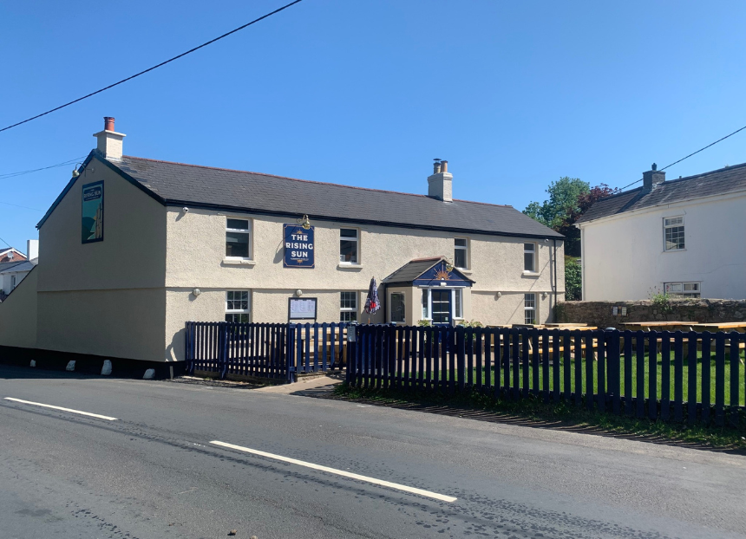

Across the UK, there are dedicated groups of people fighting to save their locals. CAMRA’s Pub Saving Award seeks to recognise and champion those who have come together to save a pub that would have otherwise been demolished or converted to another use. With less than two weeks left to nominate groups for the award, What’s Brewing caught up with last year’s winner, the Save Our Sun committee, to see how the Rising Sun (above) in Woodcroft, Chepstow and its community have fared over the past year since claiming the 2023 title. The group led a decade-long, community-led campaign to buy the pub from a developer which wanted to turn it into residential property. Started by a few locals in early 2013, the campaign finally reached fruition with the Rising Sun opening its doors again in October 2022.  Once given the keys to the Rising Sun, the community then made a herculean effort to clean, repair and refurbish the pub. With a team of local tradespeople, a volunteer project manager and more than 120 helpers all pitching in, the doors of the Rising Sun could open once again.  Rising Sun Woodcroft Community Pub Committee chair Michelle Hayes said: “Winning the award generated lots of publicity, with us appearing on BBC Points West news and this really helped raise the profile of our pub. It was brilliant for the community of volunteers to get recognition for their efforts, and as a result people started travelling from further afield to visit the pub. “In the last year, the pub has gone from strength to strength. Being in the pub trade is not without its challenges, but we are wiser and making improvements and more volunteers have stepped forward to help our brilliant paid staff. “It is now a real community hub that draws people of all ages together, with community coffee mornings, bike clubs, book clubs, darts team, social crib, live music, community art wall and a really welcoming atmosphere where all feel safe. While this is key, we have not forgotten that good beer and quality, home-cooked food is the foundation the pub is built on, and our reviews speak for themselves. “Without doubt, winning the CAMRA Pub Saving Award has really helped our pub thrive. We can’t imagine our community without it. We hope our story inspires others to never give up. Come and visit us if you are in the area, you can be sure of a good pint, great food and a friendly welcome. Thank you, CAMRA.” Nominations for the Pub Saving Award can be submitted here. Along with the Pub Saving Award, a new Heritage Award category is open to all pubs on the National Inventory of Historic Pub Interiors, whatever their star rating. It recognises and celebrates the achievements of a heritage pub that has been revitalised in some way. Nominate a heritage pub revitalisation project here.