Plan your November festival trips now!

31/10/2024 by Matthew Rogers

Campaign

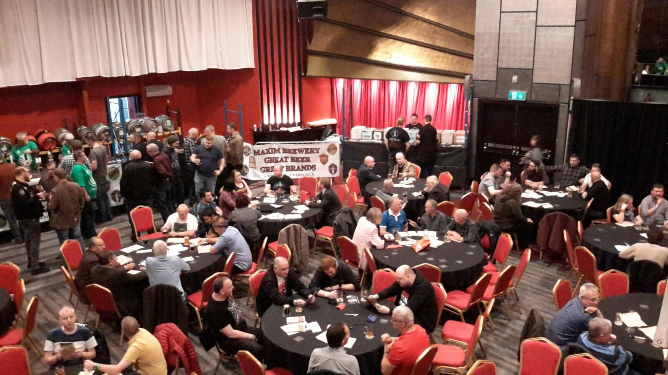

Plan your next festival trip with the help of the list below. To see all upcoming CAMRA events visit https://events.camra.org.uk/   Norwich Beer Festival for Charity 2024, 24 October-3 November Various venues across the city of Norwich https://norwich.camra.org.uk/festival/forcharity2024/   Redhill Beer Festival, 31 October-2 November Merstham Village Hall, Station Road North, RH1 3ED https://ems.camra.org.uk/festival   Poole Beer Festival, 1-2 November St Aldhelm's Centre, Poole Road, Branksome, Poole, BH12 1AD https://eastdorset.camra.org.uk/index.php/festivals/poole-beer-festival/   Woolston Beer Festival, 1-2 November Pear Tree Church Hall, 80 Peartree Road, Woolston, Southampton, SO19 2HA https://woolstonbeerfestival.camra.org.uk/   Kidderminster Beer and Cider Festival, 7-9 November Kidderminster Harriers Social & Supporters Club, Stadium Close, Kidderminster, DY10 1NB https://www.wyreforest.camra.org.uk/viewnode.php?id=221189   Belfast Beer and Cider Festival, 7-9 November Banana Block, 310 Newtownards Road, Belfast, BT4 1HE https://belfastbeerfestival.co.uk/   Alloa Real Ale and Cider Festival, 8-9 November Marshill, Alloa, FK10 1AB https://www.facebook.com/events/8056113574456544   Derby Heritage Beer Festival, 13-16 November Museum of Making, Silk Mill Lane, Derby, DE1 3AF https://derbymuseums.org/event/derby-camra-heritage-beer-festival   Bristol Beer and Cider Festival, 14-17 November City Hall, College Green, Bristol, BS1 5TR https://www.camrabristol.org.uk/festival.html   Bishops Stortford Beer Festival 2024, 15-16 November Belgian Brewer, Links Industrial Estate off Raynham Road, Bishop's Stortford, CM23 5NZ https://bishops-stortford-beer-festival.co.uk/   South East Essex CAMRA Beer Festival, 21-23 November Naval & Military Club,20 Royal Terrace, Southend-on-Sea, SS1 1DU https://www.see.camra.org.uk/viewnode.php?id=14968   Dudley Winter Ales Fayre, 28-30 November Dudley Town Hall, St James' Street, DY1 1HP https://dudley.camra.org.uk/viewnode.php?id=227869