Strong return for closed Cumbrian pub

30/10/2024 by Timothy Hampson

Pub

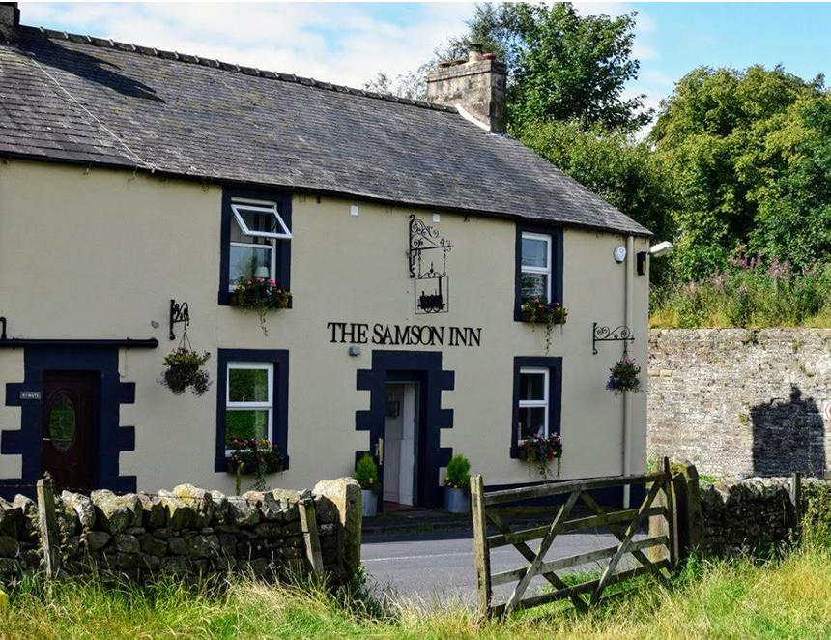

A village pub is set to reopen after hundreds of people clubbed together to buy it. The Samson Inn at Gilsland, on the Cumbria-Northumberland border, closed in October 2022 leaving the area with just one bar. The asking price was £295,000 and, after raising around half from 466 shares, the Save Our Samson campaign group secured the venue’s future this summer with the help of a government grant of £215,000. Newly appointed tenants George Campbell said: “It is the sort of pub I like running – being part of a small community and I can do lots of different events, getting everyone involved. “You can see the community is very passionate about the pub. You can see that in the number of people that bought shares in it.” Save Our Samson vice-chair Steve Rozario said it was “amazing” to have hundreds of shareholders from the community. “They’ve all invested in the future of the village, to preserve the future of our pub for us. And there's been tremendous effort from everybody in the village – volunteers who turned out to clean and paint and do all sorts of stuff – so it’s been a really good project for bringing everyone together.” The new-look Samson will provide food and accommodation with the hope of attracting some of the thousands of people who visit the nearby Hadrian’s Wall trail each year.