Scotland CAMRA celebrates golden anniversary

29/10/2024 by Timothy Hampson

Campaign

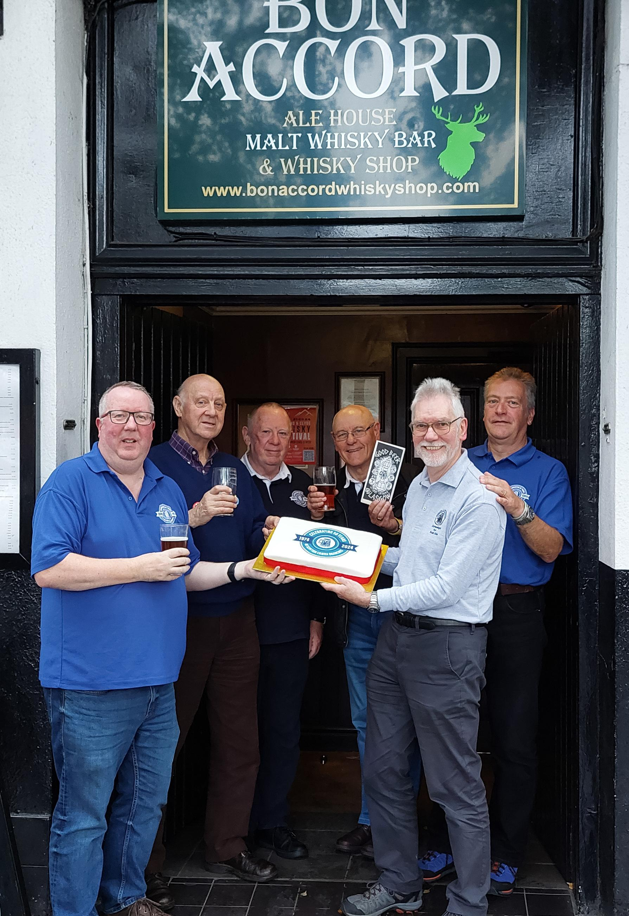

CAMRA members from all over Scotland have celebrated the 50th anniversary of the founding of the country’s first branch at an event in Glasgow’s Bon Accord pub. The Campaign for the Revitalisation of Ale, and what is now known as CAMRA, the Campaign for Real Ale, was founded in 1971 by four enthusiasts with the aim of saving real ales from disappearing due to the introduction of poor quality kegged beer by the Big Six breweries – Allied Breweries, Bass Charrington, Courage, Scottish & Newcastle, Watney Mann & Truman, and Whitbread. During its first few years, CAMRA quickly grew its membership nationally with branches popping up around England. In Scotland, a small group of Partick Thistle supporters had signed up as members, and regularly drank in the very small number of ale outlets in Glasgow at the time. In 1974, when Scottish & Newcastle removed cask ale from all the Glasgow outlets, action was needed.  Letters to the Glasgow Herald and Evening Times enquiring if there was still “beer life” out there solicited a sole reply that the Golf Inn in Bishopton still offered real ale from Belhaven brewery, and CAMRA members would be welcomed. An initial “testing support” was held in September 1974 which saw 25 people attend. The following inaugural meeting on 7 October 1974 drew 75 real ale partisans and Scotland’s first CAMRA branch was born. Half a century later, there are now 10 CAMRA branches throughout Scotland with a collective membership of more than 4,200. More than 60 members attended the 50th anniversary event, including branch founders Hugh Stevenson and Mick Lee. Other events to commemorate the anniversary have been held throughout the year including hosting CAMRA’s Members’ Weekend, Conference and AGM in Dundee; an all-branch social recognising Scotland’s three oldest surviving breweries – Belhaven, Broughton and Traquair House; and a series of special awards to CAMRA members who have been, or still are, active volunteers within the organisation. Pictured, from left, CAMRA's Scotland director Scotland Stuart McMahon; Hugh Stevenson; former regional directors Lindsay Grant and Ray Turpie; Mick Lee; and former national chairman Colin Valentine at the Bon Accord.