Brewery closures slow

27/10/2024 by Timothy Hampson

Industry

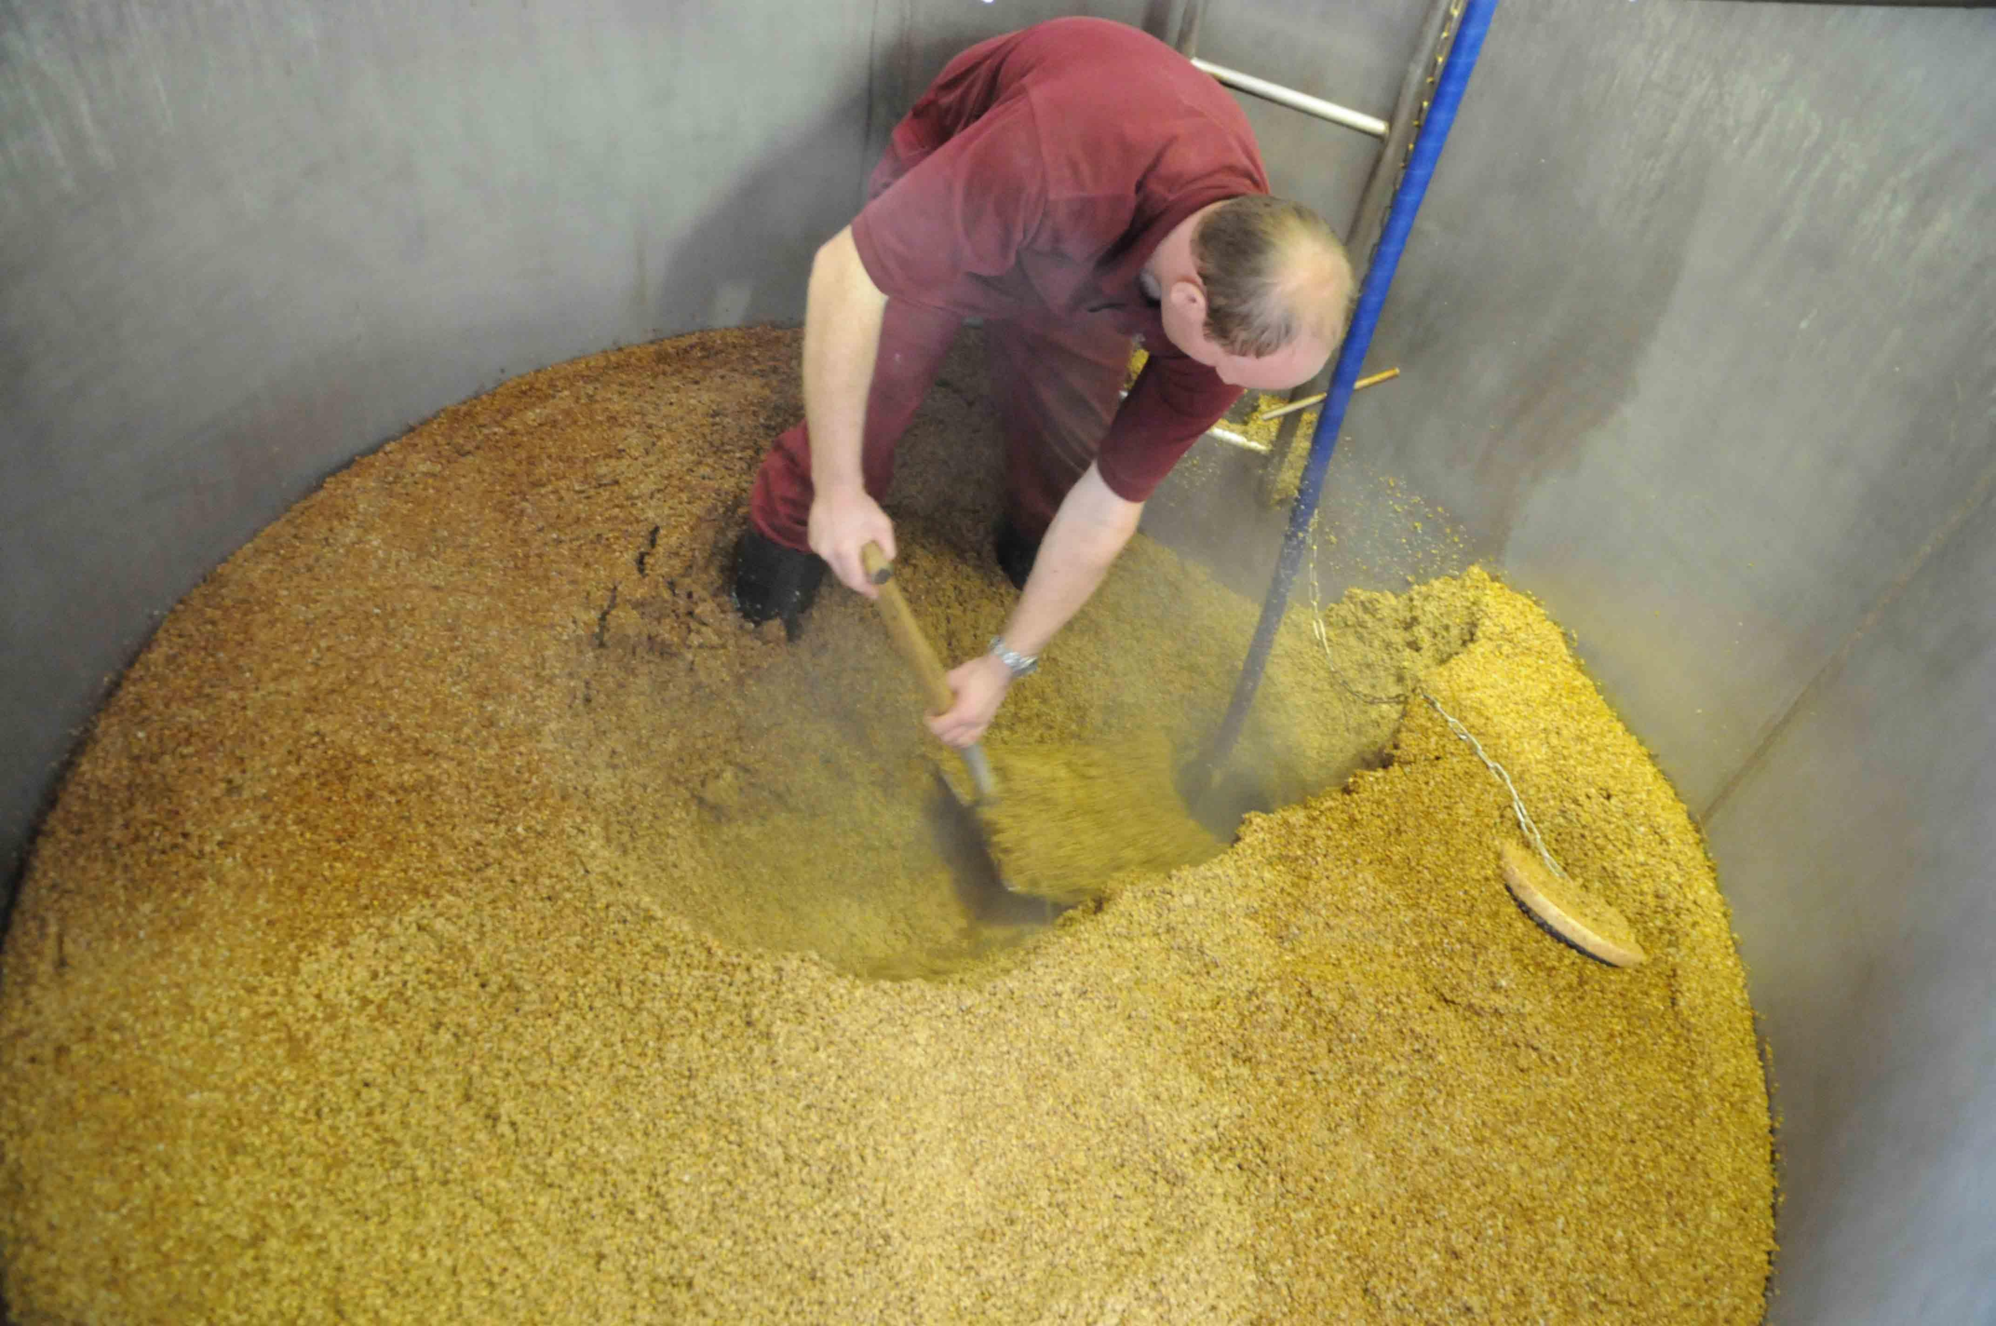

Has the brewing industry turned a corner? For the first time in 2024, some regions of the UK have seen brewery numbers rise, with the overall net closure rate across the UK also slowing. The UK had a net closure rate of minus 27 in the third quarter up to the end of September, compared to a minus 29 in Q2 and an even larger 38 loss in Q1, according to figures released by the SIBA UK Brewery Tracker. While this marks the third consecutive quarter of overall brewery numbers decline, there are some success stories, with the South West seeing an increase of two, the highest of all regions in the UK, followed by Wales with a plus one increase. The tracker takes into account all brewery openings and closures to give an accurate picture of the number of active brewing businesses. The latest figures show the total number of active UK breweries now stands at 1,721, compared to 1,748 at the end of June. SIBA head of communications Neil Walker said: “It’s positive to see some regions of the UK now in growth and an overall UK-wide closure rate which appears to be slowing.  “Demand for beer from independent breweries has never been higher from consumers, but access to market and profitability are still big challenges for small brewers across the UK, with high taxation and rising raw ingredients costs squeezing the already fine margins most independent breweries are working with. “In short, small breweries need your support so next time you’re in the pub or supermarket opt for an independent beer from a local brewery and help to keep local breweries and pubs alive. “The challenge isn’t consumer demand; the challenge is getting small independent breweries access to pubs that are dominated by global brewers.” Regionally it is Northern Ireland which has struggled in Q3, with a huge minus six net closure taking the country’s active breweries down to 23.  Elsewhere in the UK, the North East of England also had a net six drop, but on a much larger starting number with 242 breweries now remaining. It was a similar story in the South East, with a minus six drop taking the total to 325. Scotland and the East of England both struggled dropping four a piece with 129 breweries now north of the border with 183 in the latter region. The Midlands was down a net three with the total dropping to 329, followed by the North West which lost a net one taking the number remaining to 188. The two regions with net rises now sees 205 producers in the South West and 97 in Wales.