Celebrate Cider and Perry month in the nation’s finest specialist pubs
26/10/2024 by Tori Wood
Campaign

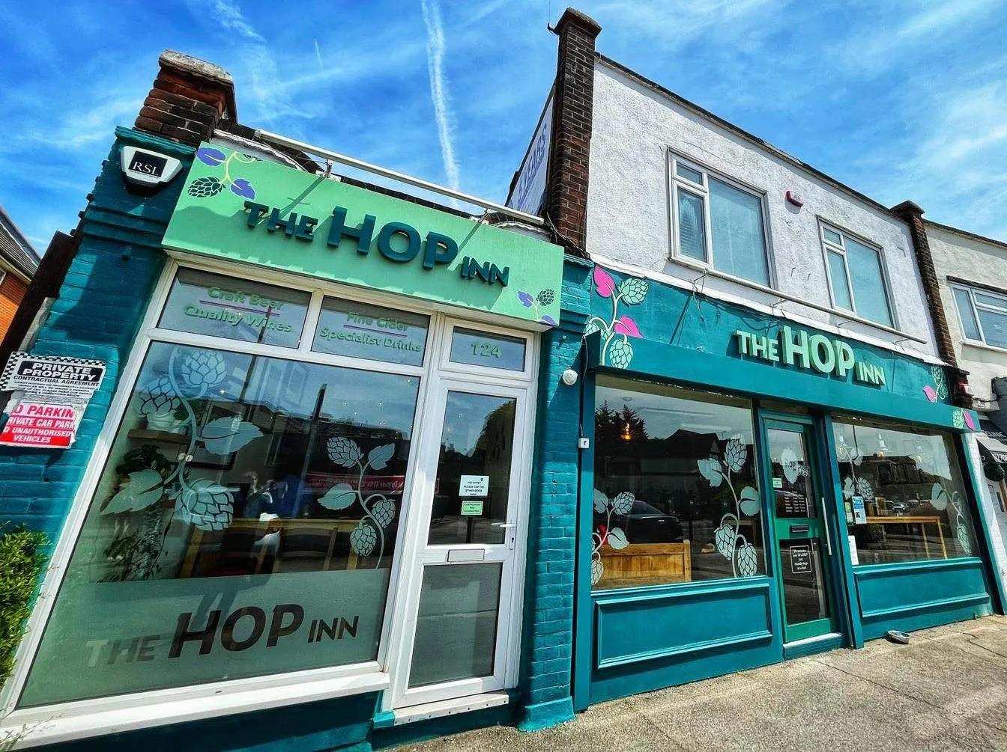

CAMRA’s month-long cider and perry promotion is almost over but there's still time to take part and where better than in one of the regional finalists for this year’s Cider and Perry Pub of the Year award? Pick where you are going to enjoy top cider and perry from the list below which completes our round up of this year’s finalists. Wales Flute and Tankard Windsor Place, City Centre, Cardiff, CF10 3BX A one-bar pub just off Queen Street towards its eastern end where an excellent range of traditional ciders are served. The Flute and Tankard has established itself as the city centre's leading real ale pub in terms of range and quality of its beers. Music – mostly jazz – and comedy night are held in the upstairs function room, so why not check the Flute and Tankard’s events calendar, and see if you can pair a performance with your pint this Cider and Perry Month? Awards: Cider and Perry Pub of the Year 2024. Greater London Hop Inn (above) North Street, Hornchurch, RM11 1SU The Hop Inn micropub opened in December 2019 by two hospitality veterans. This team is dedicated to cider and perry campaigning and runs the London Cider and Perry Club. This micropub serves real ciders and perries directly from the cooled cabinets, as well as six KeyKeg taps for UK and foreign beers plus up to five cask ales. High and low tables, along with comfortable seating, are provided throughout the pub with beer-related magazines available to read. The Hop Shop off-licence has been renovated into the new Snug Bar. Awards: National Cider & Perry Pub of the Year 2022

Greater London Regional Pub of the Year 2021 and 2022

Greater London Regional Cider Pub of the Year 2021, 2022, 2023 and 2024

South West Essex Branch (London Area) Pub of the Year 2021, 2022 and 2023

Cider Pub of the Year 2021, 2022 and 2023. Kent Old House Redwell Lane, Ightham Common, TN15 9EE Located in a narrow, secluded country lane, this Grade II-listed Kentish red-brick and tile-hung cottage comprises of an entrance lobby and two separate bars. The public bar features a Victorian, wood-panelled counter, parquet flooring and an imposing inglenook fireplace. Ciders are served at this pub, with one local to the Old House kept in a wooden cask. Up to six gravity dispensed beers are also available, some from wooden casks in the tap room, including at least one bitter, golden ale and dark beer. Awards: CAMRA branch Cider Pub of the Year 2024

CAMRA Kent Regional Cider Pub of the Year 2024. Surrey & Sussex Robin Hood Main Road, Icklesham, TN36 4BD This 17th-century, friendly pub has a welcoming open fire and a large dining area where you can enjoy home-cooked food. The Robin Hood has a striking ceiling display of hops, coppers and brasses that have been built up over 20 years, and a large garden which includes a play area for children. Up to 12 real ciders are available plus four real ales. Awards: South East Sussex Regional Cider Pub of the Year 2024. Wessex Woodman South Street, Bridport, DT6 3NZ This finalist has a cosy single bar with a stone floor and log burner. There are sunny pavement tables at the front, a pleasant garden to the rear and a skittle alley. The Woodman has a focus on quality ciders and beer, with one handpump dedicated to dark beers, principally stouts and porters. Awards: West Dorset Regional Pub of the Year 2024

West Dorset Regional Cider Pub of the Year 2024. South West Tom Cobley Tavern Spreyton, EX17 5AL The Tom Cobley Tavern, the only pub in the UK to receive both Pub of the Year (2006) and Cider Pub of the Year (2023) titles, is nestled on the edge of Dartmoor. It is a 16th-century pub named after a local folklore figure. The bar walls are decorated with CAMRA certificates and other accolades that have been won over the years. An open fire is lit in the winter months and the bar has a unique thatched roof. At the rear there is a separate restaurant and access to the garden. More than 15 West Country ciders are available along with a selection of clearly identified non-real and fruit variations from around the country. Awards: Pub of the Year 2006

Cider Pub of the Year 2023

South West Regional Cider Pub of the Year 2023 and 2024

South West Regional Pub of the Year 2006, 2008, 2012 and 2019

Exeter and East Devon Cider Pub of the Year 2013, 2018, 2020, 2022, 2023 and 2024

Exeter and East Devon Pub of the Year 2006, 2008, 2009, 2010, 2012, 2015, 2016, 2017 and 2019.

