Thrills, chills and great cider

25/10/2024 by Camilla Weddell

Campaign

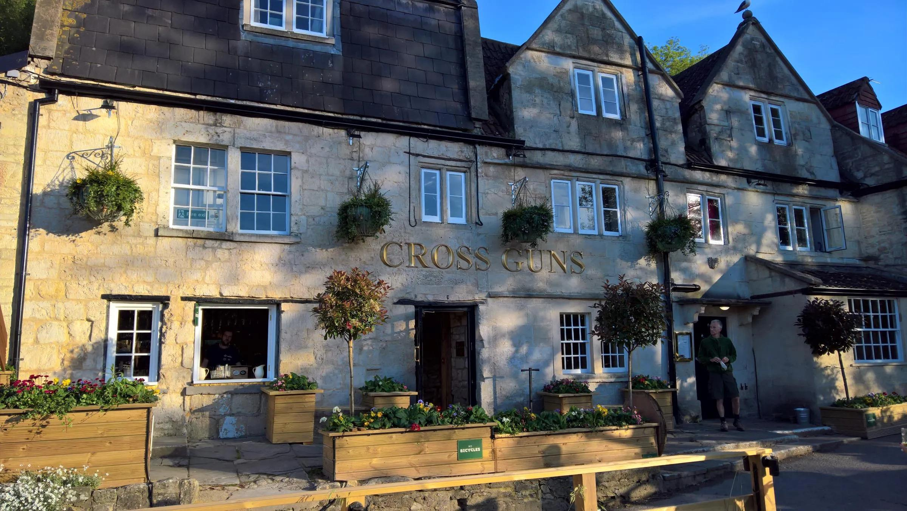

In the last instalment in our guide to haunted pubs for Cider and Perry Month we encounter priest holes, smuggler’s tunnels, and a drowned landlady.  Kings Arms   1 Hollywood Road, Bristol, BS4 4LF   A beautiful, traditional inn with all you would expect from a 17th-century, reputedly haunted pub.   Settle into the cosy nooks and crannies with a pint of real cider or perry. Thick stone walls, real fireplaces and oak beams complete this ghost-hunting spot. The beer garden is open all year and no children are permitted inside the pub after 7pm.  Regular entertainment is on offer including Tuesday quizzes, open mic nights every Thursday, karaoke on Saturday’s, and monthly live bands.  Moorend Spout 1 Union Street, Nailsea, BS48 4BB   An allegedly haunted, 17th-century, former jailhouse where Judge Jeffries apparently hung ’em high.   These days the well-appointed bar is complemented by lounge rooms, restaurant, dedicated function suite and a large sunny garden, providing plenty of space for you to enjoy a celebratory pint of real cider or perry. If you and your friends are eager to test your knowledge, quiz nights take place every Monday at 8:30pm.   themoorendspout.co.uk  Cross Guns (above) 159-160 Avoncliff, Avoncliff, BA15 2HB   A world away, yet only 12 minutes by rail from Bath, this 16th-century canalside inn, with sloping terraces down to the River Avon, is popular with walkers, cyclists and narrowboaters. Overlooking the small village is the historic Avoncliff aqueduct where the Kennet and Avon canal crosses both the river and the railway line. Features include inglenook fireplace, priest hole, garden bar, and resident ghost.  An easy one-and-a-half mile walk along the canal from Bradford-on-Avon. Children and dogs are welcome at the Cross Guns, so why not venture down this Cider and Perry month.  crossgunsavoncliff.com/  Waggon & Horses Old Frome Road, Shepton Mallet, BA4 4LA  The Waggon and Horses is a large country pub, originally a coaching inn built in the 17th century, on the Old Frome Road north-east of Shepton Mallet. Watch out for the ghost...  There is food served daily, and up to three real ales, depending on the time of year. Outside there is a walled garden and plenty of parking if you are visiting by car.  Plough Inn Back Lane, Holford, Bridgwater, TA5 1RY   After entering this 16th-century country inn, you will be welcomed by a large open fire and many beams decorated with brasses, as well as a newly opened orangery as an additional dining area.   Reputably, there are several ghosts causing mischief at the Plough Inn, and it said to be the sixth most haunted venue in Somerset!   The Plough has been voted Best Dog-friendly Business of the Year for the South West of England region. Water and treats are available for your fluffy friend, plus a doggy menu of food and drinks!  Brewery Shades 85 High Street, Crawley, RH10 1BA   Brewery Shades is arguably the oldest building in Crawley High Street, dating back to 1400, and is complete with two active ghosts.   As befits such a building, the pub has a great range of up to six ciders, eight real ales, plus keg and cans, complemented by a traditional food offering.   CAMRA members will receive a discount, and Brewery Shades also runs an additional loyalty scheme. Why not ask one of the ghosts which cider they would recommend when you get to the bar?  breweryshades.co.uk  Uncle Toms Cabin 51 High Street, Wincanton, BA9 9JU   Uncle Toms Cabin is a traditional thatched pub at the top of Wincanton and is the oldest in the town, consisting of two rooms and a rear patio area.   The pub sign pays homage to novelist Sir Terry Pratchett who frequented the pub when visiting the now closed Discworld Emporium in the town. Get to know this historic pub while treating yourself to a pint of real cider this month, but watch out for the ghost...  Reputed to be haunted by Emily, a seven-year-old girl run over by a horse and cart outside the pub in the 1700s.  Cavalier Inn 26 Well Street, Torrington, EX38 8EP   A family friendly pub, which welcomed Nat and Cherri as the new management in August this year, is just off the main square with a lively bar and a separate 60-seat restaurant. Home-cooked and good-value food is served at the Cavalier Inn, and three real ales are available.   This pub is reckoned to be haunted, and if you’re keen to be more proactive in your Halloween ghost hunting, you can attend regular paranormal evenings – a perfect chance to celebrate Cider and Perry Month with a spooky spin!  cavaliertorrington.co.uk  Anchor Inn Cockwood, EX6 8RA   On the picturesque Cockwood harbour, this 450-year-old inn, and former seaman's mission, has an extensive award-winning seafood menu, with mussels being a speciality. You’ll find many old settles: timber panelling, low beams and snugs, with an impressive display of old nautical memorabilia. A perfect atmosphere to enjoy real cider!  Anchor Inn is haunted by a friendly ghost and his dog...   Close to the main Great Western Railway line, it is a steam train spotters’ paradise. There is limited parking at the pub, but the Stagecoach Number 2 bus stops on Cockwood Bridge which is around 200 yards away.  anchorinncockwood.com  Palk Arms Church Road, Hennock, TQ13 9QB   This reputedly haunted 16th-century freehouse is close to the south-eastern edge of the Dartmoor National Park and there are spectacular views over the valley and across to the Haldon Moors.   The Palk Arms serves one draught cider and two guest ales from local breweries. The public bar is at the front of the pub and has a lovely wood-burning stove in the winter months. The lounge is comfortable and cosy with settees and armchairs and leads to a dining room.   Food is available every evening excluding Monday when the pub is closed. Dogs are welcome to join you in the bar and children can come along until 8.30pm. An on-site brewery will also be opening at the Palk Arms soon!  thepalkarms.co.uk/  London Inn 8 Church Road, Plympton, PL7 1NH   A very friendly 16th-century pub, next to a church, is the epitome of a typical village inn and is allegedly haunted by Captain Hinds.  The London Inn has several real ciders available and up to eight cask beers, which are mainly sourced from the South West of England. The cosy lounge bar is adorned with a large collection of Royal Navy memorabilia, while the public bar boasts a pool table, dart board and TVs for sports enthusiasts.   Acoustic nights take place every Wednesday, with a meat raffle and karaoke every Friday as well as regular beer and cider festivals.   The inn is dog friendly so feel free to bring your canine along on your Cider and Perry Month adventure!  londoninnpub.co.uk/  Fisherman’s Arms Higher Market St, Looe, PL13 1BW   This reputedly haunted olde-worlde 16th-century pub is claimed to be the oldest pub in Looe (along with the the Jolly Sailor).  Opposite the “olde” museum and gaol, it has a modestly sized, square-shaped and beamed single bar room at the front with a slate-flagged floor, all subject to a preservation order, and a welcoming open fire in winter.  Traditional Cornish and Irish music is performed on Friday, Saturday and Sunday nights at the Fisherman’s Arms if you’re looking for somewhere to have a dance with your pint of cider!   First & Last Inn Sennen, TR19 7AD   A fitting end to our haunted pubs guide, real cider is served at the historic First & Last pub as well as two guest ales which change regularly.  The walls are decorated with a variety of nautical pictures and paraphernalia, and a glass panel in the floor covering an old well – Annie's Well – which leads to a smugglers’ tunnel.   Legend says that a former landlady was staked on the beach and drowned after turning the King’s Evidence against some smugglers, her body was taken back to the inn where her ghost inhabits the pub...  Don’t step too close to Annie’s Well if you visit the First and Last Inn this Cider and Perry Month!  firstandlastinn.co.uk