Amarillo is the way to champion beer success

24/10/2024 by Timothy Hampson

Campaign

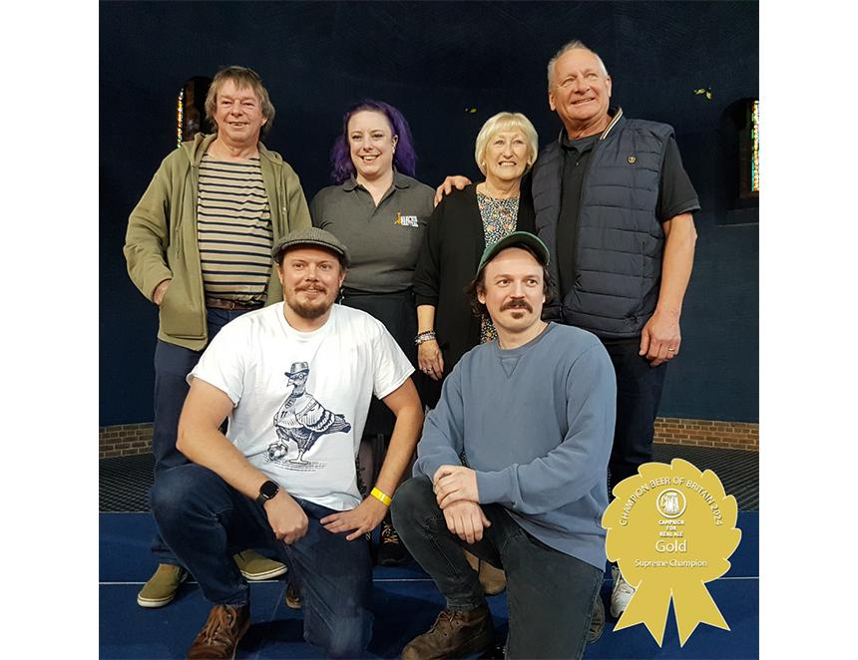

Crouch Vale’s Amarillo (5 per cent ABV) has been crowned CAMRA’s Champion Beer of Britain 2024. The winner was exclusively revealed at Kelham Hall Beer and Cider Festival trade session yesterday in Newark, following a hard-fought final round of judging. The long-standing CAMRA award is one of the most coveted and well-respected cask beer prizes in the world, putting the winner firmly in both the national and international spotlight. Festivalgoers will be able to enjoy sampling this year’s newly crowned champion, along with the well-deserved silver and bronze winners’ beer, which will be on sale at the Kelham Hall Beer and Cider Festival, which runs until Saturday. Tickets are available from https://www.kelhamhallbeerfest.co.uk/ Champion Beer of Britain judging panel organiser Christine Cryne described the beer as having “a tangy aroma with a faint note of biscuit. The flavour is full of tropical and citrus notes on a sweet biscuit base. Dry sweetish bitter finish. A full-flavoured beer”. She added it was a “commendable winner, worthy of the respected title despite exceptionally strong competition”. Judging for the competition takes two years to complete, starting with nominations from CAMRA members and tasting panels, then regional competitions. Each round of judging uses a strict blind tasting policy. Crouch Vale directors Colin and Fiona Bocking said: “We are delighted. We have been doing this for half of our lives. We won in 2005, and we won in 2006, and there has been a 19-year hiatus. “Hopefully, this will demonstrate to people that we are still around, and we are still making great beer. This is a beer that has been brewed for 30 years, at the time, when a lot of these very exciting American hops were coming on the market, we decided to use Amarillo hops from Washington State in the USA, and we are still using them today.” Silver went to The IPA (6 per cent) from Anspach & Hobday, which judges described as “a wonderful fruity New World IPA. Aromas of citrus and tropical that are also on the palette where the developing bitterness is perfectly balanced by the bitterness leading to a dry, spicy finish. Morish for a six per cent beer”. Bronze winner was Trawlerboys Best Bitter (4.6 per cent) from Green Jack brewery, which was described by judges as an “attractive orangey brown beer with a honey biscuit nose. Sweet orange marmalade with nutty notes and slight hint of chocolate. Finish is fruity and sweet, becoming bitter and dry. Complex and very drinkable”. CAMRA’s awards director Laura Emson said: “I would like to congratulate Crouch Vale for winning the 2024 Champion Beer of Britain award with their incredible golden ale, Amarillo. “After many years of CAMRA holding this competition, the Champion Beer of Britain final is still one of the most exciting days for us as well as for all the brewers involved. Only two points separated first and second place. We’re hugely grateful to Kelham Hall Beer and Cider Festival for hosting this year’s judging and announcement, it’s a fantastic setting to celebrate fantastic beer. “These awards cannot happen without the incredible work of volunteers that give up their time to see a worthy winner crowned. This process begins with CAMRA members nominating their favourite tipples and ends with a decision from a highly experienced and professional judging panel. Crouch Vale should be incredibly proud of this accolade, and I hope that beer lovers across the UK will seek out and try Amarillo out for themselves.” WHO WON WHAT MILD:Gold – Penzance Brewing Co, MildSilver – Brains, DarkBronze – Five Kingdoms brewery, McGregor’s Mild SESSION BITTER:Gold – Logan Beck Brewing, Proper BitterSilver – Mighty Oak Brewing Co, Captain BobBronze – Windsor & Eton brewery, Guardsman PREMIUM BITTER:Gold – Green Jack brewery, Trawlerboys Best BitterSilver – Sharp’s brewery, Sea FuryBronze – Cairngorm brewery, Wildcat IPA:Gold – Anspach & Hobday, The IPASilver – Byatt’s brewery, Mahana IPABronze – Bragdy Twt Lol, Dreigiau’r Diafol/Diablo Dragons SESSION PALE, BLOND & GOLDEN ALES:Gold – Loch Lomond brewery, Southern SummitSilver – Oakham Ales, CitraBronze – Bewdley brewery, Sunshine PREMIUM PALE, BLOND & GOLDEN ALES:Gold – Crouch Vale brewery, AmarilloSilver – St Austell brewery, Proper JobBronze – Swannay brewery, Orkney IPA WINTER CHAMPION BEER OF BRITAIN WINNERS:Stouts and Porters, Session: Lancaster brewery, Lancaster BlackStouts and Porters, Strong: Green Jack brewery, Baltic Trader Export StoutSpeciality, Flavoured: Purple Moose brewery, Elderflower Ale (Cwrw Ysagwen)Barley Wines and Strong Old Ales: Sarah Hughes brewery, Snowflake The Kelham Hall Beer and Cider Festival is running until 26 October at Kelham Hall in Newark, Nottinghamshire with all winners available in limited supply. Tickets are available from https://www.kelhamhallbeerfest.co.uk/ Pictured: Brewers from Crouch Vale, Anspach & Hobday and Green Jack with Laura Emson (back row second from left).