2024 Branch Magazine and Website of the Year awards round up

24/10/2024 by Matthew Rogers

Campaign

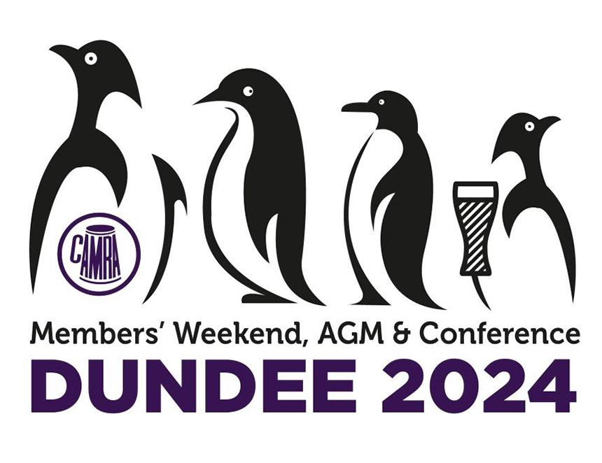

With registration now open for CAMRA’s Members’ Weekend, AGM & Conference next year in Torquay, WB is rounding up all the announcements from the 2024 event in Dundee. The Branch Magazine of the Year and Branch Website of the Year awards were announced at Members’ Weekend. View both a video recording of the presentation and transcript below. The Magazine and Website of the Year PowerPoint presentation can also be viewed here. Nik Antona: “We’re now going to do the members’ awards for the Website of the Year and the Magazine of the Year, so I’ll hand over to Nick Boley.” Nick Boley: “Good afternoon Conference. “I will read to you what the judges thought, and then I’ll give the awards. We won’t have any spoilers. Like the Oscars aren’t we? “Website of the Year bronze award. [The] website has an attractive style. Judges found it engaging and clear. [The] summary of branch geography made a great introduction for those unfamiliar with CAMRA. [The] top menu and the categorised news items made the site clear and easily navigable. There is a vibrant field to [the] homepage. Good use of images. Judges praised the way detail never became overwhelming and felt it would attract new members to the branch. They particularly praised the balance article on CAMRA discounts. Very good to view that I have to say. And so, the bronze award, for this year’s the Website of the Year goes to Norwich and District Branch. “The silver award. The judges noted this site was very up to date and gave a wide selection of news and campaigning issues, including cider and perry not being forgotten. Everything a site user might want to know is here and easily found. Judges selected it as an excellent example of a beer engine site that makes use of all the functions available through that particular platform. The website is packed full of useful information, with pages on LocAle and pubs offering members’ discounts receiving particular praise. So well done for the silver award to the South Devon branch. Anybody come that far? “And now for the winner, for the gold award for our Website of the Year competition. The judges praised the clean layout of this website, which shows how active the branch are with plenty of events. The home page is inviting and contains just the right amount of information, with good links to everything. The site’s informative nature photos of local pubs and rotating homepage banner was described as impressive and professional. So well done, Website of the Year, Gold Award, Shrewsbury and West Yorkshire branch. “Perhaps we should do Magazine of the Year now. Keep you all in your toes. Okay, bronze award. The judges praised the magazine’s good local coverage and appealing informal tone. An enjoyable read which maintains the standard expected of a CAMRA branch magazine, managing to both be entertaining, informative and treating readers as if they were part of the conversation in the pub with their pals. It contains humour, with a serious debate on both local and national issues in a way that draws its readers in. So well done, bronze award to Bradford branch for Tyke Taverner. “Okay, silver award runner up. The judges noted local coverage with lots of news and views. It was very professional, put well together magazine with excellent articles and attractive layout. And at 24 pages managed to appear well balanced between advertising and editorial contents. So the silver award this year, Soxon Ale, South Oxfordshire branch. “So the gold award winner, the bright and attractive publication with lots of local news and good coverage of branch activities, winning praise for its colourful and attractive front covers. It was found to be exceptionally well put together, offering articles of local and national interest, along with a crossword competition and a beer scoring guide. Not only of interest to CAMRA members, but a great recruitment tool in the area it covers. So well done, gold award Magazine of the Year, Full Pints from Ayrshire and Wigtownshire. Popular winner here in Scotland. “Thank you everybody. Well done to all the winners.”