Castle repels mild magic rivals

24/10/2024 by Timothy Hampson

Campaign

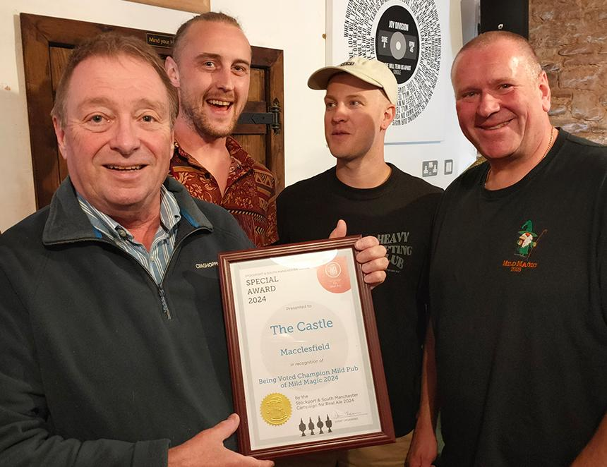

It’s cheers to the Castle in Macclesfield, which has scooped the best pub award on the 2024 Mild Magic Ale Trail, organised by Stockport and South Manchester CAMRA. The annual ale trail, now in its 30th year, covered 100 pubs in and around the Manchester area, and, for the first time, pubs in Macclesfield were invited to join in. The Castle was voted best pub for mild ale, but that’s not all. One of the many milds the pub served in the five-week trail, Sarah Hughes Dark Ruby, was voted best mild of the trail. Sarah Hughes brewery is based at the Beacon Hotel in Sedgley in the West Midlands, and owner Simon Massey travelled to Macclesfield to receive the award. He revealed that 60 per cent of the Dark Ruby output went to the Beacon but was delighted that some was available for other pubs to enjoy. When Castle regular Kevin Rothwell heard the pub was participating in Mild Magic, he asked owner Rebecca Prunty to order Dark Ruby. She managed to obtain three nine-gallon casks, and each sold out within 24 hours. Needless to say, there was another nine-gallon cask available for the awards ceremony and this too only lasted 24 hours! Mild Magic organiser Darren Berry said: “We were not sure whether the inclusion of Macclesfield on the trail for the first time would be a success. However, we needn’t have worried as all four pubs involved stepped up to the mark and introduced ale-trailers to the town with a wide range of milds to enjoy. “The Castle is a fabulous pub, full of history, and we were pleased that it reopened three years ago, after being closed for some time. In 2023 it was CAMRA Cheshire Pub of the Year and won CAMRA's Historic England Conservation Award. Now it is the Mild Magic champion pub as well. “It is also fitting that the pub was selling the iconic Sarah Hughes Dark Ruby mild, as they restarted brewing in 1987 after years of closure, and, like the Castle, have won many awards since. One of their beers, an eight per-cent barley wine called Snowflake, is the current CAMRA Champion Winter Beer of Britain. It just shows that determination and enthusiasm can overcome difficulties and result in success all round. Congratulations to both of them.” Pictured, from left, Castle regular Kevin Rothwell, and bar team members Dave Dooley, Tommy Lewis and Darren Berry.