Campaign backs new Indie Beer mark

23/10/2024 by WB Reporter

Campaign

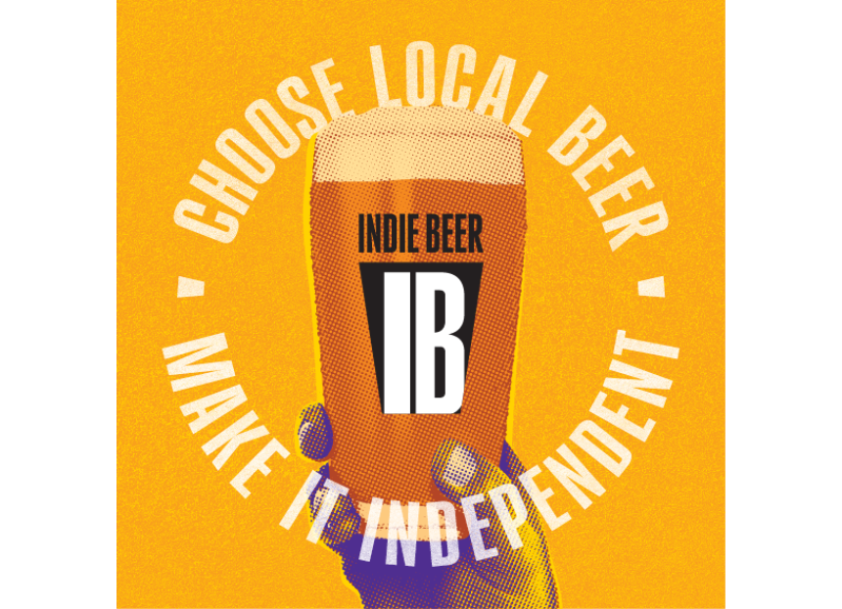

CAMRA has thrown its weight behind SIBA’s new Indie Beer campaign, designed to help consumers seek out independent beers and breweries.   The campaign includes a brewery checker tool so consumers can find out if a brewer is independently owned, and an “assured” mark for brewers to use to show their independence.   CAMRA national chairman Ash Corbett-Collins said: “CAMRA is delighted to be supporting SIBA’s Indie Beer campaign. We know that finding independent and local beer is often a top priority for our members and beer drinkers across the UK. It’s great that SIBA are committed to transparent communication about ownership in beer.  “Unfortunately, we often see global brewers market their own brands as if they were independent, tricking consumers in the process. It is vital that consumers have access to the right information about where their beer is being brewed, and whether it’s in independent ownership.”  Find out more about the Indie Beer initiative here.