New fight for independents

22/10/2024 by WB Reporter

Industry

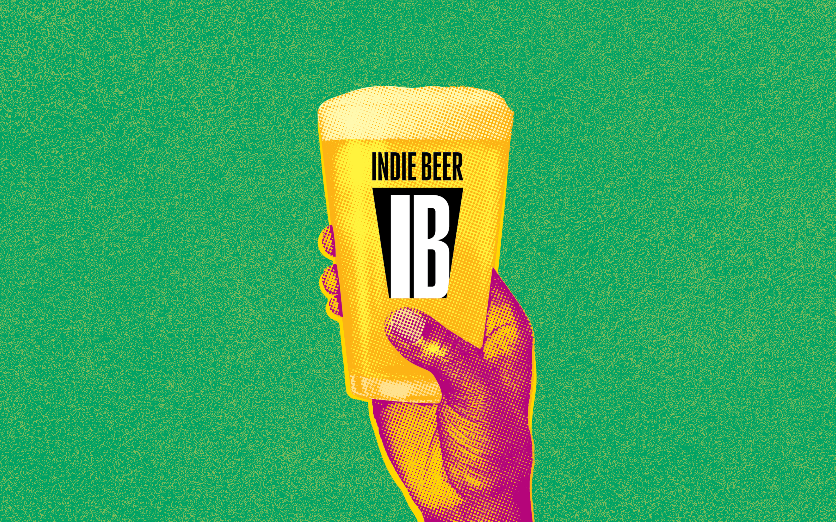

A new campaign to make it easier for drinkers to identify beer from independent breweries in pubs, bars and shops has been launched as demand for local produce rises across the UK. Production volumes for independent breweries have returned to pre-Covid levels with cask beer sold in pubs also in double-digit growth, according to statistics from the Society of Independent Brewers and Associates (SIBA) which has launched the new Indie Beer campaign. SIBA says the issue isn’t demand for independent beer but getting access to market and ensuring genuine products are sold to drinkers. “Support for local independent brewers has never been stronger. Between them independent brewers employ 10,000 people, run over 2,000 pubs bars and taprooms and pay millions in taxes in the UK. They are a force for good in the local communities they represent and it’s essential global beer companies are not taking credit for the hard work of independent brewers,” said SIBA chief executive Andy Slee. New YouGov data published today found 75 per cent of people surveyed believe consumers are being misled when purchasing beer from once independent craft breweries. People were shown images of five beers from breweries that have been bought by global beer giants: Beavertown Neck Oil (Heineken), Fuller’s London Pride (Asahi), Camden Hells (Budweiser), Brixton Reliance Pale Ale (Heineken), and Sharp’s Doom Bar (Molson Coors). When told these breweries were owned by global companies and not independent, 75 per cent of people surveyed said they felt consumers were being misled, with the figure for the beer drinkers even higher at 81 per cent. “People want to support smaller independent businesses, but when buying these beers, they’re actually spending their money with global beer giants,” said Slee. CAMRA national chairman Ash Corbett-Collins said: “CAMRA has campaigned for more than 50 years for quality cask beer and thriving pubs in every community. This excellent campaign will help pub-goers make more informed choices at the bar, while supporting our much-loved independent breweries. “We strongly believe it is vital people know the background to their beer – where it has come from, who has produced it and this is an incredibly effective way for people to find out more, while giving much needed support to local businesses and breweries, while protecting our pubs.” The results of the research also showed consumers generally were more likely to think global-owned brands were actually independent, with Beavertown Neck Oil the beer people surveyed most likely to think was produced by an independent craft brewery. The survey found 40 per cent of people surveyed thought Neck Oil was independent – higher than genuinely independent breweries such as Vocation, Fyne Ales and Five Points. The research was commissioned by SIBA as part of the launch of its Indie Beer logo, which will be used on pumpclips, cans and bottle labels to identify beers produced by a genuine UK independent brewery. The campaign also includes a new tool available at indiebeer.uk which allows people to find out who owns the beer they are drinking. Slee said: “There is more choice than ever when buying beer, but it can be really hard to know what’s the real deal – so we have launched the Indie Beer checker to make it quick and simple for people to see whether the beer they’re buying is brewed by a genuine independent brewer or actually owned by a global beer giant. You can also look for the Indie Beer logo when buying beer, which can only be used by genuine independents.” SIBA is a not-for-profit trade association which campaigns for the fair treatment and promotion of independent brewers and supplier businesses in the UK. More than 300 of its member breweries have now enrolled in the campaign and will be adding the Indie Beer mark to their bottles, cans, and pumpclips, with hundreds more to join in coming months. Breweries backing the campaign include: Cloudwater Brew Co, Thornbridge brewery, Attic Brew Co, Windsor & Eton brewery, Elusive Brewing, Brains brewery, Ossett brewery, Titanic brewery and Rooster’s Brewing. The campaign is open to all independent UK breweries and is supported by consumer and industry organisations representing the beer and pub sector, including CAMRA, British Institute of Innkeepers and the Independent Family Brewers of Britain (IFBB).