Bob’s just the job

22/10/2024 by WB Reporter

Campaign

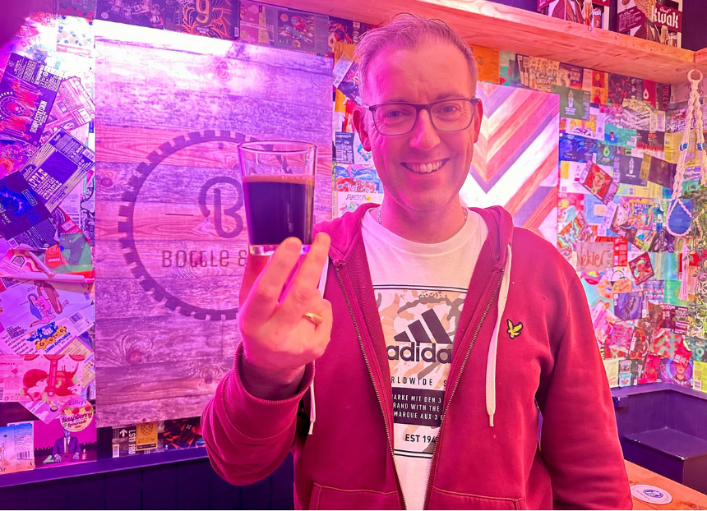

CAMRA’s Homebrewer of the Year crown has gone to an enthusiast who has only been producing for less than two years. Adam Waterson’s Black Bob (4.7 per cent) also won the Session Stouts and Porters: up to and including 4.9 per cent category and he will now brew his winning beer with the London Brewing Company with the support of the head brewer.   The final judging and results announcement took place at the Bohemia in North Finchley, London, presented by Elusive Brewing’s Andy Parker.   Waterson said: “I’m absolutely thrilled about the win as a relatively new homebrewer, as I started under two years ago this is quite something! Black Bob has been a project I’ve been perfecting for the last nine months and represents a meld of flavours; balancing coffee and chocolate with some fruit undertones and finishing with a softness that makes you want to take another sip. I can’t wait to experience brewing my own beer with the team at London Brewing Company on a commercial scale, it’s something I only had as a pipedream and an experience I hope to learn more brewing tricks from. I'm also glad this gives me the opportunity to share this beer with more people and hope they feel the same way too.”  The overall silver went to Ian Benfell for his Old Geoffers (6.3 per cent), which won the Brown and Red Ales, Old Ales and Strong Milds: 4.1-4.6 per cent category, winning a  case of eight craft beers every month for a year from competition sponsor BEER52.   Third went to Tom Wright for his Great Scot! – 80 Schilling (4.75 per cent), a premium bitter, with Tom picking up four tickets to the Great British Beer Festival 2025 in Birmingham.   Judge and brewer Andy Parker said: “The standard was incredible this year, especially the beer that won, it really turned our heads as judges. We had four or five beers that really stood out in the final and they each won their category. Overall, the quality was just outstanding.”  Parker is the owner and head brewer of Berkshire-based Elusive Brewing and champions the British homebrewing scene, where his love of beer and brewing developed. His new title The Modern Homebrewer, written with Jamil Zainasheff – a homebrewer, author and beer judge – was recently published by CAMRA.  CAMRA awards director Laura Emson said: “It’s fantastic to see that the passion in the beer community runs all the way through from the people that love to brew, to those that want to celebrate and drink good beer, at a fantastic venue. CAMRA is very proud to be celebrating the brewers of tomorrow, a huge congratulations to all our winners.”  The competition was sponsored by The Malt Miller, BEER52 and Brew At Home.  Who won what?   Milds: up to and including 4 per cent  Gold: Peters, Kathy’s Mild (3.4 per cent)   Joint Silver: Adam Waterson, Mild How You Go (3.5 per cent) and Kev Warnes, More Brown Than Red  Bronze: Zach Graham Mildly Nostalgic (3.2 per cent)  Session Bitters: up to and including 4.3 per cent  Gold: James Cross, Old Oak Common (4.2 per cent)  Silver: Kev Warnes, Away Kit (not available) Bronze: Christopher Bennett, Conisbrough Lad (3.8 per cent)   Premium Bitters: 4.4-6.4 per cent  Gold: Tom Wright, Great Scot! - 80 Schilling (4.75 per cent)  Silver: John Lee, Deep Harmony (5.5 per cent)  Bronze: Ken Johnson, Rough Seas (5.5 per cent)  Session Pale, Blond and Golden Ales: up to and including 4.3 per cent Gold: Ian Benfell, Admiral Nelson (4 per cent)  Silver: Simon Alcock, Nocora (4 per cent)   Premium Pale, Blond and Golden Ales: 4.4-6.4 per cent  Gold: Arthur Olcot, Arf's Gold (5.4 per cent)   Silver: Chris Cameron, Wee Fergus (5 per cent)   Bronze: Les Manley, Pirate Pale (5 per cent)  British & New World IPAs: 5.5 per cent and above  Gold: Richard Roseblade, Black Magic (5.8 per cent)  Silver: Stuart Hubbard, Lunar Eclipse (5.5 per cent)  Bronze: Charles Tucker, Mosaic DIPA (8.1 per cent)   Brown and Red Ales, Old Ales and Strong Milds: 4.1-6.4 per cent  Gold: Ian Benfell, Old Geoffers (6.3 per cent)  Silver: Joe Whittle Brown Bowze (4.7 per cent)  Bronze: Steven Thompson, Northern Coalfields (4.7 per cent)   Session Stouts and Porters: up to and including 4.9 per cent ABV  Gold: Adam Waterson, Black Bob (4.7 per cent)  Silver: Russell Peters, Alison's Stout (4.8 per cent)  Bronze: Richard Roseblade, Muesli (4.8 per cent)  Pictured: Adam at his brew club venue, Bottle & Co in Barnsley.