New site puts great pubs and pints front and centre

21/10/2024 by WB Reporter

Campaign

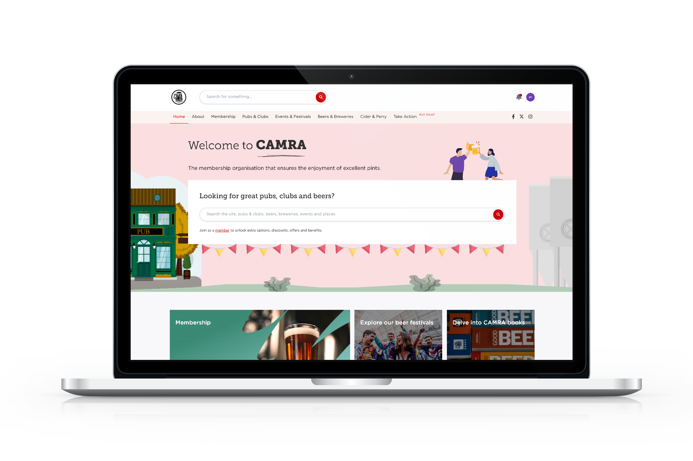

CAMRA has launched a new website experience to help enthusiasts unlock a host of innovative features in their quest to find the perfect pint and a great pub to enjoy it in.  The tools created for the CAMRA website herald an exciting new chapter for cask beer, cider and perry lovers to explore much-loved pubs, clubs and taprooms.   Designed to help users explore hidden gems, plan pub visits or just find out more about their local venues, the CAMRA site now offers features with pub-goers needs at the core, without the noise of advertising or third-party interests.    People can plan and share their upcoming trips, as well as mark which venues they have visited, or would like to return to. The site offers a “favourites” option, while “find pubs near you” allows visitors to see what’s close and navigate to them – all helping to build a unique experience.  CAMRA national chairman Ash Corbett-Collins said: “I am delighted that our new digital experience has been officially launched. This has been months in the making with extensive research and testing into what consumers want, but it’s also the culmination of more than 50 years of CAMRA’s unique perspective.  “The CAMRA website now makes it easy to seek out the best pubs, clubs and events, bringing people together socially, while supporting CAMRA and our aims for quality cask beer and thriving pubs. The website brings everything together, meaning people can carry out a range of activities in one place.   “This is only the beginning; more work is in the pipeline to create even more tools for this new go-to destination for beer and pub lovers, to easily plan trips and visit the absolute best places the UK has to offer.”   There are a range of features available to all, but CAMRA members and digital subscribers to the site can unlock more online tools, such as finding out about beer quality, the Good Beer Guide, trip planning and marking their favourite places.   CAMRA members can also submit beer scores which goes into the Campaign’s national beer scoring system. This fun and sociable activity is a vital campaigning tool as it helps decide which pubs go into the Good Beer Guide.   The user-friendly site puts all that is important to CAMRA front and centre, helping meet its vision and campaign for having quality cask beer, cider and perry and thriving pubs in every community.  The site also shows what developments are in the pipeline and lets users have their say on features they would find useful as it evolves putting the membership and visitors at the heart of future plans. Visit the bew website here. More information and FAQs about the new website can be found here.