Lakes’ loss of community

19/10/2024 by Matthew Curtis

Opinion

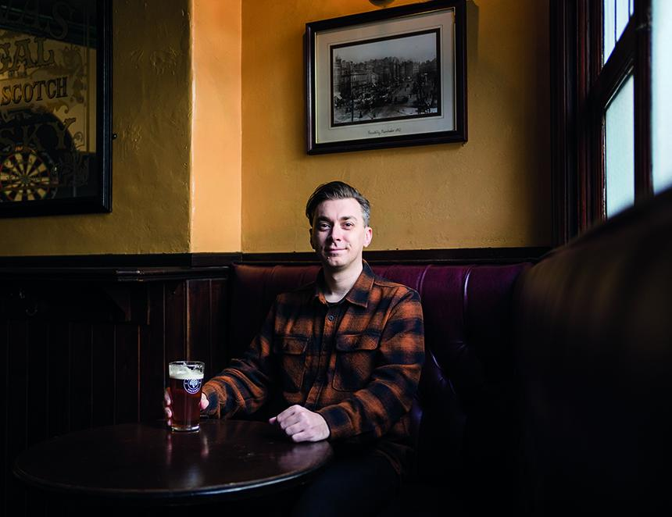

Halewood Artisanal Ventures is to permanently close the Hawkshead Beer Hall and Taproom in the village of Staveley. Located on the Mill Yard industrial estate, five miles from the thriving Cumbrian town of Kendal, the destination was as popular with locals as it was with tourists visiting the nearby Lake District. While much has been said about its impact on both the business and its staff, little has been observed of how the damage this closure will impact the local community. With a loss of both jobs and a well-liked beer destination, it’s a decision that will no doubt leave a bitter taste in residents’ mouths. Hawkshead brewery was founded in 2002 by former BBC foreign correspondent Alex Brodie. It became popular thanks to beers such as Lakeland Gold, Windermere Pale and a stout, Brodie’s Prime, named after its founder. The brewery also found favour with younger beer drinkers thanks to beers like Key Lime Tau, a sour beer infused with limes developed in collaboration with Crooked Stave brewery of Denver, Colorado. Hawkshead was one of those rare creatures – a brewery founded long after the real ale pioneers but before the new wave of ‘craft’ producers that managed to find plenty of favour in both camps. It was perhaps because of this why the beer community was shocked, when in 2017 Brodie decided to sell the business to Halewood ahead of his retirement two years later. Perhaps best known for products such as Stones’ Tonic Wine, Crabbie’s Alcoholic Ginger Beer and Dead Man’s Fingers spiced rum, there was an awkwardness about this new development that left some members of the beer community – myself included – uneasy. Still, initially it seemed to be a fruitful relationship, with Halewood almost immediately investing in a brand new, German-built, 60-hectolitre Krones brewhouse, installed at the brewery’s main production facility in Flookburgh, on Cumbria’s Cartmel Peninsula. Soon after, however, cracks in this new relationship began to show. One month into the Covid-19 enforced lockdowns of 2020, Halewood opted not to put staff on furlough, instead making 12 redundancies. This included several employees in senior positions such as head brewer Matt Clarke, who had been a key ambassador for the brand, helping to develop the brewery's good standing with beer drinkers. One onlooker described it as “the heart being ripped out of Hawkshead” on social media.  Clarke, his partner – and former Hawkshead marketing manager – Michelle Gay, and several other figures would go on to found Lakes Brew Co in Kendal the following year, restoring some of the Lakeland town’s local pride. But despite the Beer Hall reopening after lockdown had finally ended, Hawkshead’s reputation struggled to recover, especially within the North-West. Four years on, it seems that Halewood is engaging in a similar strategy. On 4 September it issued redundancy notices to 12 full and part-time staff, with the site reportedly expected to close on 22 September. According to reports, the company claimed that the current site was “unsustainable” and blamed parking charges issued by the landlord that made the Staveley site unprofitable. It's a claim that has been refuted by landlord David Brockbank, who told the BBC he had been met by a “wall of silence” while trying to contact Halewood over four months up to the announcement. Although three of the newly redundant staff were offered the chance to be relocated 21 miles away at the Flookburgh production facility, it once again sparked ire within the local community. This was compounded when on 10 September members of the Staveley community reportedly witnessed the Beer Hall’s bar being “ripped out”. One Kendal resident, who wished to comment anonymously, described the closure to me as “cultural vandalism”. Another local and CAMRA member Caroline Schwaller told me how locals are “furious” with the news. “It will also knock the tourist income into Staveley, so lots of other independent businesses will be affected,” she said. “Especially those in the Mill Yard who probably set up there because of the spin-off trade from the Beer Hall.” Halewood is not the only company which has recently decided to shutter a popular brewery and taproom following its acquisition and subsequent unsatisfactory performance. In March 2024, Asahi decided to close the Meantime brewery in Greenwich, moving production to its central facility at the Fuller’s Griffin brewery in Chiswick, West London. This followed Asahi’s decision to close the Dark Star brewery in Sussex in November 2022. Closures such as this should send warning signs to all of those who cherish good beer. Not just because of how these closures impact communities and jobs, but because of how culturally important brewing institutions are potentially being mismanaged. While it is easy enough to wag a finger at a challenging beer market, there are also hugely positive examples of successful breweries to be found all over the country, from Siren in Berkshire to Thornbridge in Derbyshire, and Timothy Taylor’s in Keighley, West Yorkshire, to name a few. Why then, are the likes of Halewood or Asahi, with all their millions, not able to produce the same, positive results? That’s a question to be pondered for another time. For now, the locals of Staveley and Kendal have been left licking their wounds, as they mourn the loss of a cherished community asset.