Top tips for Cider and Perry Month

18/10/2024 by Tori Wood

Campaign

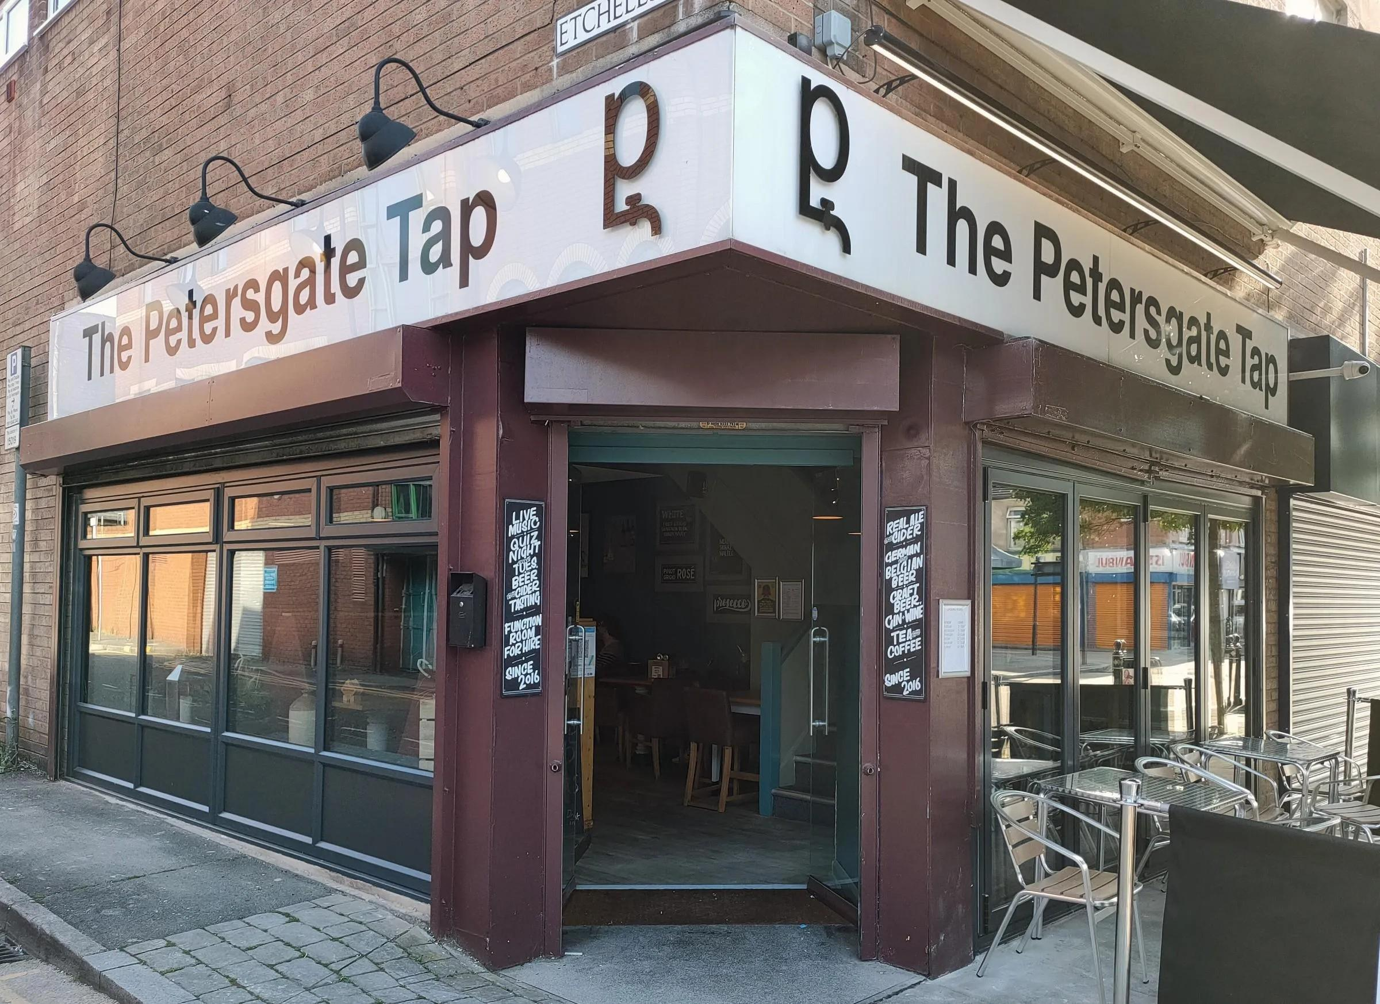

Want to visit a great pub this Cider and Perry Month? Then check out these regional winners from this year’s Cider and Perry Pub of the Year award.  Greater Manchester   Petersgate Tap  9A St Petersgate, Stockport, SK1 1EB (above) A family pub based in a former betting shop, run by Chris and Alan Gent. The pub is over two floors, with downstairs displaying a fairly modern setting and a continental feel to the bar area. Recycled, solid oak-topped tables dot the pub, with a mix of seating under posters and breweriana hung on the walls.   There is a fridge which carries the house cider plus a selection of real cider available in bottles, and a further eight in the cellar including perries.   A full range of Stockport Gins are showcased the distillery next door. There is also an impressive range of single malt whiskies, six handpumps, and a good selection of red and white wine.  Additionally, there is an extensive bottle shop upstairs, where online orders are also catered for.   Petersgate Tap has won:  Stockport CAMRA Champion Mild Pub 2018 and 2019

Stockport CAMRA Pub of the Year 2023

Greater Manchester CAMRA Cider Pub of the Year 2018-19, and 2024

Stockport CAMRA Cider Pub of the Year 2018-20, 2022-24.  https://petersgatetap.co.uk/   Merseyside & Cheshire  That Beer Place  116, Foregate Street, Chester, Chester, CH1 2HH  This year’s National Cider and Perry Pub of the Year, as well as the regional winner for Merseyside and Cheshire. That Beer Place is a hub for both beer and cider enthusiasts, with a diverse range and an interesting variety of ciders and perries.  This pub was previously in Chester’s market, but you’ll now find it on the edge of the city centre. A simple single-room layout with an additional space upstairs and outdoor seating available in good weather.   Up to 140 real ciders and perries are available at any one time with at least three served on draught as well as a variety of bottled beers and keg lines, including two live draught Belgian sours. Cask ale was introduced in July 2024, with a full menu available on That Beer Place’s website.  The pub also hosts monthly cider meetings.  That Beer Place is fast becoming a fixture of local awards, and has won:  CAMRA’s National Cider and Perry Pub of the Year 2024

West Cheshire Cider Pub of the Year 2024. https://thatbeerplace.co.uk/  East Midlands   Red Lion at Kniveton Main Street, Kniveton, DE6 1JH  An attractive stone pub on the main road through the village of Kniveton. In February 2020, ownership changed, and the pub is now run by a local couple who also own Kniveton Cider Company.   The pub has a big emphasis on cider and perry with more than 50 bottled versions available including their own offering. There is also a range of well-kept beers from local breweries, including Wincle and Aldwark.  The pub has friendly and welcoming staff, with a range of food served most of the time.   Red Lion at Kniveton has won:  Branch Pub of the Year 2024

East Midlands Cider Pub of the Year 2023 and 2024.  https://www.theredlionkniveton.co.uk/     West Midlands  Bailey Head  Bailey Head, Oswestry, SY11 1PZ  Once named the Castle Tavern after the nearby remnants of Oswestry Castle, you’ll find four real ciders and one perry served on handpulls as well as a substantial range of bottles and cans from across the UK and overseas. The beer selection is also excellent, with six cask beers and a regularly changing range.  A range of board games for children and adults are provided and the Bailey Head was named the Most Dog Friendly Pub in the West Midlands by DogBuddy in 2017.  Bailey Head has won:  Branch Market Towns Pub of the Year 2019

SIBA’s Best Rural Independent Craft Beer Pub or Bar 2020

Branch Pub of the Year 2024

East Midlands Cider Pub of the Year 2023 and 2024. https://baileyhead.co.uk/   East Anglia    Frothblowers Arms   78 Storrington Way, Werrington, Peterborough, PE4 6QP  The Frothblowers was one of four finalists in this year’s Cider and Perry Pub of the Year competition. At least 25 ciders and bottled beers are served at the Frothblowers along with five handpumps and more beer available in the cellar. Alcohol-free beers are also stocked.   A hub of the local community, activities include tap takeovers, acoustic music, bus tours, summer cycling and knitting clubs. If you’re planning a visit, be aware the Frothblowers accepts cash only.   Frothblowers Arms has won:  Peterborough Pub of the Year 2019

Cambridgeshire Pub of the Year 2019 and 2020

County Cider Pub of the Year 2024

East Anglia Cider Pub of the Year 2024

Cider Pub of the Year Super-Regional finalist 2024. http://www.frothblowers.site/