Fab four go for title

17/10/2024 by Timothy Hampson

Campaign

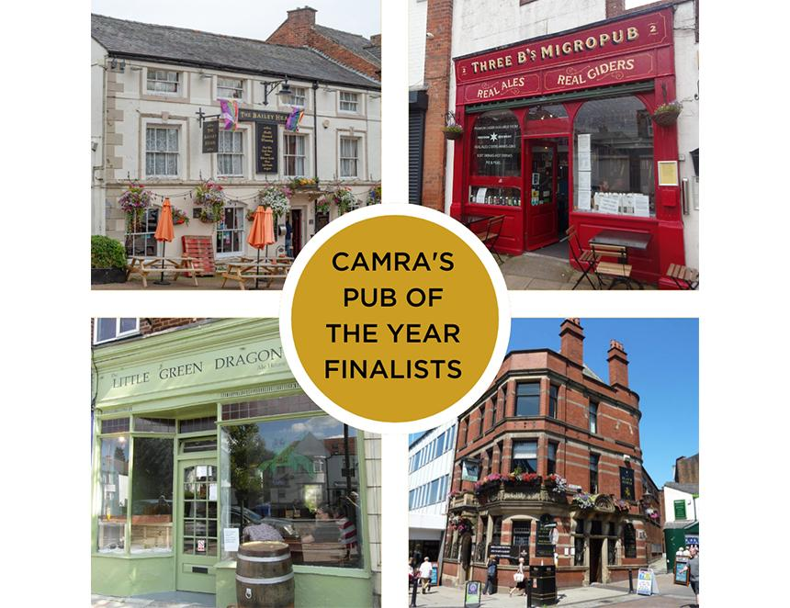

The race to be crowned CAMRA’s Pub of the Year 2024 is hotting up, with the 17 national and regional finalists now whittled down to a final four. The final four are:   Black Horse, Preston  A visually stunning Victorian Grade II-listed pub opposite the historic Preston open market, the Black Horse is a fantastic example of Victorian architecture, retaining original fittings from the era. Most noteworthy is the beautiful semi-circular ceramic bar, tiled walls and meticulous mosaic flooring throughout the pub. The Black Horse serves through 10 handpumps including four changing guest beers, plus a range of ciders. A seating area has been dubbed the Hall of Mirrors due to the impressive use of original stained glass. Three B’s, Bridlington  Run by a husband-and-wife team passionate about beer and cider, the popular micropub is described as “Bridlington’s Real Ale Destination”, showcasing four cask beers with a focus on local Yorkshire-based beers. The pub is renowned for its excellent customer service, with the staff providing knowledge on the drinks they serve, as well as information for visitors about what they can get up to in the town. The pub aims to never sell the same beer twice, making for an exciting range of everchanging beers at the bar, becoming the Society of Independent Brewers’ (SIBA) UK’s Best City Independent Craft Beer Pub or Bar finalist in 2021. Also, as a CAMRA National Cider Pub of the Year finalist in 2023, at least 10 ciders of varying styles and strengths are served from local suppliers.  The Three B’s represents what a micropub can bring to a community, by listening to its customers, mainly serving cask ales, promoting conversation, and steering away from electronic entertainment pubgoers may find in other establishments such as televisions and fruit machines. The focus is on quality drinks and creating an atmosphere welcoming to all.  The pub also prides itself on being inclusive and catering to a diverse collection of locals. They also open their doors to dogs, with a chicken broth-based ‘Dog Beer’ on the menu for furry friends. The Three B’s holds bi-weekly quiz nights to raise money for their charity of choice, the Yorkshire Air Ambulance.   Landlord Mark Bates said: “To be told we have been judged one of the top four pubs in the country is truly amazing, this is a testament to the hours we put in at the pub and our great customers. We visit many other great pubs in Yorkshire and beyond so know this is a very high standard, this really is an accolade beyond our dreams and would like to thank CAMRA for bestowing such recognition on us.” Little Green Dragon, Winchmore Hill  A former shop, Enfield’s first micropub opened in 2017. Focussing on the quality and diversity of cask beer, the Little Green Dragon has an everchanging selection of four cask beers sourced from local microbreweries and other independent brewers from further afield, plus real cider, perry and four keg beers. Traditional pub games such as table skittles and shove ha’penny are available for pub-goers to play. The Little Green Dragon’s interior features an eclectic range of seating, from wall-mounted benches to low sofas, and even repurposed bus seats.  Owner Richard Reeves said: “I was delighted (and also a little shocked) to learn that our little micropub had been judged by CAMRA as one of the top four pubs in the UK! Clearly, at this stage of the competition, it is about far more than beer quality, so I really must thank my incredible family and staff and amazing regulars for making visitors feel so welcome in the Little Green Dragon.” Bailey Head, Oswestry  Nestled near the Welsh borders in the market town of Oswestry, the Bailey Head is a must-visit for beer lovers. The pub has one of the largest beer ranges of any in Shropshire, claiming to have sold more than 3,400 draught beers since opening in March 2016. Six constantly changing cask beers, always including one dark brew, are supplemented by 11 other draught beers, plus four ciders and a perry. The pub also has a substantial range of canned and bottled beers from across the UK and overseas. The Society of Independent Brewers (SIBA) named the pub the UK’s Best Rural Independent Craft Beer Pub or Bar in 2020, and it has been a finalist for the same award many times since. Regular tap takeovers and meet the brewer events, among other activities are organised for the local community. Landlord Duncan Borrowman said: “To say we are shocked to make it into the final four nationally is an understatement. I am not sure we will ever stop pinching ourselves. It is a testament to our hard-working small team of dedicated staff and our loyal regulars." Landlady Grace Goodlad said: “When we bought the pub nearly nine years ago, we never dreamt this could happen. It had been failing under the ownership of a major pub company and CAMRA had it protected as an Asset of Community Value. We couldn't have done this without that happening.” National Pub of the Year Coordinator Andrea Briers said: “It gets harder each year to whittle down the regional and national top 17 pubs to just four places, such is the standard of the competition. These fantastic four are the epitome of what a good pub should be – welcoming to all, friendly hardworking staff and serve well maintained cask beer for a wonderful pub going experience. I am excited to find out which one will be crowned the best pub in the UK. “Pubs need our support more than ever, as the licensed trade continues to feel the strain under the burden of unfair tax, high costs and regulations. I urge all pub lovers and beer drinkers to experience not only our incredible Pub of the Year finalists, but support as many pubs as possible.”   The overall winner will be announced in 2025.