Even more haunted pub chills and thrills

17/10/2024 by Tori Wood

Campaign

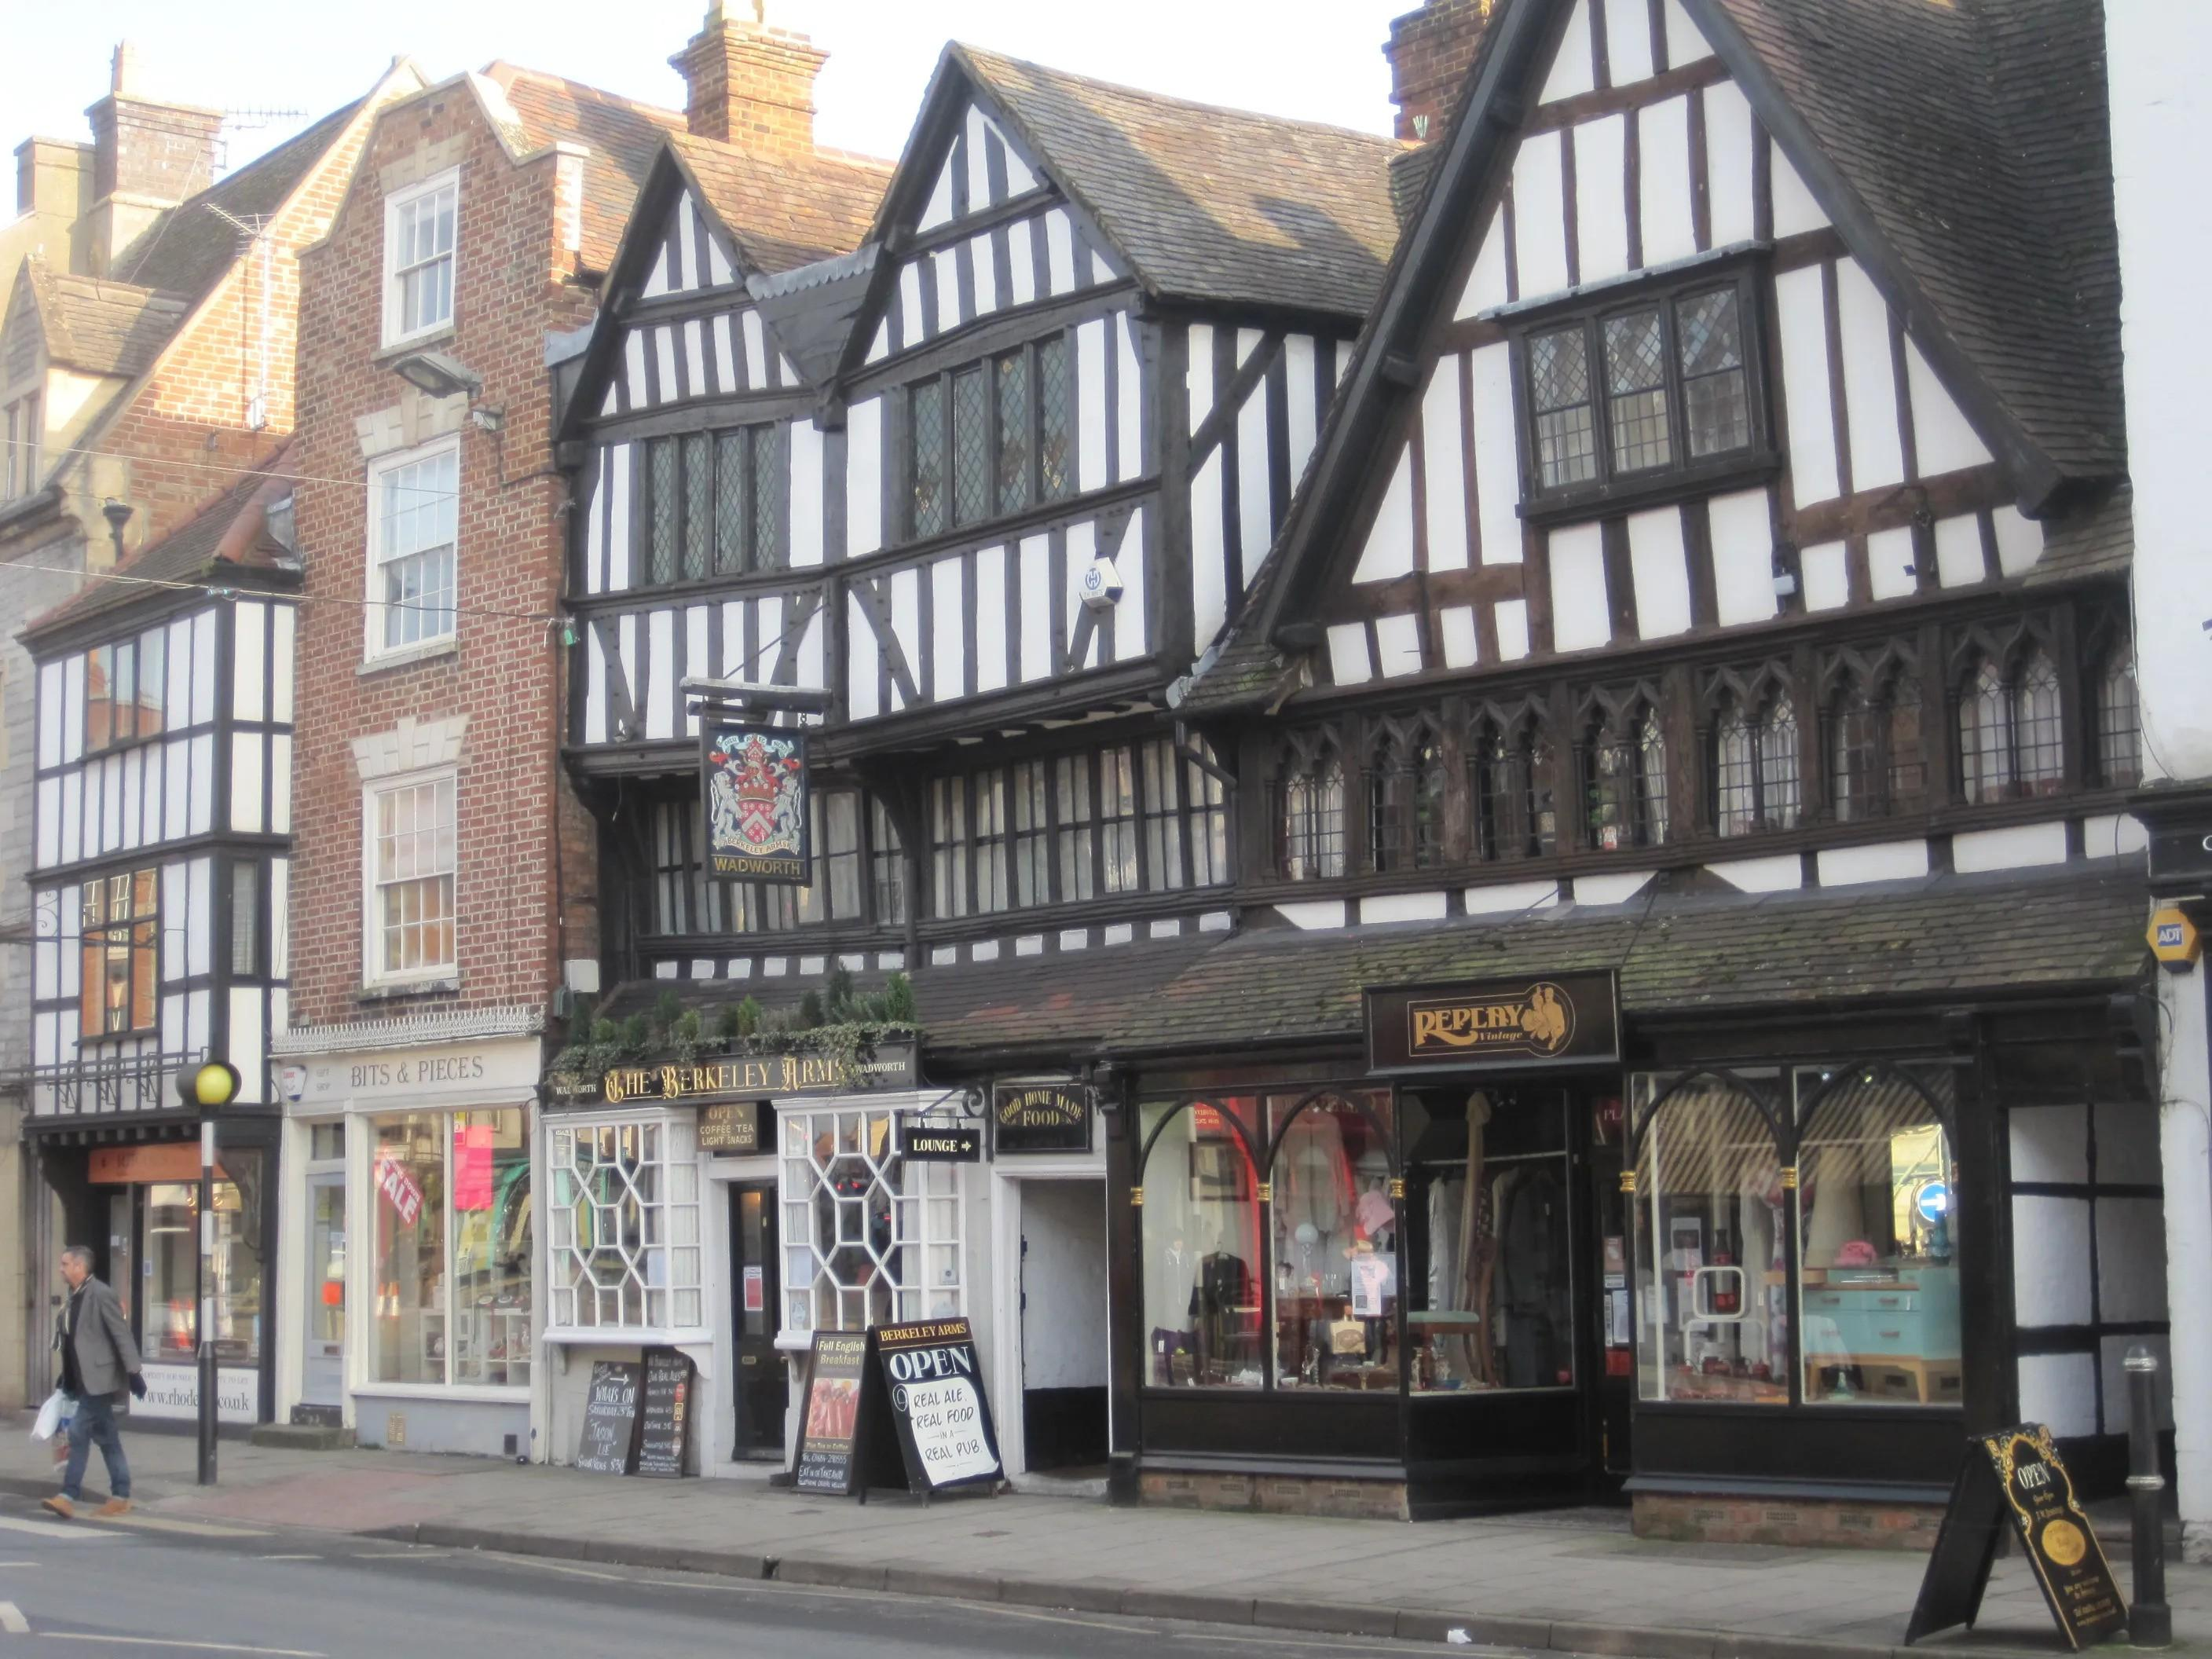

If you’re looking for a pint and a fright this October, read on for the latest instalment in our guide to haunted pubs put together for Cider and Perry Month. As well as serving up real cider and perry, these pubs claim to offer apparitions in the cellar, a ghostly abbot, and objects flying across the bar.  Nottingham Arms   129 High Street, Tewkesbury, GL20 5JU   Dating back to the 14th century, this town-centre hostelry offers welcoming rooms, a public bar at the front and a bar and restaurant behind.  Fill up on its excellent, well-priced food, served lunchtimes and evenings, or catch one of the regular live music nights or quizzes. You’ll find knowledgeable staff who will happily tell you about their resident ghosts over a cider or perry.  https://www.nottinghamarms-tewkesbury.co.uk/  Berkeley Arms (above)  8 Church Street, Tewkesbury, GL20 5PA   This popular 15th century half-timbered Grade II pub includes a historic barn as its multi-use function room.   Catch some live music on a Saturday, a roast dinner on a Sunday, or the chance to spot a ghost any day of the week. This pub was also voted Tewkesbury CAMRA Pub of the Year 2022, so you know you’re in for a treat.   https://theberkeleyarms.pub/  Royal Oak   43 The Burgage, Prestbury, GL52 3DL   An attractive, 16th-century Cotswold stone pub in reputedly Britain's most haunted village.   Find a photo of the ghost of the “Black Abbot” hanging in the lounge bar. He’s said to haunt the area along with a horseman and a second, headless one who can be seen riding through the village.  The food is primarily home-made (notably the desserts) and includes cheeses from a local producer. A cider festival is held in August, but you can find a range on year-round.  https://www.butcombe.com/pubs/the-royal-oak/  Crown Inn Old Hereford Road, Pantygelli, NP7 7HR   The building likely dates back as far as the 16th century and may have originally been a large farmhouse which then became a coaching inn. Rumour has it that a resident Georgian ghost dwells here, matching the grand Georgian facade.   Enjoy the sympathetically updated interior, pleasant flagstone floor and log fire. The adjacent hills of the Sugar Loaf, Bryn Arw and Ysgyryd Fawr make this a perfect starting (and finishing!) point for a crisp autumn walk with a pint at the end.  https://www.thecrownpantygelli.com/ Angel Hotel Market Place, Coleford, GL16 8AE   A 17th-century inn centrally placed in the market place of Coleford. It is reputedly haunted, with a number of the hotel rooms coming with their own ghosts.   Theydon Oak 9 Coopersale Street, Coopersale, CM16 7QJ   The Theydon Oak is near Epping, Essex, and is a quaint pub with an open fire, comfortable seating and plenty of room for you to settle in and relax.   A sense of history surrounds you with exposed beams, an inglenook and areas of the original brickwork laid down more than 400 years ago. Rumours abound locally that an apparition has been seen several times in the depths of the cellar, and occasionally passing silently across the inglenook fireplace.   http://www.thetheydonoak.co.uk  Carpenters Arms Usk Road, Shirenewton, NP16 6BU   Very popular country pub with a gristly tale to tell and historic items and bar fittings on display.   Crashing noises have been heard in the cellar, objects were seen flying around the bar and the ghostly presence of a young woman can be detected. These events were attributed to the crime of a former landlord who had murdered his daughter and had walled up her body in the snug. Talking of bodies, one table in the room immediately to the right of the entrance was used to lay out bodies, although not recently!  Mabel’s Tavern   9 Mabledon Place, London, WC1H 9AZ   The 2006 North London CAMRA Pub of the Year offers consistently good beer and real cider.   Named after Mabel Macinelly of Dublin and reportedly haunted by her, it attracts tourists, locals and workers, coming for a glimpse of ghostly happenings, sport on the screens at either end of the pub or just a good pint.   https://www.mabelstavern.co.uk/  George IV 185 Chiswick High Road, Chiswick, W4 2DR   There has been a pub here in the heart of Chiswick since 1777 and the present inter-war building had a substantial makeover in 2014. Luckily this doesn’t seem to have deterred George the ghost (no relation).  Notable for the large Boston Room at the back, which hosts the Headliners Comedy Club, you can settle in for a pint and a giggle – if George doesn’t pop up that is…  https://www.georgeiv.co.uk/  Bull Hinton, SN14 8HG   This inviting pub dates back to the 17th century and is noted for food. In its time it has been an inn, farm and dairy and has accumulated its fair share of ghosts through the years.   Notable for the local (and sometimes home-grown!) ingredients used in the menu of pub classics.   http://www.thebullathinton.co.uk/  Cross House Inn High Street, Doynton, BS30 5TF   After more than two years closed, this traditional country pub reopened in September 2019 following extensive refurbishment.   You’ll find this pub at the centre of a peaceful, pleasant and small village. The pub is allegedly haunted by the ghost of Archie Carrow, who was landlord for 50 years – perhaps you’ll want to stay that long too! The garden is child-friendly, and dogs are welcome.  https://www.crosshousedoynton.com/  Llandoger Trow King Street, Bristol, BS1 4ER   An iconic Grade II-listed pub dating from 1664. Tradition has it Daniel Defoe met Alexander Selkirk, who became the inspiration for Robinson Crusoe here, and that it was also the inspiration for the Admiral Benbow pub in Stephenson’s Treasure Island.   The pub is alleged to be haunted but if you’re looking for something more lively, you’ll find tap takeovers, sea shanty singing, comedy evenings and regular live music nights.  https://www.llandogertrow.co.uk/