Shuttered pub numbers surge

16/10/2024 by WB Reporter

Campaign

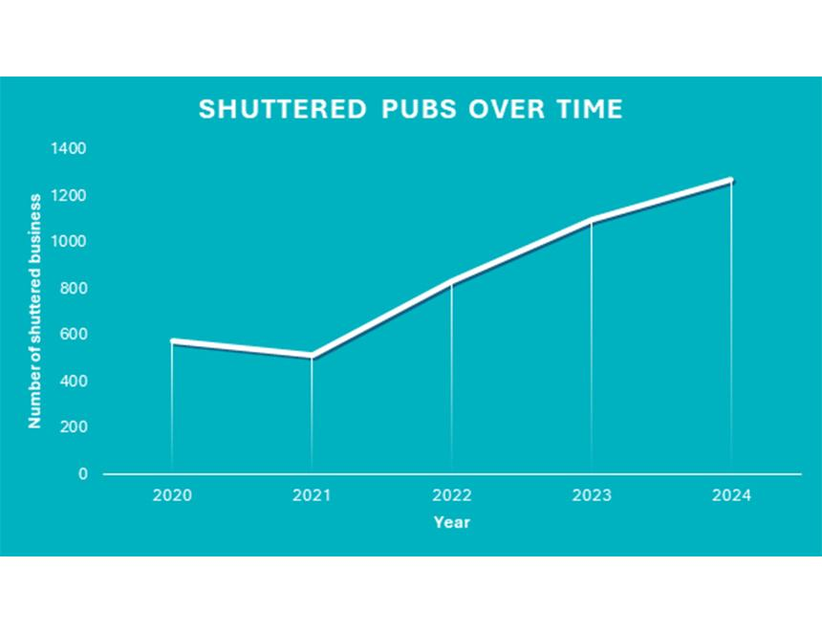

Shocking figures released today by CAMRA show the alarming rate of licensee turnover in the pub trade as the crushing weight of unfair taxation and high operational costs leave businesses struggling. CAMRA pub and club campaigns director Gary Timmins said the chancellor should consider this a wake-up call ahead of the Budget.   In recent years, the rate of pubs lost to conversion or demolition in England has slowed slightly as communities make use of planning protection and the right to have their say on the future of their local. Despite this clear evidence of demand, thousands of licensees – many of whom have run successful businesses for years – are now struggling to pull their pubs from the brink of closure, as record numbers of venues are forced to shut their doors.   Based on current trends, CAMRA data shows that more than 1,200 pubs will likely be shuttered this year, compared to around 1,000 in 2023, and just over 800 in 2022.  While in many cases, new licensees step in to keep the pub open to its community, this rate of churn highlights a deeper problem. In many cases new licensees find themselves battling the same high costs as their predecessors and without meaningful government action pubs everywhere may be in jeopardy.   Timmins said: “Hardworking licensees who run busy and popular pubs should not be struggling to make ends meet. The trend in business closures that our data has highlighted is truly shocking and I hope this is a wake-up call for government ahead of the Budget.  “Without meaningful change to our outdated and unfair tax system, this cycle will likely continue, with more licensees’ businesses failing, higher rates of pubs being shuttered to their communities, and new operators stepping into an increasingly hostile business environment.   “CAMRA has called for a fundamental overhaul of the business rates system, a greater discount on the tax paid on pints at the bar, and a new VAT rate for hospitality. Our campaigning relies on as many people as possible taking the time to get involved. With our simple online campaigning tool, it only takes a few minutes to contact your MP, and every email makes a difference.”  CAMRA’s online campaigning tool can be found here: https://action.camra.org.uk/page/156994/action/1   Pictured: the chart shows the rate of shuttered pubs over time. The figure for 2024 is an extrapolation based on data for the year so far. Figures for 2020 and 2021 do not include mandatory closures from the pandemic, these numbers show pubs closed to their communities for specific reasons such as seeking new owner, tenant or lease holder, or being in the process of seeking planning permission for conversion or demolition.