2024 Campaigner of the Year Round Up

16/10/2024 by Matthew Rogers

Campaign

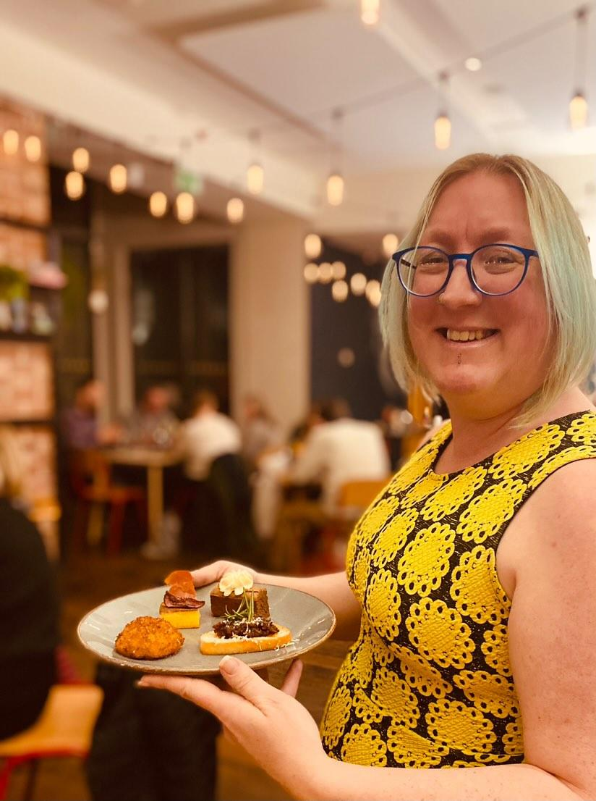

In our latest round-up of this year’s Members’ Weekend, AGM & Conference in Dundee, we look at Laura Hadland (above) becoming CAMRA’s Campaigner of the Year 2024. View both a video of Laura’s acceptance speech and transcript below. “Just got to say a huge thank you for bestowing this amazing honour on me. It’s just wonderful how I’ve been welcomed into the CAMRA community. “Back in 2019, when I first got the commission to write 50 Years of CAMRA, I never expected that my involvement with the organisation would really become so all consuming, but it’s just a huge part of my life now. I think because the CAMRA ethos, the support for cask ale, for pubs and for independent brewers is really something that’s a huge focus for me as well. “It is fantastic to be a part of writing regularly for What’s Brewing and BEER magazine, but also, despite all the research that I did, no one really warned me to not make eye contact my branch chair when they were looking for volunteers. So now I am on the ground as well, helping out with my branch, volunteering nationally, doing things like the Learn & Discover bar at GBBF, which I will be sad to miss at this year’s festival. “I hope that that we can all keep spreading the good word about cask ale. I have been doing lots of talks, tastings, pub tours here in Shropshire, at food festivals all around Shrewsbury, making sure that people know that cask ale is something fantastic, delicious and special. “I am trying really hard to help keep pub heritage in the public eye. So, keeping a good check on what’s happening with the Crooked House for example, and also trying to big up that campaign to get the local pub interiors recorded by branches. “I think there is loads of great work we can all continue to do, and it’s really, really kind that you’ve recognised the work that I have been doing up until now. I hope that all of you within CAMRA keeps supporting diverse voices, talking about great beer. Have a great Members’ Weekend, and hopefully see you all soon. Thank you!”