Workers take over brewery

15/10/2024 by Dave Pickersgill

Industry

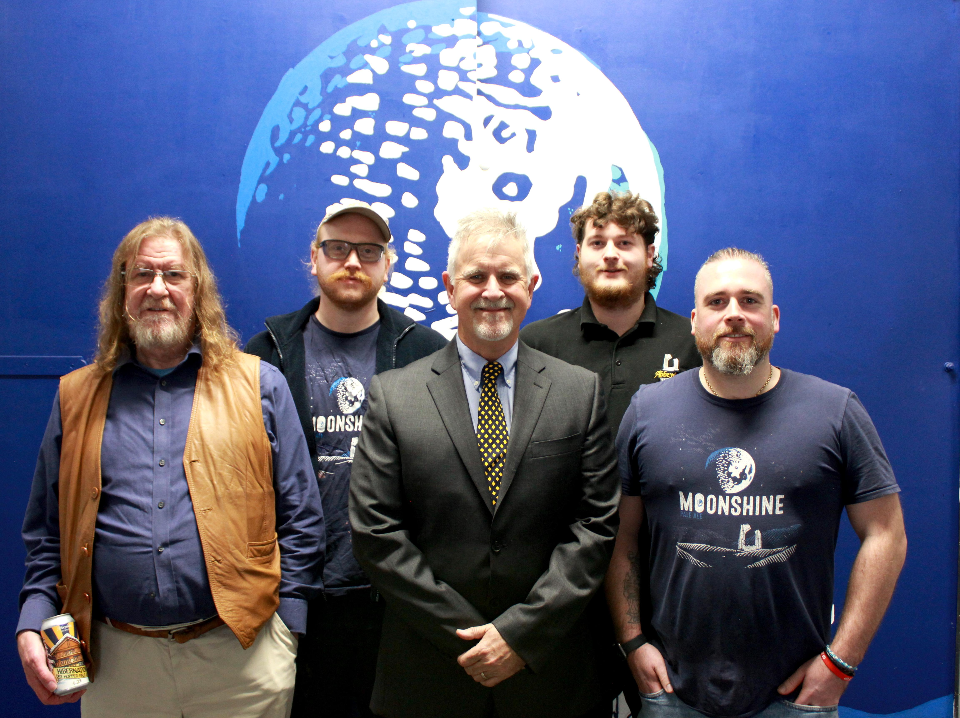

Sheffield-based Abbeydale brewery has become an Employee Ownership Trust. The change of ownership covers the whole business, encompassing both the brewery and its pub, the Good Beer Guide-listed Rising Sun in Nether Green. Both the brewery and pub are now 100 per cent employee owned, and renamed Sheffield Beerworks EOT. The name is a nod to the past – some early beers, including all of the original Doctor Morton’s series, were released under the Beerworks brand. Since its foundation in 1996, the business, which employs more than 50 staff (split between the brewery and the pub), has been rooted within the community. Staff include lead brewer Jim Rangeley who was named Brewer of the Year at the recent Brewers Choice Awards. Selling owner Sue Morton said: “As well as trying to grow the business safely and organically, we have always tried to maintain an inclusive and supportive culture with the people who work with and for us. The future of the business is important to us, and we have always said we would not sell out to the ‘big boys’. We can think of no better option to secure the legacy of Abbeydale brewery than to trust our team with the business they have helped us to build, together – we’re looking forward to seeing the exciting new developments they will bring forward.” A limited-edition beer will be released to commemorate the occasion. With a recipe that was chosen by the team, Trust will be a session pale ale, intended to capture the essence of the beers that have enabled the business to reach this milestone. It will be available in cask, keg and can plus will also be on the bar at the CAMRA Sheffield Steel City Beer Festival at Kelham Island Museum from Wednesday. Abbeydale will also be leading a tasting of its beers at the event.   Brewery founders Pat and Sue Morton will continue to be involved, stepping back from the day-to-day running of the business, but remaining on the board of directors (pictured). Co-MD Dan Baxter said: “I could not be more proud of our team and everything we have achieved together over the years. We are a humble bunch, mentored by Pat and Sue, and have a vast skill set among our staff at both the brewery and the Rising Sun. The future for the business is very exciting! The support of our customers and our community is paramount as it always has been. So, a massive thank you for enjoying our beer. We will continue to do what we do best.”