Sheps commits to cask production

14/10/2024 by Timothy Hampson

Industry

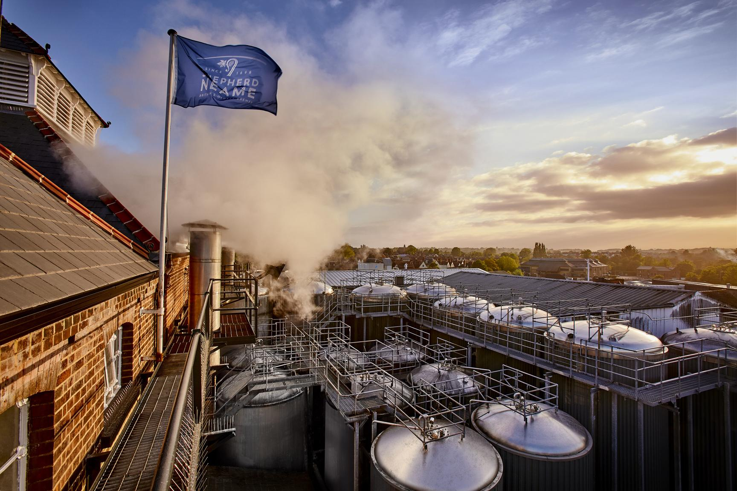

Britain’s oldest brewery Shepherd Neame (above) has reaffirmed its commitment to cask ale. The move follows a report in the Telegraph that the Kent brewer was to shift its focus away from cask beer and into kegged products. CAMRA campaigns and communications director Nick Boley said: “We applaud Shepherd Neame for swiftly reaffirming its complete commitment to cask beer. “Cask is an essential part of the UK’s drinks trade and brewing heritage, and we are glad that Shepherd Neame agrees with us on its importance. “Cask drinkers will no doubt be reassured by this, and we hope other UK brewers take note. We look forward to seeing Shepherd Neame’s future cask-focused projects, and will gladly work with it and other brewers ahead of the Budget to highlight the sky-high tax burden facing British brewers and pubs." Shepherd Neame’s chief executive Jonathan Neame said: “At present, Shepherd Neame is seeing growth in keg beer and a decline in cask beer and bottled beer, driven by the market, but we remain completely committed to cask ale and see no reason why the category will not recover again. “We brew a diverse range of award-winning cask ales, and in the past year have won multiple awards for our beers, including two World’s Best honours in the World Beer Awards 2024. “We also continue to invest in our popular Cask Club programme, which sees new beers incorporating modern styles and flavours released through the year, along with seasonal classics, and is aimed at encouraging new drinkers to enjoy cask ale. “Notwithstanding the above, the taxation and regulation facing British brewers and pub companies currently make life very challenging for all in our sector, and we hope the Government is listening to the calls for an urgent review.” CAMRA's reaction to the original Telegraph story can be found here.