Fight to save West Midlands favourite

13/10/2024 by Timothy Hampson

Campaign

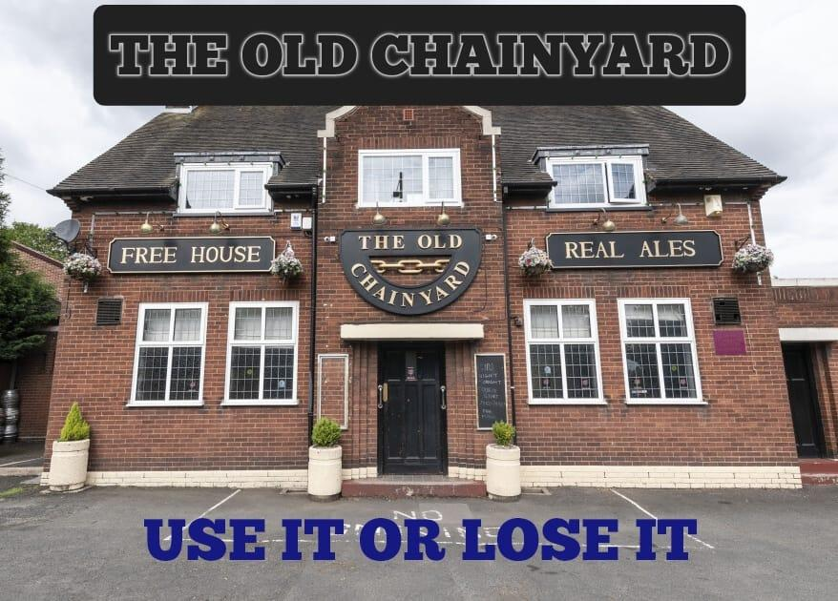

Plans to turn a West Midlands pub into a convenience store would lead to the loss of a valued community asset according to the local CAMRA branch. Dudley Council planners are set to rule on an application to convert the Old Chainyard on Castle Street, Coseley into a shop. Applicants Red Oak Taverns says the pub is not economically viable, but the plan has attracted criticism from people who would prefer to see the bar stay open. Dudley and South Staffordshire branch chairman John Corser said: “I am objecting to the loss of this public house, which is a community asset to Roseville and the wider Coseley area. “It is one of the few real ale pubs in the area and serves an important role in putting on events for the local community. “It is well used by regulars and visited by CAMRA members from across the West Midlands and further afield.” Plans submitted to the council propose the demolition of a single storey extension to the side of the building and a new extension at the rear of the site to create a retail space. A report from real estate company Savills commissioned by the applicant concluded the business is not viable as it is and would not become viable even if it underwent a refurbishment. The report says: “Public houses such as the Old Chainyard have suffered more than others since the economic downturn of 2008 and more recently due to them not having the economies of scale to compete with large managed house operations. “The property has no kitchen facilities; it is unlikely to attract much ‘destination’ custom and instead had to rely on the local population. “There are better located venues with superior facilities within close proximity.” Chainyard manager Amanda Fisher said on Facebook: “It is with a heavy heart that I announce the closure of the old Chainyard pub. Unfortunately, the rumours are true. “Planning permission is currently being sought to become an Asda store.  “When the planning permission is accepted, I will have three months' notice to leave.” “It is hard to put into words how I feel, apart from saying, my customers are not just customers, but part of my family. We have had so many celebrations, laughs, some tears and plenty of love and support from each other over the last 8 years. “We have so many memories that cannot be erased, themed discos, parties, charity events, Christmas markets.” Red Oak Taverns has been approached for a comment.