Dark delight takes bottled beer title

13/10/2024 by WB Reporter

Campaign

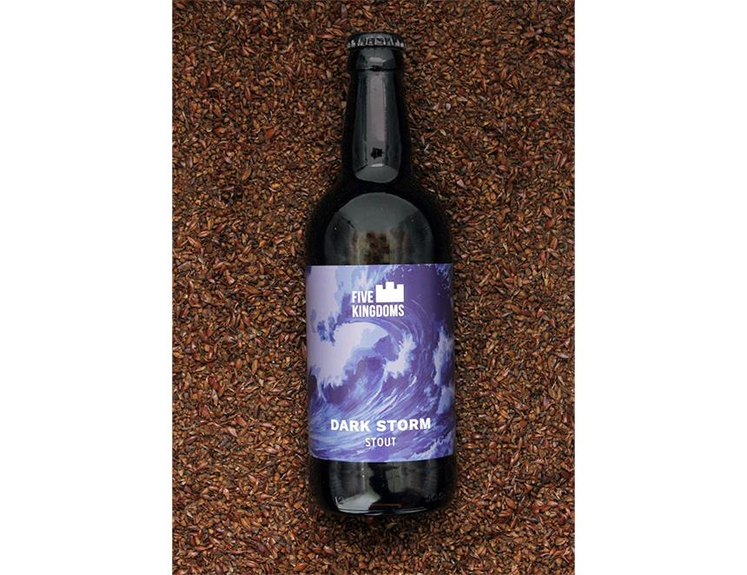

Five Kingdoms Dark Storm stout (6.9 per cent ABV) is CAMRA’s Champion Bottled Beer of Britain. The annual competition recognises the best bottle-conditioned beers in the country and the winner was revealed at The Bohemia in Finchley, London.   Five Kingdoms, a small brewery on the Isle of Whithorn, Scotland, started in 2015 as a hobby and passion project between Alastair Scoular, owner of the local pub and restaurant the Steam Packet Inn, and head chef Brendon Dennett Scoular said: “The brewery team was thrilled to have won this award for the whole of the UK. We are a tiny brewery from a remote corner of Scotland, so to win an award at this level is incredible, great recognition for years of hard work. It is also fantastic publicity for our local CAMRA branch which has been incredibly supportive since we started brewing.” Judge Alex Lines said: “Judges commented on the enticing chocolate aroma, the notes of coffee, liquorice and chocolate on the palate and dry finish. The panel was also impressed by its drinkability despite its strength.” Lacons’ Audit, an 8 per cent barley wine, scooped the silver award, and bronze went to Milk Stout by Incredible Brewing Co in Bristol. CAMRA awards director Laura Emson said: “Huge congratulations to this year’s worthy winner. It’s great to see some of the big names alongside some of the up-and-coming brewers, I hope beer drinkers will search out these brews to give them a try for themselves.” The other finalists were Lynn Ferry Bitter (4 per cent), Merlin Sir Galahad (4.3 per cent) and Monty’s Dark Secret (5.6 per cent).